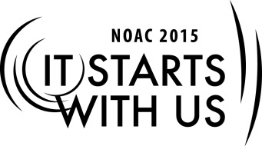
eScouting: Internet and Social Media
2015 National Order of the Arrow Conference
Session Length: 50 Minutes
Through this session, you will:
Explain How does the Lodge communicate with it's members in the 21st century
Demonstrate How the use of the internet and social media keeps members informed and up to date on Lodge events
Guide what resources are available in the social media world
Enable Return to Lodge, use these tools to improve lodge communication and membership

This session will help the Lodge with the Journey to Excellence Requirement(s) 3,6,7,8
- Better communication helps improve participation.and more participation makes a stronger Lodge

The theme of NOAC 2015 is “It Starts With Us”. This session will relay this theme in the following ways:
- Encourages members to use Social media to improve Lodge membership and participation

Learning objectives:
- Using the Internet, Social Media, and the lodge website
to communicate and enhance the lodge member’s
experience in the OA
- Finding ways to connect with members beyond paper
based mailings and phone calls
Effective website and social media management and
security
Required Materials:
- Laptop computer with a browser
- Power Point presentation file
- Handout – BSA Social Media Playbook
- Extension Cord and power strip
- Presentation Screen and Projector
- Live internet connection (wired or wireless)
Set up and test power, laptop, projector and screen. Set up Presentation background slide. Set up and verify browser and internet connection. Arrange room in so all seats can see the screen easily.
The session will be conducted in discussion/participatory format accented with multi-media and/or hands-on exercises.
Trainer Tip: The General flow of the course will include examples and attributes of various social media sites, and how they can be tied back to the main lodge website to promote better communications and involvement. This will include a discussion on what works best for the lodges in the audience.
Welcome everyone to the session as they arrive, and ask them to inter-mix as they sit down.
Introduction: 20 Minutes
Communication and engagement with members is one of the hardest things for any lodge to do effectively. As an additional resource to the lodge website, social media can play an important part of any lodges’ communication and promotion plan.
How many of you are in a lodge that utilizes a website as a form of communication? How many are using social media like Facebook and Twitter? What makes your particular chosen form of social media effective as a communication tool in your lodge?
[Elicit answers from the participants]
Possible Responses:
Facebook (for communications and promotion)
Twitter (for reminders and promotion)
Instagram (for pictures visual gratification during events)
Lodge Website (for the Calendar, Bulletin Board, Chat Room, E-mail List, Sign-up, Blogs, articles, promotion,, surveys, etc., FAQ (Frequently Asked Questions), Blogs, Surveys, New Arrowman Resources, etc.)
Display Lodge website (Example lodge) | http://www.OA466.org
Display Facebook Page | https://www.facebook.com/groups/130910980301572/  https://www.facebook.com/oabsa
Display Twitter Page | https://twitter.com/
Display Pinterest Page | https://www.pinterest.com/
Display Instagram Page | https://instagram.com/#
Display TEXT SMS Messaging site and App | https://www.rainedout.net/team_page.php?a=2d84f7acf7a35282444c

[Display a page above]. Is this page effective to promote the activities of the lodge? What draws you to this page? What makes it effective? Are the youth members already using this form of interaction? If not, why not? What about adults? Will they use it? Are they using it now?
What works for youth may not work for adults! Multiple methods of communications are necessary.
What about email? This is more relevant for adults than youth, although everyone is likely to have an email account. The frequency of checking email varies per age group.
What percentage of the youth and adults members have a cell phones with smart features? Are TEXTs more or less effective than using Twitter? Group SMS messaging services and apps.
Trainer Tip: Allow the participants to provide answers to each of these questions, while ensuring you get response from as many participants as possible. Try to elicit responses from both youth and adults.
Informational Portion: 15 Minutes
- Attributes of an effective Lodge Website
- Setting up a Facebook page for the lodge
- Developing a Twitter following for the lodge
- TEXTing as a form of reminders, group SMS messaging
- BSA and OA Guidelines, maintaining privacy and confidentiality
- Oversight to prevent abuse, hazing, etc., maintain content appropriateness

Question and Answers 10 Minutes
Discussion
Real World Application: 3 Minutes
Show lodge websites, real Facebook pages
[Provide handout packet?]
Conclusion: 2 Minutes
Develop conclusion based on findings before and during session….
Appendix: 0 Minutes
Data for further review on your own time….

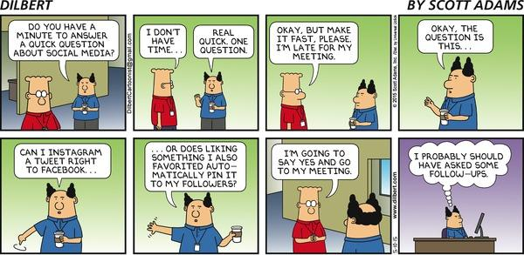

Appendix: Recommended flipcharts/Slides
The following is a recommended list of .PPT slides that can be used for visual presentation.
- Introduction to class and content
- Effective Lodge Websites and features
  - Tying over to social media sites and national resources
- Facebook page with callouts of features
- Effective use of Instagram to show pictures and videos at events
- Snapchat. Can this site be useful?
- Pinterest pages showing OA content
- Twitter and TEXTing as a means of communicating
  - Show example sites
- Social Media survey of OA youth and Adults
  - What this data tells us
- Effective controls to prevent abuse and maintain privacy
  - BSA and OA Guidelines on Web and Social Media use
- Effective controls to prevent abuse and maintain privacy
  - BSA and OA Guidelines on Web and Social Media use
- How to make Social Media effective for your lodge
- Questions and Answers from Audience

Appendix: Source materials, LINKS AND resouces
http://www.scouting.org/scoutsource/Marketing/Resources/SocialMedia.aspx
http://www.oa-bsa.org/pages/content/centennialupdate-2014-09-3

