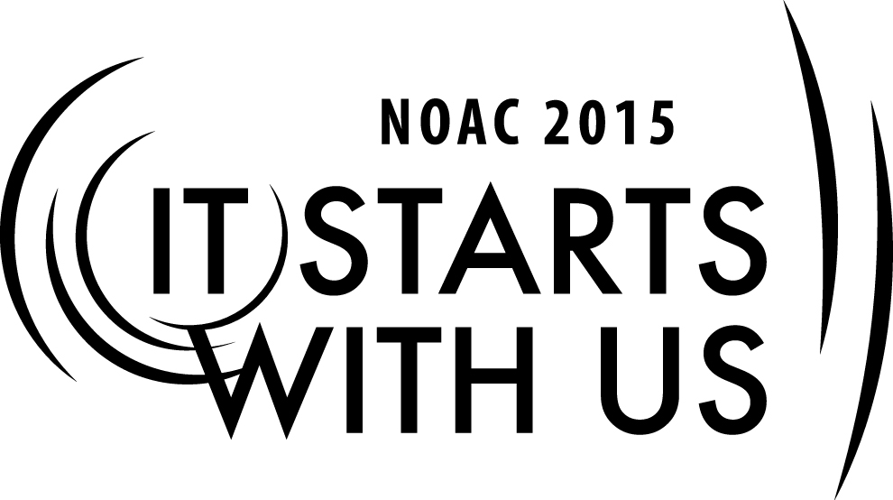
The Youth to Adult Transition:
How to Ensure the Successful Retention of Young Adult Members
2015 National Order of the Arrow Conference

Session Length: 50 Minutes
Through this session, you will:
Explain: Explores various methods of keeping young adults active in the lodge, through leadership and program opportunities.
Demonstrate: Successful ideas and strategies that will increase retention and help to develop the next generation of advisers.
Guide: Group discussion of ways to ensure successful retention of young adult members.
Enable: To identify what elements are needed to develop the next generation of advisers.

This session will help the Lodge with the Journey to Excellence Requirements: #4 Membership retention and #7 Lodge event participation.

The theme of NOAC 2015 is “It Starts With Us”. This session will relay this theme in the following ways:
- Recognizing how our acknowledgement, fostering, and development young adults influences their retention.
- Identifying elements required to develop the next generation of advisers.
- Developing strategies that will increase retention and development of young adults within the OA.
SESSION NARRATIVE

INTRODUCTION 5 Minutes

Basic introduction of the course will lay the groundwork for the session including: who you are, what the objective of the session is, and how your experience relates to the material in this session.

Trainer Instructions: Welcome everybody, introduce yourself, and give a brief background about your experience with the Youth/Adult Role in the Order of the Arrow

EXPLAIN 5 Minutes

Trainer Instructions: Read the prompt below about how the roles should be different between Youth and Adult while the goals should be the same.

The Order is not a youth-only organization and advisors play an important role in the success of the lodge. When youth arrowmen reach the age of 21, the realization hits…Is there life after 21 within the Order of the Arrow? The answer is an unequivocal “YES”! But how do I fit in? How should my interaction with youth members change? Is there a role for me? Answers to all of these questions are found in two places. The first is with the young adult themselves (Do not over commit. This is a busy time for anyone). The final answer can be found within the Order (Chapter, Lodge, Section) itself and will be the focus of the training cell.

Why do they leave? & The benefits of retaining young adult members 10 Minutes
Just like your local troop or crew, why do we lose our young adults?

Besides the statistical benefit to the Journey to Excellence Program, how do young adult members benefit the Chapter, Lodge, Section, Council, and the Scouting Community?
Trainer Instructions: Break the class into small groups. The groups will be given specific instructions. Spend approximately 5-7 minutes discussing and organizing responses to the above two questions. The intent of this exercise is to get participants thinking about the potential reasons why retention can be a challenge and the benefits of retaining young adult members. The second question will provide the justification as to why it should be a priority of the Order of the Arrow to retain and enable young adults.

Reconvene the class and ask each group to report on what was discussed. This is a great opportunity to utilize a whiteboard or flipchart to organize the course’s need and purpose.

Example Responses:

Why do they leave?
- Life outside of Scouting (Work, School, Family)
- Interest in the Program
- Not having or understanding their new role as an adult (Purpose)

Benefits of young adult retention
- Experienced scouter and leader
- Understands the youth perspective
- Next generation of OA advisers, scout leaders, and trainers

Retention Methods and Strategies 10 Minutes

We now know the benefits and importance of retaining young adults; however, how do we accomplish this goal? How do we maximize the benefits for both the arrowmen and the program? What has and hasn’t worked in your lodge? Does the size of the lodge and/or its geographic extent influence the type of methods and strategies you employ?

Trainer Instructions: Break the class into small groups. The groups will be given specific instructions. Spend approximately 5-7 minutes discussing and organizing responses to the above questions. We want participants to share their success and challenges (from the chapter to the section). The intent of this exercise is to get participants to share and engage ideas on retention methods and strategies.

Reconvene the class and ask each group to report on what was discussed. This is a great opportunity to utilize a whiteboard or flipchart to organize the course’s need and purpose.

Example Responses:

- Just ASK! How often does this not happen? Resource: “Let’s have lunch together” (Book)
- Don’t ask for too much all at once. Have S.M.A.R.T Goals. They can help at a single event, troop elections, training, or be a mentor and/or an adviser to a committee.
- Temper expectations
- Stay in contact. Invite them to events, make them feel valued.
- Have them help you recruit their cohorts

Enable and Inspire 10 Minutes

Success! Your lodge’s young-adult retention is increasing. How do you keep the enthusiasm and the trend up? How do you enable and inspire this new generation of adult arrowmen to continue to stay involved and foster their leadership development? What tools can your chapter, lodge, and section provide them?

Trainer Instructions: Break the class into small groups. The groups will be given specific instructions. Spend approximately 5-7 minutes discussing and organizing responses to the above questions. The intent of this exercise is to get participants thinking about ways to enable and inspire young adults in their chapter, lodge, and section. Discuss how approaches may change as you go from a chapter to a section. Also think about how approaches may differ in a small lodge to a large lodge.

Reconvene the class and ask each group to report on what was discussed. This is a great opportunity to utilize a whiteboard or flipchart to organize the course’s need and purpose.

Example Responses:

- Stay in contact. Just like a merit badge councilor, reach out to them when you are running an LLD, Service Project, Vigil, and Conclave/NOAC contingent.
- If they are a ceremonialist, perhaps they could work with the next generation of ceremonialists to build regalia or learn their speaking role.
- As they provide service to the lodge, recognize them and encourage them to advance their own development (ex. NLATS).
- Develop a succession plan for all of our adult leadership roles. A nomination committee could help identify or place young adults on leadership tracks.
- Partner young adults with older mentors.
- Solicit feedback.

CONCLUSION 10 Minutes

Recap the 3 main topic areas (Challenges/Benefits, Retention Methods/Strategies, Enable/Inspire) and highlight the key points and ideas that came from the facilitated discussions. Open the floor to the participants. How might you implement these ideas in your lodge? How might your lodge do things differently? Does anyone have any other ideas or concerns regarding retaining young adults? Anyone from a small or large lodge wish to share how they might incorporate these ideas into their membership strategy?

Trainer Instructions: The final segment of the training is intended to be a “town-hall” format. The trainer should recap the 3 main topic areas (Challenges/Benefits, Retention Methods/Strategies, Enable/inspire) and highlight the key points and ideas that came from the facilitated discussions. Open the floor to the participants.

TRAINER PREPARATION

The preferred trainer for this session should be a young adult who can relate to the life of the young adult member (between the ages of 18-28). He should be experienced in the leadership positions of the lodge (preferably as both a youth and an adult).

Appendix Resources:
- White Board or Flip Chart for Discussion Results
- Discussion Prompt Handout for Youth facilitator

