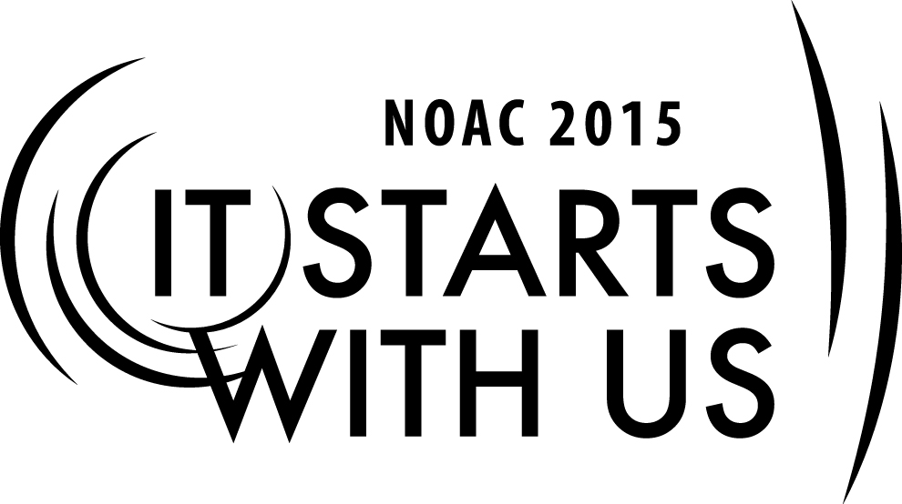
The Youth to Adult Transition: Redefining the Youth/Adult Role
2015 National Order of the Arrow Conference

Session Length: 60 Minutes
Through this session, you will:
Explain The goals of the Adults and Youth are the same but the roles and methods are different
Demonstrate The differences in perspective from the Adult and the Youth
Guide Roleplaying of possible Adult/Youth interactions at the Lodge/Chapter level
Enable To identify what elements are needed to establish a synergetic relationship

This session will help the Lodge with the Journey to Excellence Requirements: #4 Membership retention and #7 Lodge event participation.

The theme of NOAC 2015 is “It Starts With Us”. This session will relay this theme in the following ways:
- Acknowledging how our perspectives as Youth or Adults differ from one another
- Identifying elements required to establish synergetic Youth/Adult working relationships
- Developing strategies for implementing identified elements at the Lodge/Chapter level
SESSION NARRATIVE

INTRODUCTION 5 Minutes

Basic introduction of the course will lay the groundwork for the session including; who you are, what the objective of the session is, and how your experience relates to the material in this session.

Trainer Instructions: Welcome everybody, introduce yourself, and give a brief background about your experience with the Youth/Adult Role in the Order of the Arrow

EXPLAIN 3 Minutes

Trainer Instructions: Read the prompt below about how the roles should be different between Youth and Adult while the goals should be the same.

The Order is a youth-lead organization. It should be the purpose of every lodge to get as many
Youth involved with the lodge program as possible. Youth involvement in creating, developing, and running the program will keep the program from getting stagnate over the years. With each new slate of lodge officers and new set of new inductees comes new ideas and new ways of doing what we already do. The Order is not a youth-only organization however and advisors play an important role in the success of the lodge. Adults seek to achieve the Purpose of the Order of the Arrow and helping the Lodge to achieve its Journey to Excellence goals just as the Youth members do. However, the underlying reason adults are involved in the Order is to provide young men with the opportunity to develop into leaders of character. They should operate as advisors and mentors so that the Youth can seize the opportunities given them to become effective lodge leaders and to achieve the goals of their lodge and our Order.

DEMONSTRATE 12 Minutes

This group exercise will show the differences in solutions to situations a lodge may face from the adult perspective and the youth perspective. This should demonstrate the difference in roles between adults and youth.

Trainer Instructions: The participants will be divided into a youth group and an adult group. Each group is tasked with devising a solution they would implement to the situation. Reinforce that adults are there to ensure that the youth succeed, not to run the lodge. Give 5 minutes for the groups to come to a consensus and then report on their results. Spend a few minutes noting the similarities and differences as to how each would handle the problem. If the exercise runs short provide a 2nd situation and repeat the reporting, comparing, and contrasting of solutions.

Examples of situations that may be used for this exercise are:

- Participation at the last Lodge Service Project was disappointing and the Lodge has an important and very public Community Service Project in 2 months
- Lodge Membership over the last 3 years has been stagnant
- The Unit Election Team has only completed unit elections in 25% of council troops due to reluctant Scoutmasters and the limited time of the current Unit Election Team members

GUIDE 25 Minutes

Specific examples of behaviors experienced in the Lodge between Adults and Youth can be illustrated with role playing. The three scenarios to be acted out by a volunteer Youth and Adult participant are designed to guide the participants through real life scenarios that may occur in the Lodge. The first scenario shows the Adult crossing his boundary as an Advisor. The second scenario shows the Adult maintaining the proper balance as an Advisor mentoring his Youth to a solution. The third scenario falls somewhere in between but ultimately is another example of a well-meaning Advisor taking on the role of a Youth.

Trainer Instructions: All three scenarios should be acted out. Use different participants for each role play. Allow the actors to read the instructions provided in the Appendix of this syllabus briefly before acting it out. After each role play allow 3-5 minutes for reactions and discussion. A quick hand vote of who thought each ‘character’ maintained their proper role as a Youth or Adult can be used. After the three scenarios it would be appropriate to note that although these scenarios illustrate the more common well-intentioned Advisor trying to help too much it is entirely possible for Youth to go beyond their role. Examples of this may include making decisions that put individuals in danger, go against BSA policy, or are counter to Scouting values.

Scenario 1: The Show Must Go On

Denis is the Youth Arrowman in charge of the Lodge Monthly Newsletter. His Advisor John noticed that Denis wasn’t able to get the newsletter out the last three months after five months of successfully completing this obligation. John speaks to Denis on the phone soon after the Lodge Executive Committee Meeting to discuss. He quickly begins to chastise Denis for “allegedly” failing to produce a Newsletter and states that he will take care of next Monthly Newsletter to help Denis get back on track. John feels it is important that the Newsletter gets out as that is the Lodge’s primary form of communication for Lodge events.

Scenario 2: Help Without Helping

Sam is the newly elected Lodge Vice Chief which in his lodge puts him in charge of the Lodge’s annual Lodge Leadership Development (LLD) Training. The Lodge Advisor has appointed Bob to serve as Sam’s Advisor for the LLD. Sam, as an ambitious, but relatively new member of the Order is quickly overwhelmed with designing such an important lodge training event. Sam worries about what trainings to include, who will be the trainers, and how to encourage members to attend (which has been a difficulty for the Lodge in past years). Sam calls Bob and asks him if he will pick the trainings to include and recruit trainers as he knows Bob has been in the Lodge for a long time and Sam is overwhelmed. Bob asks Sam about why he is overwhelmed and tells Sam he will help him pick trainings and provide some names for potential trainers. He suggests Sam elicit desired trainings from the Lodge Executive Committee and call the potential trainers provided to see if they might be available.

Scenario 3: Lodge Success?

Andrew is an Advisor in the Lodge and has recently completed the Adult Wood Badge Training. Andrew has identified the Lodge Extended Elangomat Program as one of his Wood Badge Tickets that he must complete within 18 months. Excited about this program and it’s potential to reduce the Lodge’s “Sash and Dash” problem he brings it back to the Lodge Executive Council where all are in favor of beginning to implement the program. The Youth member Patrick is put in charge of this program. This program requires Elangomat Training and steps for the Elangomats to follow after the Ordeal Weekend. It also requires someone to coordinate contact info and follow up with the Elangomats to ensure they are reaching out to the new Ordeal members that were in their clan. Andrew goes full speed ahead planning and scheduling the training for the following month so the program can be implemented for the next Ordeal. Patrick is the trainer for this training and has been kept informed since the Lodge designated him the Youth in charge of Elangomats. Patrick is a great trainer, the training is well attended, and all are excited for this program to be implemented at the next Ordeal.

ENABLE 10 Minutes

A Youth member should facilitate the discussion on:
- What elements are required for good working Youth/Adults relationships?
- What traits should the Youth bring to the table to help achieve the Lodge’s goals?
- What traits should the Adults bring to the table to help achieve the Lodge’s goals?

Trainer Instructions: Allow a Youth member to facilitate the discussion using the prompts. Have them (or their designee) write down answers on a flip chart or white board. They should be considering the situations discussed and scenarios enacted and even the decision to have a Youth lead this discussion!

CONCLUSION 5 Minutes
Conclusion will define Synergy and relate it to the results of the Youth facilitated discussion. Synergy is the interaction or cooperation of two or more organizations, substances, or other agents to produce a combined effect greater than the sum of their separate effects.

Trainer Instructions: Define synergy and give a real life example of synergy (i.e. small school districts combining to have enough members for a football team). Then tie in how the points from the Youth led discussion are examples of ways to create synergy within the lodge. Encourage participants to remember these elements and traits and to bring them back to their lodges to promote Youth/Adult synergistic relationships.

TRAINER PREPARATION

The preferred trainer for this session should be a young adult who can relate to the life of the young adult member (between the ages of 18-28). He should be experience in the leadership positions of the lodge (preferably as both a youth and an adult).

Appendix Resources:
- White Board or Flip Chart for Discussion Results
- Scenario Instructions Handout for Actors
- Discussion Prompt Handout for Youth facilitator

