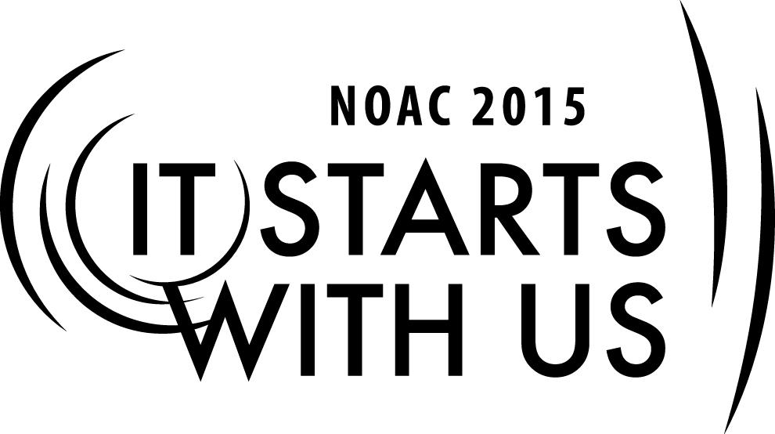
2015 National Order of the Arrow Conference
Troop/Team Enhancement: The Troop Meeting Program

Session Length: 50 Minutes
Through this session, you will:
Explain how participants can help their units by becoming involved in your Chapter and Lodge
Demonstrate how to use the OA Representative at unit and chapter meetings
Guide participants through creative problem solving as the OA Representative
Enable participants to better work with their unit, chapter, lodge and council

These three sessions within the Unit Enrichment Cell training will help your Lodge with Journey to Excellence Requirements #3 – #15.

The theme of NOAC 2015 is “It Starts With Us”. These sessions will relay this theme and through them you will:
- Be reminded of your duty to give service back to your unit first.
- Gain a better understanding of the history and purpose of the OA Unit Representative program.
- Become familiar with the resources available to you online and through local contacts within your chapter, lodge, and section.
- Recognize the value of the OA Unit Representative program.
- Understand and become comfortable with the requirements for the Journey to Excellence program.
- Learn how to better use the OA Unit Representative in your Unit, your Lodge, and your Chapter.

SESSION NARRATIVE

Introduction [1 minute]

Slide 1 - Cell Topic
Trainer Instructions: As session participants gather play music from Awesome Mix #1.

Slide 2 - Session Objectives

Hello everyone, and welcome to the second of the three sessions in this cell, made to inspire and assist you to benefit your unit through the Unit OA Representative program. My name is [your name], and assisting me in this session is [assistant’s name(s)].
Slide 3 - Cell Mission

Topic #1 [5 minutes]

Your peers chose you because they see potential in you to lead by serving. Those same people who chose you need you. This is an excellent chance to give back to those peers. Most Arrowmen were chosen at the unit level, and the unit is the foundation of the Scouting program. Scouting is most successful when the units are strong and supported.

Now that you are an active Arrowman, how can you best give back to your units? How can you show yourself worthy of being elected to the Order? We suggest becoming your Unit Rep or Unit Rep adviser.

Roll Video # 1 Star Wars ep. IV: A New Hope: “I’m Not Afraid” Time: #:##

Topic #2 - The OA Rep Functions [10 Minutes]

Slide 4 - The OA Rep In the Unit

Remember that the Order of the Arrow is, as Scouting’s National Honor Society, meant to use its program to support Scouting units. Similarly, the Unit Rep can fulfill several functions to support the programs of the individual units. What do you think some of those functions are?
Trainer Instructions: Solicit answers from the audience. Use a flipchart, or whiteboard, to write answers down. Use these answers to help facilitate the flow of discussion.

Some answers may include:
- Liaison to local OA chapter/lodge
- Member of the Patrol Leader’s Council
- Promotes camping opportunities
- Promotes OA events
- Helps facilitate OA troop elections

Let’s take a look at how these functions help the unit. By being a liaison, the Unit Rep provides a direct line of communication from your unit to the lodge and chapter leadership and the collective resources of those bodies’ members. As a member of the Patrol Leader’s Council, the OA Rep can keep the unit leadership updated on upcoming events and opportunities, like chapter meetings, lodge events, section conclaves and National Leadership Seminar/National Lodge Adviser Training Seminar trainings that other OA members can participate in. The Unit Rep can ensure the unit has an OA election and coordinate with the chapter to schedule the election. Finally, as a regular member of the unit, the Unit Rep can be a positive example of the Order of the Arrow and remind the regular membership of the Order’s ideals.

Slide 5 - The OA Rep Above the Unit

Ideally, an OA Representative and his adviser are active members of their lodge and chapter. This is essential in providing the useful dialogues to chapter and lodge leadership to access resources and stay up-to-date on relevant information to pass on to the unit. If your unit is demonstrating a good program, such as achieving Gold Journey to Excellence status, the importance of the OA Rep above the unit becomes that of a leader by being a resource to other units that may be struggling with their own program rather than seeking resources for his own unit.

Slide 6 - Troop/Team OA Elections

Topic #3 - OA Elections [5 Minutes]

The OA Representative plays a vital role in making sure a unit has an OA election. This is an essential component in maintaining positive growth within the lodge. It is the first step in the induction sequence, and it serves as an excellent landmark event on the troop calendar to promote the Order as a whole.

It is coordinated through the chapter, but one of the Unit Rep’s responsibilities can be to reach out and schedule the date of the election. The Unit Rep can promote this date to unit members long in advance, and by doing so guide the unit members in reflecting the worthiness of their peers for election to the Order of the Arrow.

Slide 7 - What if you don’t have an OA Rep yet?

Roll Video # 2 Star Wars ep. V: “He’s Worth a Lot To Me” Time: #:##

Topic #4 - Getting an OA Representative [5 Minutes]

There are several challenges that can occur associated with the Unit Rep, not all of which have to do with using a Unit Rep properly. For an example, your unit may not even have a Unit Representative. This can be due to several reasons. Maybe your unit leaders don’t see the merit in having a Unit Rep, or the Order of the Arrow is not a big part of your unit’s program. Whatever the situation, you are empowered to ask around with your scoutmaster, coach or youth leader, maybe the Senior Patrol Leader or Team Captain can appoint you to the role. After all, having a Unit Rep can only be a benefit to a unit, and if used to its fullest potential become invaluable to keeping a program fresh.

And don’t forget, you don’t need to have the position patch to represent the Order of the Arrow at your unit; that is a duty of every Arrowman.

Slide 8 - Video

Roll Video # 3 Star Wars ep. V: “What Are You?” Time: #:##

Topic #5 - Breakout Session [20 Minutes]
Trainer Instructions: Have pre-made situation cards ready. The situations are as follows:
- Your Scoutmaster and Committee Chair are openly having disagreements at meetings.
- You’re in a dysfunctional chapter that is not meeting or has no leadership.
- Your unit’s chartered organization is questioning the value of having an affiliated Boy Scout unit.
- Your district and chapter just merged with another district, doubling its geographical area and adding twice as many units.
- You are a Star Scout and have just moved to a new area. As a member of the OA you want to be involved in the local chapter and troop but the troop at your church does not have a positive relationship with the local chapter or lodge.
- Your Senior Patrol Leader (or Team Captain) is not leading, refuses to delegate duties or
- Your Scoutmaster is absent and an assistant scoutmaster is serving reluctantly.
- Your district is located in one of the larger states that encompasses several hundred square miles, how can you be an effective Unit Rep and an active member in the local chapter?

Now we will do a breakout session to brainstorm solutions to some hypothetical situations. Please split up in the same groups you did in the previous session. Each group will have two situations. Let’s take five minutes to discuss each situation and come up with a solution from the perspective of being an OA Representative.
Trainer Instructions: Set a timer for five minutes to count down the first situation. Announce the completion of the countdown and the transfer to the next situation, and then reset the timer. After the second countdown, announce the end and solicit the groups to discuss the solutions they came up for their situations.

Slide 8 - Closing

Topic #5 - Closing the Session [5 minutes]

Trainer Instructions: Allow a quick questions/answers session as time allows.

To recap, we talked about the potential functions of a Unit Rep in the contexts of units and chapter levels, the usefulness of having a Unit Rep promote and facilitate elections within your units, and what to do if you don’t have one yet. We also discussed how the Unit Rep could be a useful asset to troubleshoot issues by collaborative problem solving with other Unit Rep, to better help their own units. I hope this has been useful, and if you took anything from this session it is a better understanding that the Oder of the Arrow exists to support the units, and the Unit Rep can be an excellent ambassador from your unit to others in Scouting.

That concludes this session, thank you for being a part of it.

Trainer Instructions: As the session ends, play music from Awesome Mix #1.

TRAINER PREPARATION

It is important that the trainer be not only knowledgeable about the OA Unit Representative resources and website available online, but also has knowledge of OA Unit Representative programs and best practices that are utilized by other lodges, chapters and unit. The trainer should also have an understanding of how the lodge Journey to Excellence program is involved with a year-round OA Unit Representative program. Educating oneself is essential; the more comprehensive knowledge the instructor can gain through research, the better understanding he/she will have in answering questions from Arrowmen.
This session is intended for both youth and adult Arrowmen who work in a unit, chapter, or lodge leadership capacity. The ideal trainer will be a person who has previously held a significant position of leadership, such as a Chapter, Lodge or Section Chief, or a Chapter, Lodge or Section Adviser, and has had some success in that role. A well-prepared trainer will come up with his own examples and anecdotes, based upon the intended audience, to illustrate the concepts described here.
When setting up your training area for this session, be sure to give yourself enough room for the projector so that you can display an adequate sized picture. Because you are using a projector, a room with a large amount of light may hinder the quality of the projection, so be sure to take that into account in choosing your training area. Place the laptop so that the screen is facing away from the audience so that it does not distract the participants.
It is important to have an internet connection during this session so you can show the participants how to find the resources you are discussing and so they can get a sense of how the new website works. If it is not possible to maintain quality internet connection (or you do not have access to internet), include additional screenshots of the OA Unit Representative website and resource areas within your PowerPoint presentation.

Appendix Resources:
- Blah blah blah.

