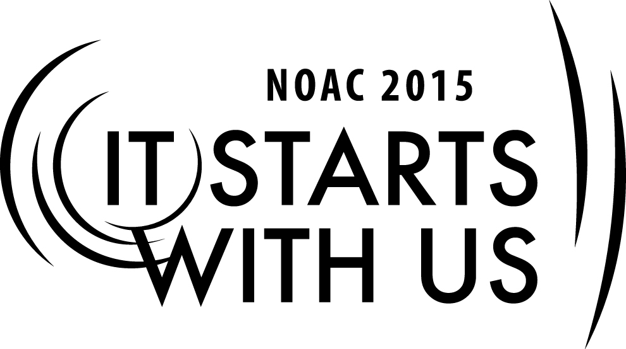
Skills for Advisers: Building the Team Team

2015 National Order of the Arrow Conference
Session Length: 60 Minutes
Through this session, you will:
Explain What a successful team is, and how and why it forms
Demonstrate The importance of values, vision, and mission
Guide How leaders select the right people on the team
Enable Members of team to remain focused on the team mission

Moderated discussions of what good and poor teamwork look like, with opportunities for Lodges to share best practices and support each other through their shortcomings. Topics covered here can be used by any member of the Key 3 to improve their own team, personally or professionally. Each part of the Key 3, in addition to its other roles, serves to keep its other two members performing at a high level.

The theme of NOAC 2015 is “It Starts With Us”. This session will relay this theme in the following ways:

- Identify ways to build high-performing teams to operate in order to accomplish objectives efficiently
- Describe relationships between the members of the Key 3 using the Disc profiling system
- Work to improve the dynamic of their own Lodge’s Key 3 upon completion of the conference
SESSION NARRATIVE

Introduction 5 Minutes

Building on the “Role of the Key 3” session, we aim to delve deeper into the unwritten relationships between Lodge Chief, Lodge Adviser, and Lodge Staff Adviser and show how to build high-performing teams to accomplish their goals and objectives quickly and efficiently. Encourage members to share their experiences and comment on others’ stories – issues are often resolved through collaborative efforts. We have the best people in the Order here for a week – make use of their talents and experiences.

THE GOOD AND THE BAD

8 Minutes

Open discussion to get attendees talking about what their own experiences have been – good and bad – with members of their Key 3. Does one person drive the group more than the other two? Is one non-existent? Facilitator/scribe will take notes of issues raised to be addressed further in the session.

TRAITS OF HIGH PERFORMING TEAMS

10 Minutes

Review notes on what makes a team successful – ask random attendees to read from handout to ensure attentiveness. Ask questions such as “Does this sound like your Key 3?” to encourage audience to think about their own situation back home, and what they might be able to do to improve it. Lead discussion and conversation toward how to apply these “successful traits” to a Key 3, and where in the job descriptions for each that some of these traits already appear. Use scenarios offered by attendees to show where a trait is being used (or “abused”) by members of the team. Note some of these mismatches for use in the “Understanding Man” section below.

35 Minutes
UNDERSTANDING MAN

Every team and every person is different. We see in Scouting all the time that one approach most certainly does not “fit all.” The toughest part of making a team function is to understand the other players. Reading people takes a lifetime to master, but there are some shortcuts to make it easier to interact and keep all team members working toward the common objectives of the team.
Trainer Instructions: share the abridged DiSC assessment and ask that members take 3-5 minutes to complete the assessment of themselves and their other Key 3 members. The assessment should be done rapidly, since the first answer is likely the truest description of the individual. Discuss with members the “interacting with others” handouts to review how successful and poor interactions will be determined.

Return to the scenarios offered earlier in the class and reference discussion by members in identifying whether the communication used followed the guidelines through the DiSC assessment and interaction guide provided.

Steps on How to Build a Successful Team

A team is only as strong as its weakest link, and for this reason, putting together a team takes time and smart analysis of your organization objectives. Understanding the needs of the organization will better prepare you for selecting team members, and learning the strengths of potential team members will be the determining factors when the time comes to build a successful team.

For these reasons, consider the following when selecting potential team members.

Pick team members who are motivated to demonstrate their skills and make a difference. Each individual in the team should have an interest in the overall objective of the team, and be accountable for his own performance in relation to the team's performance as a whole.

Select a team with diverse knowledge and skills so that as a whole your team is well rounded and prepared to deal with any complications that may reveal themselves.

Establish a purpose that unifies your team members and make sure that each person in your team knows what that purpose is. When it comes to successful team building, it is important that all members know what is expected of the team as a whole and how the overall purpose of the team reflects a plan directly related to the company's mission. When members understand the significance of their performance, and when they see that each member is accountable for their personal responsibility, they will be motivated to executing plays that meet that ultimate goal.

Determine the roles of each team member and how each role relates to each other and the team as a whole. Members are no longer individuals, but rather, they each play an integral role in the team's overall objective, and each must now rely on the others in order to complete the final goal. In order for a team to be successful, each team member should understand what his personal responsibility is and how important it is in relation to the overall team goal.

Mandate that all team members openly commit to the team. Such commitment is a necessary step for successful performance. Without such public commitment to their personal assignments and the overall team objective, the team as a whole would not be effective.

Institute a team leader, if not yourself, and make sure that that person is highly motivated toward team goals, and that he shares your mission for the organization. Ensure too that the leader has knowledge and skills above and beyond the other team members.

Communicate privately with each team member who is having problems committing to, and ultimately producing for, the team. Ask what obstacles are hindering them from meeting those commitments. As the team member and leader, it is your responsibility to commit yourself in turn to assist those members who are lacking and help remove those hurdles.

2 Minutes
CONCLUSION/WRAP-UP/QUESTIONS

Emphasize that once we have built a team, understanding how to communicate with each other many of the problems we might face together can be eliminated. “It Starts With Us” to ensure that we are able to communicate effectively, quickly, efficiently, and to the best of our ability – by removing barriers, to help individuals openly commit to the team objectives.

TRAINER PREPARATION

Trainer should have experience in the Order of the Arrow both as a youth and as an adult so they can view the coaching relationship from both sides. The trainer for this session should be someone familiar with all aspects of the Troop/Team Representative program, ideally, someone who has experience as a Troop/Team Rep. Committee chairman or served as a Troop or Team Representative. The trainer should also be highly energetic, enthusiastic and leverage his past team building experiences in order to create enthusiasm among the members.

Appendix Resources:
- Computer & Projector for PowerPoint presentation
- Easel & Flipchart or access to chalk/dry-erase board for session notes
- Prepared handout packet: “Traits of High-Performing Teams,” “Quick Dominance, influence, Steadiness, Conscientiousness (DiSC) Assessment,” and “Applying DiSC”

