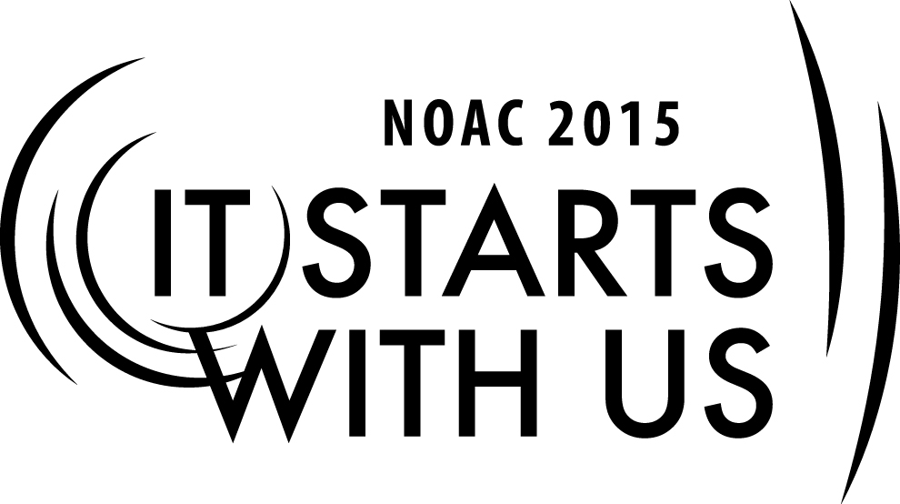
Skills for Advisers: Coaching Your Youth
2015 National Order of the Arrow Conference
Session Length: 60 Minutes
Through this session, you will:
Explain the similarities and differences between coaching, mentoring, and advising.
Demonstrate how to be responsible to youth rather than responsible for youth.
Guide guests on how to listen to needs from youth and communicate their own expectations
Enable guests to coach youth leaders in achieving their goals

This session will help the Lodge/Chapter/Section Adviser reinforce all aspects of lodge development through youth leadership & energy.

The theme of NOAC 2015 is “It Starts With Us”. This session will relay this theme in the following ways:
- By understanding what youth need from a coach - adults in the lodge and chapter can be more responsive to youth needs.
- Having a youth who feels supported and empowered ‘starts with us’ as adults setting the example
SESSION NARRATIVE

Introduction: 2 Minutes
The purpose of the BSA, the OA, and the mission of the lodge all focus around developing strong youth leaders with the help of qualified adults. Youth leadership is foundation of the Scouting program and the key to its success. That is why youth leadership development is vitally important to the program and should be the mission of every lodge.

Trainer Instructions: Trainer should introduce himself. He should provide information on his Order of the Arrow experience, what lodge and city he is from and any other relevant items of interest. Trainers should follow the outline of this session narrative and should also develop their own style of delivery. Though out the session, the trainer should draw on their own examples to add depth to each concept.

Defining Coaching versus Mentoring versus Advising 15 Minutes
First we should define what coaching is, to do that let’s do some word associations with these three words.

Trainer Instructions: Trainer has three flip chart sheets ready with the titles: Coaching Is…; Mentoring is…; Advising is… Depending on class size and technology availability, this could be done via a projector as well.

Instructions: Take two minutes to think to yourself how you would complete these sentences on your own. Write it down if you need to; try to be brief and to the point. It could even be what it is not.
After two minutes: Let’s quickly go through each of the three words. Tell me in rapid fire how you completed the sentences and let’s get them on paper.

Trainer Tip: Have a second trainer write the sentences on the charts while you are guiding the guests through the exercise.

Examples:
- Coaching is not mentoring and coaching is not advising.
- Coaching happens in the moment when the youth needs a push
- Coaching is a kind word of encouragement
- Coaching is being willing to listen.
- Coaching is advice, not direction.
- Coaching is used to help members of the lodge develop skills that will benefit the lodge
- Coaching is used to teach new concepts
In smaller groups Coaching is used to enhance competency
- Coach is used to help a team reach it’s short term goals

Now that we have all the charts completed, what do you see that is similar between these three? What do you see as different?

As you can see, these three words or titles are very similar in that they all describe a relationship between two people, but they are also different ways to define that relationship. Advising is a specific and defined role in the Order of the Arrow, and Mentoring is a long term relationship and is usually behind the scenes, coaching is being there for the youth in the moment, when they need it. You don’t have to be a named adviser to be a great coach.

Now that we defined what coaching is, how do I coach? The rest of this session is focused on this very important question.

• Coaching is task oriented
• Coaching is short term
• Coaching is performance driven

Coaching Step 1 – Engage the Youth Where They Are 10 Minutes
Trainer Instructions: Have the Social Styles Matrix chart ready to go. Where possible, also have handouts of this available to pass out after the session.

Analytical  - Indirect and self-contained  - Focus on logic  - Need all facts before they will make a decision  - [aka Planner] | Driver  - Direct and self-contained  - Task and results oriented  - Takes charge and makes quick decisions  - [aka Director]
Amiable  - Open and indirect  - Cares deeply about other people and their feelings  - Needs to feel trust and support to make a decision  - [aka Agreeable Friend] | Expressive  - Open and direct  - Important to share ideas and enthusiasm  - Wants group excitement to encourage their decision  - [aka Socializer]

Let’s take a few minutes to look at this Social Styles Matrix. You can find this in any number of corporate and sales related trainings, but it is relevant here. There are two axis, one with direct or indirect personality and one open or self-contained personality. There are also four quadrants, each has a combination of the two behaviors. Each quadrant describes a social style of a person. These are archetypes and typically folks will fall mostly into one of these quadrants but it can be situational.

The point of showing you this matrix is so you might understand your youth better. Once you know their social style, the best thing you can do as a coach is MIRROR AND MATCH their style and help them get what they need to make a decision.

For example, if your youth is an analytical, they need all the information to make a decision. They will want to know how conclave was run in the past, what the expectations are for that particular role, and will not start making plans or telling people what they need for this year until they have all the facts on the table. As a coach your responsibility would be to be patient and give them all the info they need to make that decision on their own.

For example, if your youth is an expressive, they want to foster excitement about conclave. They will socialize with other youth, tell them about the activities and fun it will have even if the details of their ideas have not been finalized yet, then they will make decisions based on how others respond to their ideas and excitement. They will likely look to you as a coach for affirmation which you can give, or you can guide them to get affirmation from other youth instead. As a coach you may need to guide them to encourage them to make firm plans.

To take it one step further, if you who have done NLS you might think about the leadership styles matrix. Hat chart would also be helpful to understanding your youth’s leadership style. For those of you who have not done that training – get there – it is the best leadership training you can ever do.

Now let’s make this relevant to you. Pick a youth in your lodge whom you know and whom you have coached before. What quadrant are they in? How can you meet them where they are?

Turn to your neighbor and describe your youth and how you engage them where they are. If you cannot think of a specific situation, think about how you want to engage a youth in your lodge during this NOAC.
Coaching Step 2 – Communicate Expectations and Needs Clearly 20 Minutes

Just as it is in any personal interaction - communication is what makes it work or not. As a coach it is your responsibility to both start that communication and respond to communication from the youth.

In a perfect world communication in person is the best practice to have, especially for a coaching interaction. But we don’t live in a perfect world and often need to be available via email, twitter, facebook or even snap chat. So no matter the platform we communicate on, the hard part is finding the right words to use, so here are two phrases you can try and see if they work for you.

What do you need from me?

This simple phrase is direct and to the point. The answer could be ‘nothing’ or it could be ‘I need you to tell that other adviser to stop talking during our LEC’. It is not ‘how can I help?’ or ‘I will do X’. Using this phrase automatically empowers the youth to ask something that may otherwise be difficult to say. It also opens a direct dialogue that leads to what the youth expects of you as their coach.

Have you thought about…?

This is an excellent way to challenge an idea or plan that the youth has made without challenging their authority as the youth leader. It is not ‘you should do it this way because that’s how it has always been done’ or ‘I think you need to run conclave like this.’ This phrase allows you as the coach to ask for something more from the youth and challenge their thinking while at the same time giving them space and time to learn for themselves.

Now let’s practice these phrases in two different situations.

Trainer Instructions:
Partner activity – have guests pair up and use these phrases and act it out. You can use these situations, provide your own, or ask for real recent situations that needed coaching from the guests.

Situation 1: Nolan is Lodge Chief of your lodge. He is an experienced leader and has built a strong team of youth leaders around him. Currently he is running the LEC meeting but it goes on and on as one of the advisers keeps adding his two cents about every item on the agenda. You can tell Nolan is getting irritated.

What do you do as a coach?

Situation 2: Zander just became a brotherhood member of the Order of the Arrow. He is excited about hanging out with his new friends more, so decided to run for Chapter Chief. He does not really know much about what that means or what he is supposed to do.

What do you do as a coach?

If time allows – create your own phrase that opens communication channels and share it with your partner.

Now your assignment is to use these phrases or ones like to coach your youth – it starts with us.

Coaching Step 3 - What Not to Do 10 Minutes

The third step to coaching is about letting your youth perform on their own, which brings us to what not to do. Every youth is going to have their own pet peeves and particular things a coach might do that irritates them.

Think back to your youth – what did a coach do that was not what you needed at the time? Share that with your partner.

Let’s talk about some examples of what not to do.
Trainer Instructions:
If you have access to an older youth who is a lodge or section leader who might help with a first person opinion on what not to do as a coach it could be a great way to enhance this portion of the session.

Examples:
- Direct the youth what to do, rather than let them succeed (or fail) on their own.
- Make commitments you cannot keep
- Tell your youth: I think you should…etc.
- Assume if they work well with you, they will work well with other adults
- Preventing failure by doing it yourself rather than youth taking responsibility for that problem
- Criticize your youth for not doing it the way you thought it should be done

Final Word 3 Minutes

Responsibility TO versus Responsibility FOR

If there is one take-a-way from this session, let it be this. Coaching is where you take on a responsibility TO your youth. It is not where you take responsibility FOR your youth. Did you catch the difference? Your responsibility in this relationship is to be there for your youth, to listen, to guide, to provide context and experience. It does not mean that you have the ultimate responsibility whether your youth completes the task or becomes the leader you think he should be. Your job as a coach is to be responsible TO your youth – it starts with us.

Thanks for your great participation in this training session.

TRAINER PREPARATION

Trainer should have experience in the Order of the Arrow both as a youth and as an adult so they can view the coaching relationship from both sides.
Appendix Resources:
- Speaking directly to youth about what they need from a coach prior to the session would be helpful in making the session more relevant.
- Speaking with coaches you admire in your lodge and section about what they have found to be successful would be helpful in making this session more relevant.
- Clips from movies like ‘Remember the Titans’ or ‘Invictus’ or ‘Apollo 13’ or ‘Coach Carter’

