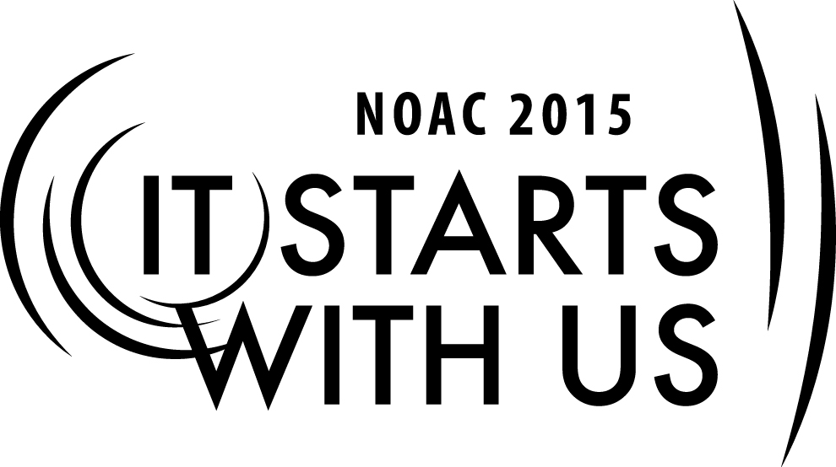
Skills for Advisers: The Role of the Key 3
2015 National Order of the Arrow Conference
Session Length: 60 Minutes

Explain the role of each member and their relationship to other members of the key 3 team
Demonstrate how to support each other as members of the Key 3 chapter, lodge and section
Guide ways in which they Key 3 can strive to lead the youth and adult members of a chapter and lodge
Enable chapter, lodge and section Advisers to understand their roles and know how to apply their leadership skills while contributing to the success of the Key 3 team.

The theme of NOAC 2015 is “It Starts with Us” in this session we will relay this theme by discussing and considering the different roles of each member in the Key 3. In a chapter or lodge the adviser helps the other members of the team to establish goals and to evaluate progress toward the organizational goals.

Trainer Instructions: Start the course by having a good understanding of all members and their OA experiences. Introductions can be used as the main tool to allow members to become familiar with each other in the classroom which could help support the ideas that enable opened group discussions by discovering opportunities to a dynamic course. At a minimum use 10 minutes to complete.

SESSION NARRATIVE & HISTORICAL PERSPECTIVE

5 Minutes

During this session we aim to explore the roles of each member of the Key 3 team in order to develop the members to actively become contributor members of an effective key three team. Members will understand their relationships and responsibilities that each person should bring to the team. “It starts with us,” we need to ensure the success of the lodge and so the discussion today covers the specific roles and responsibilities of each of the members of the key three team. We will mainly focus our discussion on the roles of the lodge adviser. Who can tell me some of the responsibilities for a lodge Chief, Lodge Adviser and the staff professional Adviser? At the conclusion of this course members will understand their leadership roles and the responsibilities they should accept as a member of the key 3 team in order to enable the planning, development and execution of goals and programs the lodge’s Journey to Excellence.

You might’ve heard this line before, “it takes great leaders to develop great teams” As the lodge adviser and member of the Key3 team you are expected to understand your capabilities and those of your team members, recognize how to balance and when to apply those combined capabilities to fully develop what will make your team unique and ready to take on the challenges of tomorrow.

ROLES OF THE KEY 3 DESCRIPTION: LODGE KEY 3 AS A TEAM

30 Minutes
Roles of the Key 3 description: Lodge Key 3 as a team

- They meet prior to each lodge executive committee meetings and review all operations of the lodge and prepare the agenda items for the LEC.
- Meets at other times as required
- Coordinates and facilities the planning meeting, approval, and execution of the lodge annual plan
- Ensures lodge administrative tasks are completed properly and timely (e.g., re-charter renewal, Journey to Excellence program, annual budget, national program, registration etc.)
- For the lodge to be a success, “It starts with us!”
The Lodge Chief - A youth (20 years old or younger during his entire term of office) elected from the youth membership of the lodge.

Responsibilities:

- Adheres to the program and policies of the lodge.
- Works closely with the lodge adviser, seeking advice and training.
- Attends all lodge executive committee meetings.
- Appoints chairman of the lodge operating committees.
- Assigns lodge members to operating committees.
- Attends lodge Key 3 meetings.
- Communicates with lodge officers and committee chairmen.
- Presides over all meetings of the lodge executive committees.
- Responsible for the planning and conducting of lodge activities.
- Delegates his responsibilities to fellow lodge officers and committee chairmen when not present at the event.
- Responsible for chapter programs supporting the lodge program. -Undertakes lodge service projects with concurrence of Key 3.
- Appoints the Vigil Honor nominating chairman.
- Promotes the correct wearing of the scout uniform.
- Provides unit election teams with unit contact information.
- Sets the example all of the time

The Lodge Adviser – An adult (21 years or older) appointed annually by the Scout Executive.

1. Become a member of the council camping or Boy Scout committee and may be elected to the council executive board. Attends all meetings of the council committee and knows the camping situation in each unit. Know from chapter reports which units need camping promotion and training.
2. Understands the policies and principles of the OA and sees that they are followed in the lodge.
3. Sees that the lodge officers get the job done by providing them with the tools, opportunities, and necessary transportation. Knows the adult role in the Order of the Arrow and does not wait for the lodge chief to call, but is self-motivated and offers help. Assist in establishing goals and objectives, including attainment of a minimum of bronze level in the Journey to Excellence recognition.
4. Make sure that the lodge chief conducts the lodge executive committee meetings. Attends and sits with the lodge chief at all meetings and activities.
5. Appoints an adult adviser to each lodge officer and committee chairman, in consultation with the lodge chief and staff adviser.
6. Helps every adult Arrowman in the lodge to be a functioning adviser, either as a unit leader or an adult adviser to a lodge or chapter committee or project. There are no honorary adult positions in the Order, the lodge, or the chapter.
7. Reminds adult lodge committee advisers to attend the meetings if the lodge operating committees related to their assignments. Ensures the lodge charter renewal application is processed and mailed on time.
8. Aids the lodge chief in producing effective agendas for these meetings. Promote attendance of appointed adult advisers. Encourages work with officers and committee chairmen prior to the meetings.
9. Limits annual lodge activities to four exciting events scheduled each year that involve the entire lodge membership. These activities should be well planned and provide opportunities for the Arrowmen to learn more about the Order and how to provide effective service. Clear all dates with the staff adviser.
10. Helps the lodge chief delegate the full burden of the lodge program so that it is shared with the other lodge officers and committee chairmen.
11. Understand that the chapter (when so organized) is a division of the lodge for carrying out the lodge program. Understands that the chapter is not a super unit unto itself, but is a camping promotion aid for units. Every youth in the chapter activity should result in an enriched program for units. Frequently reviews the goals with officers to see that the Order of the Arrow program is being actively followed in each district.
12. Clears all lodge service projects with the staff adviser. Know that the Arrowman is primarily a member of a unit and that Order of the Arrow projects must NOT remove a youth from his unit too often. The lodge service projects undertaken should be directly related to camping, the council Cub Scout and Boy Scout programs, and/or the community.
13. Appoints and adviser to the Vigil Honor nominating committee.
14. Sets the example for youth and adult Arrowmen by correctly wearing the Scout uniform with the proper badges and insignia correctly placed.
15. Provides lodge officers and committee chairmen with district rosters of the units so that proper contact can be made or unit elections, camping promotion, etc. As the lodge advisor, maintains constant and regular contact with the staff adviser so that person can quickly relay any unit personnel changes, etc.

- Active member of the Council Camping Committee.
- Maintains awareness of units needing camp promotion.
- Understands the policies and principles of the Order.
- Works with the staff adviser to ensure lodge funds are managed properly.
- Attends all lodge functions.
- Ensures resources are available to lodge officers.
- Initiates communication with lodge chief and advisers if necessary
- Attends and sits near the lodge chief at all meetings.
- Ensures the lodge officers and committee chairmen have effective adult assistance.
- Appoints an adult adviser to each lodge committee.
- Attends lodge Key 3 meetings.
- Reminds adult lodge committee advisers to attend lodge operating committees as appropriate.
- Assists the lodge chief in preparation of effective meeting agendas.
- Limits annual lodge activities to four successful and exciting events.
- Clears all dates of lodge activities with the lodge staff adviser.
- Assists the lodge chief with his delegation of responsibilities to other lodge officers.
- Assists chapters in delivering, appropriate programs and camp promotions.
.

The Lodge Staff Adviser - A Professional Scooter over the age of 21 assigned by the Scout Executive with extensive Order of the Arrow experience.

- Works closely with lodge officers and advisers, maintaining a close relationship to benefit the lodge and council.
- Watches the lodges finances and coordinates financial operations with appropriate council
- Personnel.
- Coordinates lodge activities and get them on the council calendars.
- Coordinates OA participation in the council summer camping promotion and program. –Liaison
- with the council staff, including the camp ranger, and coordinates use of the council office facilities.
- Advises adults of their role in the Order.
- Encourages participation in section and national events.
- Takes the place of the Supreme Chief of the Fire in his or her absence when needed.
- Attends and promotes all functions.
- Sets the example.

Discussion, Questions and Answers

13 Minutes

Emphasize that once we understand how to communicate with our other team members that many of the problems we face can be eliminated. “It Starts With Us” to ensure that we are able to communicate effectively, quickly, efficiently, and to the best of our ability – by removing barriers, we help to improve the process.

CONCLUSION

2 Minutes

“It starts with Us” the success of a lodge is directly attributable to the success and teamwork of the Key 3. This session has hopefully provided you with additional knowledge and ideas on how to make your Key 3 a driving force in the lodge and council.

Appendix Resources:

- Computer & Projector for PowerPoint presentation
- Materials needed: Power-point slides
- Easel & Flipchart or access to chalk/dry-erase board for session notes

