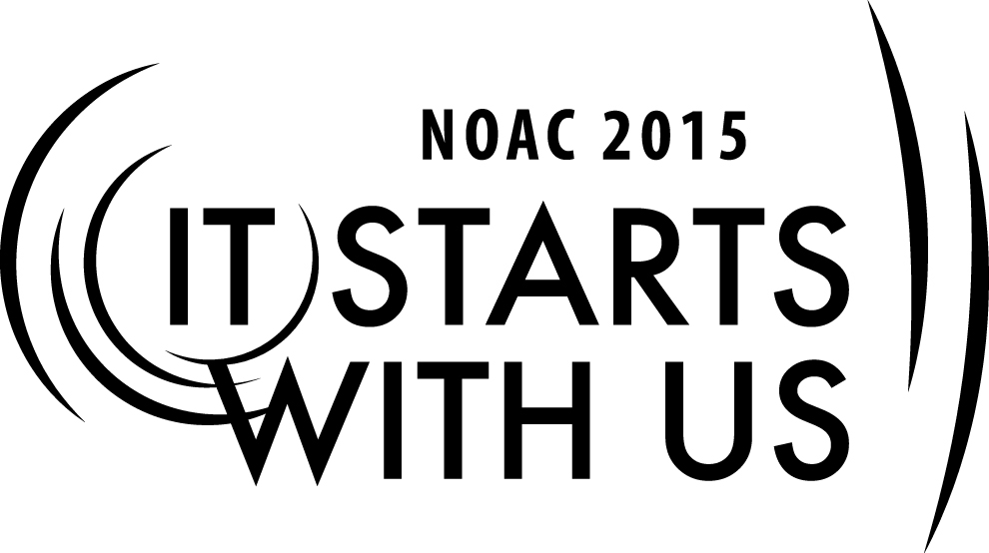
TRAINER PREPERATION

SMALL LODGE ADMINSTRATION –LOGISTICS AND ORGANIZATION

Session Length: 50 Minutes
The theme of NOAC 2015 is “It Starts With Us”.
This session will relay this theme by enabling guests to be the catalyst for positive development of their lodges by taking home with them the fruits of the discussion in this training session.
Through this session you will be able to:
Explain the strengths and challenges that smaller lodges uniquely face in administration.
Demonstrate ways to play up the strengths in order to meet those challenges.
Guide our guests in discussion of best practices to address those issues.
Enable our guests to take back to their lodges ideas that they can actually employ.
This session will help the Lodge with the Journey to Excellence Requirements:
- Membership impact #3
- Membership Retention #4
- Lodge event participation #7
- Leadership Development #16
Required Materials:
- Box of Large paperclips
- Flipcharts (2)
- PowerPoint Presentation file
- Adult & Youth Resource Survey to determine skill set available (HandOut)

SESSION NARRATIVE

Trainer Tip: In improve participation and customize the discussion, ask one member of the lodge represented to write on the board or flip chart in the front of the room 1) Lodge name, 2) Location and 3) How many members in their lodge.

- Use an ice breaker to get the group started.
- One of my favorites is to divide up on groups of 5-7, pass out a large paperclip , then get out a sheet of paper and write down how many ideas you can get with the common paper clip. Have a contest for the most answers…Time them for 90 seconds and in the end , ask each group who had the most.
- Remind them that a “mind once stretched, never regains it original shape”
- So they need to be open minded about this session.

INTRODUCTION 5-7 Minutes

Introduce yourself and share your background and experience. Based on the size of the group and time, have the participants introduce themselves where from, lodge name and how many members.

In this session we will be discussing how the problems and needs of the lodge influence its organization
How the unique character of a small lodge can be leveraged to improve its administration
The Journey To Excellence provides a clear road map to a path/plan for continuous improvement for the Lodge.

Start with Ice breaker paper clip contest.

Using The Membership 10-15 minutes

The Order of the Arrow Handbook strongly recommends that all members, no matter the size of the lodge, be given some sort of assignment. In smaller lodges, this is even more important, as human resources are numerically scarcer than they are in larger lodges.

There are some general rules for effective use of your membership that can get more out of each member’s service. Remember: “Small” does not mean “lacking.” Also, small could mean your active turnout, not necessarily the number of members on paper.

Members who are needed (I e have a reason to come to something) tend to participate more and over a longer period – they stay active. Everyone also brings unique talents to the table, and it is important to know who can do what and who wants to do what.

Trainer Tip: Have everyone list three strengths of small lodges, then three challenges smaller lodges face when it comes to administration. Use these to focus and guide your discussion of this session.
Membership Inventory

Set up a simple data base for positions needed and member’s prospective positions/skills. Like a Quartermaster in the troop, this info can be in a data base on computer or simple index cards in a box. Pass out the Adult & Youth Resource Survey to determine skill set available
Remember information is power, so keep that information handy to use to recruit and fill position.

Personal Information

Age, school, phone, interest, jobs, talent, address are essential to know in your lodge

Hint: How about manpower committee to do this? Remember for adult’s job type, list of hobbies is very important.

Scouting information

Rank, unit number, position, events attended. Honors held, years in position, training courses attended like JLT, Wood badge, University of Scouting, previous positions, and similar information

Order of the Arrow information

Status, position held, previous events attended, staff worked on, ceremony parts, Elangomat, national training and events, other area of interest.

Once inventory is done and resources identify, just connect the dots and have a backup for each position in case they are unavailable or decide on another position.

This is called succession planning.

Training

Once you have a member assigned to a task, be sure to train him or her to do it well.

All great organizations and companies do it regularly.

A regular Lodge Leadership Development (LLD) program is essential, but also encourage members to attend training at Section Conclave, send delegations to the National Leadership Seminar and adults to the National Lodge Adviser Training Seminar or OA training at Philmont. (If funding is an issue for any of these, approach your council’s camping committee or training committee to map out strategies for getting your members to these training sessions).

Training is essential and the best training is service as an assistant to the leader of the job you will be taking.

Ask how do you learn best? Ask for show of hands?
- Who would like a book and read and do a project?
- Who would rather see a demonstration and then try yourself?
- Who would like to do trial and error to complete a task?

Be sure you understand the best training for the right person.

Match the job for the person. Please do not assume that just because you see someone at an activity they are competent to lead or interested in that task.

Make sure that the person recruited has someone who will be available to answer questions along the way and can give advice or help.

All jobs need a written job description to be sure everyone is on the same page.

Remember authority is seized, not granted, sometimes a well written job description will be sure the job gets done correctly.

Another great idea for new or young leaders is to be sure you show confidence.

People follow leaders not managers.

Be humble and admit your shortcomings or mistakes. Also if you make a mistake with your lines in a ceremony, be confident, as this is the first time they hear it.

If you forget a key food for lunch, improvise or send someone to get it!

What you know is better than what you think you know – membership inventory and succession plans.

Most youth positions change every year, so training is ongoing. Advisors are normally 3-5 years, so they can overlap new emerging youth leadership.

When selecting youth and adults for a position it is best to have an inventory list of needs and potential list of talents.

The wise leader will find out all they can about a prospect before he meets or speaks with them. A good leader will find a job for every member and understand the need and wants for that member, and takes into account level of commitment and also ability.

Organization of the Lodge

Lead a discussion on the size and structure of the leadership. What size executive committee does a smaller lodge need? What are the essential positions? What operating committees are needed? How do we cover everything that needs to be covered without burning out members by giving them too much to do?

Does a smaller lodge need to operate with chapters? When might one need them? When might they get in the way?

Let’s put in use what we learned 15-20 minutes

Divide up into 3-5 members per group Chose a problem card from the deck and spend 7-8 minutes discussing it . Keep groups small for better interaction

Then have a member report back to the group. At the end and capture info on flip chart

- What number of activities are enough for the small lodge? The chapter?
- What other events besides ordeals should be put on the calendar and why?
- What makes the best draw for the youth and adults?
- What programs ideas have been successes? Disasters? More importantly, why did they work or not work?
- What manpower and training is needed to put on these events?
- How do you keep form conflicts like band, theater, sports, church activities overlap with OA and scouting?

The unique ambiance of smaller lodges can be exploited to attract and retain the youth in the organization. By using a structured brainstorming technique, develop a list of ideas that can be used by smaller lodges that will help in making the individual lodge member feel more a part of the organization.

Conclusion & Wrap up 5 minutes

This session did address four key components and will help the Lodge with the Journey to Excellence Requirements:
- Membership impact #3
- Membership Retention #4
- Lodge event participation #7
- Leadership Development #16
Remember everyone has an opportunity to serve and with the Membership Inventory you can assign the right person with the right job or jobs.
Any closing comments or questions?
Resources:
- 2012 Guide for officers and Advisors
  - Pages 1-10 Organization, Lodge Program
- Order of the Arrow Handbook
- Order of the Arrow National Bulletin – published quarterly and available online
- National Order Of the Arrow –Website
- Lodge Leadership Development, http://lld.oa-bsa.org
- National Boy Scouts of America, http://www.scouting.org

