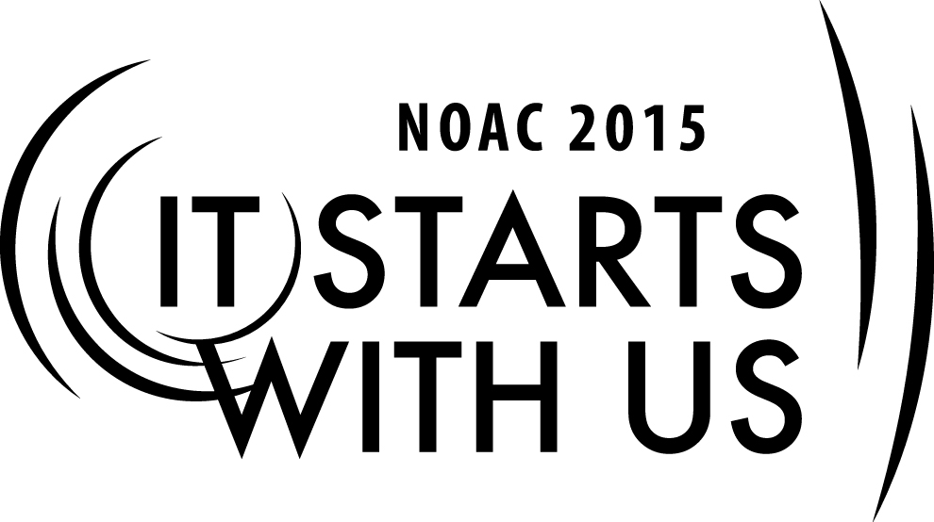
SMALL LODGE ADMINSTRATION –MEMBERSHIP UTILIZATION
2015 National Order of the Arrow Conference
Session Length: 50 Minutes
Through this session, you will:
Explain
Help current and prospective lodge officers and advisors to deal more effectively with the unique challenges of smaller lodges.
Building membership inventory that meets your lodge needs
Selecting the proper person for the proper role
Importance of succession planning at all levels
Demonstrate
How the problems and needs of the lodge influence its organization
Ways of successfully solving the problems of small lodges by reviewing its organization and changing it to meet the needs of the membership
How the unique character of a mini-lodge can be leveraged to increase member’s interest
Adult & Youth Resource Survey to determine skill set available
Guide
Develop a process to catalog membership and skills for succession planning
Interactive problem solving exercise to address common problems
Provide JTE sections that can be improved using this session

Enable
Guests to leave the conference empowered on how to better utilize the strengths and challenges found in a small lodge
This session will help the Lodge with the Journey to Excellence Requirements:
- Membership impact #3
- Membership Retention #4
- Lodge event participation #7
- Leadership Development #16

The theme of NOAC 2015 is “It Starts With Us”. This session will relay this theme in the following ways:
How to utilize the power of their lodge’s membership to take their lodge to the next level.

INTRODUCTION 5-7 Minutes

Introduce yourself and share your background and experience. Based on the size of the group and time, have the participants introduce themselves where from, lodge name and how many members.

In this session we will be discussing how the problems and needs of the lodge influence its organization
How the unique character of a mini-lodge can be leveraged to increase member’s interest
The Journey To Excellence provides a clear road map to a path/plan for continuous improvement for the Lodge.

Using The Membership 10-15 minutes

There are some basic management principles, 1) all advisors are not created equal, 2) commitments vary among individuals 3) it isn’t what you do, it’s the way you do it. There are some general rules for effective use of your member ship that can get more out of each member’s service.

Members who are needed (I e have a reason to come to something) tend to participate more and over a longer period – they stay active.

Training is essential and the best training is service as an assistant to the leader of the job you will be taking.

Ask how do you learn best? Ask for show of hands?
- Who would like a book and read and do a project?
- Who would rather see a demonstration and then try yourself?
- Who would like to do trial and error to complete a task?

Be sure you understand the best training for the right person.

Match the job for the person. Please do not assume that just because you see someone at an activity they are competent to lead or interested in that task.

Make sure that the person recruited has someone who will be available to answer questions along the way and can give advice or help.

All jobs need a written job description to be sure everyone is on the same page.

Remember authority is seized, not granted, sometimes a well written job description will be sure the job gets done correctly.

Another great idea for new or young leaders is to be sure you show confidence.

People follow leaders not managers.

Be humble and admit you shortcomings or mistakes. Also if you make a mistake with your lines in a ceremony, be confident, as this is the first time they hear it.

If you forget a key food for lunch, improvise or send someone to get it!

What you know is better than what you think you know – membership inventory and succession plans.

Most youth positions change every year, so training is ongoing. Advisors are normally 3-5 years, so they can overlap new emerging youth leadership.

When selecting youth and adults for a position it is best to have an inventory list of needs and potential list of talents.

The wise leader will find out all they can about a prospect before he meets or speaks with them. A good leader will find a job for every member and understand the need and wants for that member, and takes into account level of commitment and also ability.

Membership Inventory

Set up a simple data base for positions needed and member’s prospective positions/skills. Like a Quartermaster in the troop, this info can be in a data base on computer or simple index cards in a box. Pass out the Adult & Youth Resource Survey to determine skill set available
Remember information is power, so keep that information handy to use to recruit and fill position.

Personal Information

Age, school, phone, interest, jobs, talent, address are essential to know in your lodge

Hint: How about manpower committee to do this? Remember for adult’s job type, list of hobbies is very important.

Scouting information

Rank, unit number, position, events attended. Honors held, years in position, training courses attended like JLT, Wood badge, University of scouting, previous positions, and similar information

Order of the Arrow information

Status, position held, previous events attended, staff worked on, ceremony parts, elangomant, national training and events, other area of interest.

Once inventory is done and resources identify, just connect the dots and have a backup for each position in case they are unavailable or decide on another position.

This is called succession planning.

All great organizations and companies do it regularly.

Let’s put in use what we learned 15-20 minutes

Divide up into 3-5 members per group Chose a problem card from the deck and spend 7-8 minutes discussing it . Keep groups small for better interaction

Then have a member report back to the group. At the end and capture info on flip chart

- List some ways various ordeals spice up ordeal weekends?
- What other events besides ordeals should be put on the calendar and why?
- What makes the best draw for the youth
- How does the lodge walk the tight rope of having youth fun and meaningful adult activity?
- Why should the youth care about adults and the way they feel?
- What programs ideas have been disasters?
- How do you keep form conflicts like Band, Theater, sports, church activities overlap with OA and scouting?
- What number of activities are enough for the small lodge?

If you have more groups then double up on the questions 1,2,3,7

The unique ambiance of smaller lodges can be exploited to attract and retain the youth in the organization. By using a structured brain-storming technique, develop a list of ideas that can be used by smaller lodges that will help in making the individual lodge member feel more a part of the organization.

Conclusion & Wrap up 5 minutes

This session did address four key components and will help the Lodge with the Journey to Excellence Requirements:
- Membership impact #3
- Membership Retention #4
- Lodge event participation #7
- Leadership Development #16
Remember everyone has an opportunity to serve and with the Membership Inventory you can assign the right person with the right job or jobs.
Any closing comments or questions?
Where can I get more information?

BSA and NOAC resources are listed below.

TRAINER PREPERATION

Best Trainer:
The optimal trainer is an energetic youth (17-21) or adult who has been involved in a small lodge less than 200 members. They should be creative, motivated, and able to bring insight to training leaders from small lodges. Former or current lodge officer is best.
Prepare and review charts, power point slides, and handouts. This session is designed to be presented in a lecture and discussion format. Be sure to make time to answer the participant questions as they come up and encourage open floor and idea sharing atmosphere.
Review all Source material and resources listed in Appendix. It is always good to have actual book or publication examples to hold up or show screen shots.
Remember you do not have to be an expert, just a resource that knows people and where to get the information.
Always ask if anyone in the room has information on a question you may not know the answer. You never know what resources can be in the room. National officers, Regional officers, Section officers and long term Advisors have known to participate in training classes.

Trainer Tip: In improve participation and customize the discussion, ask one member of the lodge represented to write on the board or flip chart in the front of the room 1) Lodge name, 2) Location and 3) How many members in their lodge.

Appendix Resources:
- 2012 Guide for officers and Advisors
  - Pages 1-10 Organization, Lodge Program
- Order of the Arrow Handbook
- Order of the Arrow National Bulletin – published quarterly and available online
- National Order Of the Arrow –Website
- Lodge Leadership Development, http://lld.oa-bsa.org
- National Boy Scouts of America, http://www.scouting.org

Required Materials:
- Box of Large paperclips
- Flipcharts (2)
- PowerPoint Presentation file
- Adult & Youth Resource Survey to determine skill set available (HandOut)

