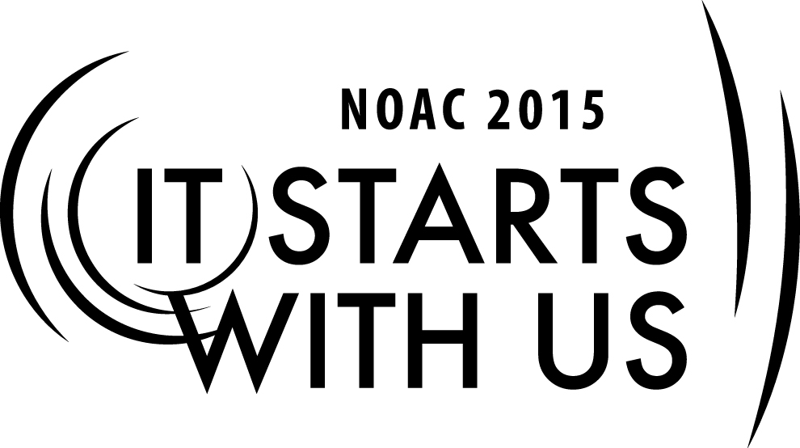
Recruiting and Training Advisers:
Building the Team
2015 National Order of the Arrow Conference
Session Length: 50 Minutes
Through this session, you will:
Explain how to build up your team of Youth and Advisers.
Demonstrate how to build your team with qualified adults.
Guide your guests in selecting the correct adults and building a team.
Enable your guests to put together a team full of qualified adults in order to achieve a common goal.

This session will help the Lodge/Chapter with Journey to Excellence Requirement(s): 3, 4, 7, 14, 16

The theme of NOAC 2015 is “It Starts With Us”. This session will relay this theme in the following ways:
- By demonstrating how to build a team starting with selected, capable adults.
- By explaining the benefits of a “team” vs. “individual” approach.
SESSION NARRATIVE

Introduction 5 minutes

Good day and welcome to our class on coaching your youth. My name is _________________________ and I am from ______________________ Lodge. My role today is to help you build a successful team.

In order for this session to be the most effective, I am going to ask for and encourage the participation of everyone here.
Trainer Instructions: If the class is at an appropriate size for timely introductions, have
guests introduce themselves and their lodge. When calling upon a
guest for a response use their name if visible on nametag or ask for
their name and lodge.

SE
Qualified Advisers 15 minutes

- Ask if there are any advisers in the room (Lodge, Chapter, Committee, Section, etc.)

- Webster’s definitions:

officer (n): one who holds an office of trust, authority, or command.
adviser (n): one who gives advice.

- The key in building a team is to start with the basic foundation. Every adviser should understand their role and responsibilities. How can you coach a team if you don’t know the plays?

Group Discussion;

What are the qualifications that make someone the right person to be an Adviser?
Trainer Instructions: Lead the group to develop a list of qualifications for an Adviser,
(lists should resemble the following)
- Able to attend all meetings related to their responsibility
- Willing to coach youth prior to and after the meeting
- Scouting experience as a youth and/or an adult
- Previous training such as LLD, NLS, NYLATS, Philmont or willingness to attend
- Sets the example for others by living the Scout Oath and Law
- Exemplifies the Purpose and Mission of the Order of the Arrow
- Willing to listen to youth members

Are you limited to someone who fits all of these requirements? Of course not! Sometimes the person that doesn’t stand out is the person you need for the job.

Evaluating your Team 15 Minutes

As an adviser, you should always listen to your team. If someone on your team does not feel comfortable carrying out their responsibilities, it is your job to help guide them and mentor them so that they feel confident once again. Sometimes the smallest things can overwhelm a person.

One method a leader can use to take an inventory of what resources are already on the team and what additional resources are needed is to do a “SWOT” analysis. SWOT stands for:

Strengths
Weaknesses
Opportunities
Threats

Strengths and weaknesses are factors internal to the team; they are related to the team members themselves. Opportunities and threats are environmental factors external to the team. Each team strength points to an opportunity while each team weakness points to a threat. A leader works to use strengths and opportunities to combat weaknesses and threats.

Group project:
Trainer Instructions: Divide the group into four teams. Have each team take one letter of SWOT
and develop a list based on their experiences. Bring the group together
and on a flipchart or whiteboard list the results. (divide chart or board into
the four quadrants: “Strengths,” “Opportunities,” “Weaknesses,” and
“Threats.” For each one of these factors, write the name (or names) or
team members next to them of someone who can either make a positive
impact for a strength/opportunity or can improve a weakness/threat. Look
at the factors that don’t have anyone associated with them, the leader then
looks for someone that can fill that role on the team.

Tips and Tricks for Building the Team 10 Minutes

How do you build your team?

First, establish communication between each other. Positive and timely communication between team
members can:

- Lead to positive outcomes
- Reduce confusion
- Get everyone on board

Once communcation is established, it is time to agree upon a common goal(s). Establishing a team goal(s) will bring the entire group together working toward a common achievement.

Now that you are communicating and have a goal, where do you get new team members?

Advisers- Look at the units in your chapter/lodge.
Which units have a large number of registered adults?
Which units have a strong OA Representative
Which units participate in OA events?
Which units participate infrequently or never? Is there a key adult in that unit that can
help your team and by doing so get that unit more involved in the OA?
Look at your District/Council volunteer leadership
Look at your Council NESA membership
Look for past Camp Staff members
Look for past youth leaders who are adults
Look for community leaders who might fill a specific need
Teachers/Coaches
Sales Professionals
IT Professionals
Marketing Professionals
Retired Professionals

Youth-Look at the units in your chapter/lodge
Look at Camp Staff members
Look at new Eagle Scouts
Take an active role at Ordeals in recruiting those new members for specitic jobs
Look at inactive Scouts who might just need a new opportunity

In order to recruit the team you need, you must be proactive. Don’t wait for the person you want to come to you. Develop a specific job description and then go find the right person! Every adult you approach may not say yes, but they will be honored by your consideration.

Every new OA member or inactive Scout may not jump at the chance but again, they will be honored that you approached them.

How did each of you get here today? Some of you volunteered, some were volunteered by others, and some were recruited. Your job is to build a team to accomplish the goals of your Chapter/Lodge. Go out and recruit you replacement!

Conclusion 5 Minutes

Questions/Comments?

Thanks for your participation!
Trainer Instructions: Trainer should answer every question to the best of the trainer’s
ability and engage the audience in active discussion.

TRAINER PREPARATION

What qualifications should the trainer have to perform this session?

- Experienced Officer/Adviser with a clear understanding of the role of an Adviser
- NLS/NYLATS trained
- Ability to lead discussion groups and keep them on task

Appendix Resources:
- PowerPoint

