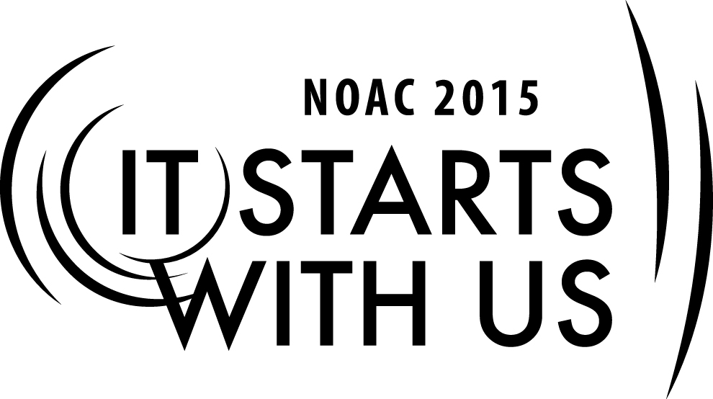
Recruiting and Training Advisers:
Coaching Your Youth
2015 National Order of the Arrow Conference
Session Length: 50 Minutes
Through this session, you will:
Explain the key elements in coaching and guiding youth.
Demonstrate how to coach youth members.
Guide your guests in selecting the best methods to coach and guide youth members.
Enable your guests to be successful youth coaches.

This session will help the Lodge/Chapter with Journey to Excellence Requirement(s): 13, 16

The theme of NOAC 2015 is “It Starts With Us”. This session will relay this theme in the following ways:
- By demonstrating how an adviser can coach individual youth leaders.
- By explaining the value of good adult coaches.
SESSION NARRATIVE

Introduction 5 minutes

Good day and welcome to our class on coaching your youth. My name is _________________________ and I am from ______________________ Lodge. My role today is to help you discover your talent as a coach.

In order for this session to be the most effective, I am going to ask for and encourage the participation of everyone here.
Trainer Instructions: If the class is at an appropriate size for timely introductions, have
guests introduce themselves and their lodge. When calling upon a
guest for a response use their name if visible on nametag or ask for
their name and lodge.

SE
Why are We Here? 10 minutes

In order to fully understand how to coach youth members, we must first have an understanding of the foundation of the Order of the Arrow. Let’s review the Purpose and Mission of the Order of the Arrow and the Mission of our Chapters and Lodges.

Purpose of the Order of the Arrow

As Scouting’s National Honor Society, our purpose is to

Recognize those who best exemplify the Scout Oath and Law in their daily lives and through that recognition cause others to conduct themselves in a way that warrants similar recognition.

Promote camping, responsible outdoor adventure and environmental stewardship as essential components of every Scout’s experience, in the unit, year-round, and in summer camp.

Develop leaders with the willingness, character, spirit, and ability to advance the activities of their units, our Brotherhood, Scouting and ultimately our nation.

Crystallize the Scout habit of helpfulness into a life purpose of leadership in cheerful service to others.

Mission Statement of the Order of the Arrow

“The Mission of the Order of the Arrow is to fulfill its purpose as an integral part of the Boy Scouts of America through positive youth leadership under the guidance of selected capable adults.”

Mission Statement of the Lodge

“The mission of the lodge is to achieve the purpose of the Order of the Arrow as an integral part of the Boy Scouts of America in the council through positive youth leadership under the guidance of selected capable adults.”

The role of a Coach on a sports team is to recognize, promote, develop, and crystallize just like in our purpose. The role of an Adviser is to be the Team Coach. On the field performance is directed by the Youth leadership, while the Coach remains on the sidelines, prepared to give the best advice possible.

Working as a Team 20 Minutes

Youth and adult partnerships in the Order of the Arrow are critical to our success. This relationship is similar to an athlete and a coach. In this case, consider yourself the coach!

Webster’s definition of coach: “A person who teaches and trains an athlete or performer.”

As an adviser, your job is to get out there and support your players by training and guiding them in order to accomplish a common goal.

Group discussion:
Trainer Instructions: Lead the group to develop a list of ways an Adviser functions. Look
for these answers;

      - Mentoring
      - Teaching
      - Evaluating
      - Supporting

How can you relate to these roles?

- Mentor – As an adviser you will work with many youth with different backgrounds and skill sets.
You job is to support each of them in a way that will help them maximize their potential
and allow them to achieve more than they thought was possible.

- Teach – As an adviser you have the opportunity to teach the youth how to accomplish a task and
provide leadership, resources and equipment for them to be successful.

- Evaluate – As an adviser, you can help the youth step back and evaluate what went well, what
didn’t work as planned, and what steps to be taken for future success.

- Support – As an adviser you must empower the youth and support them. Be there and advise
them in order for the team to achieve their task.

Key Points on Coaching Youth 10 Minutes

- Communications – two-way communication is imperative for a successful team, it reduces
confusion and misunderstandings.

The adviser’s approach on communication will influence the youth to stay in contact
- Timely – don’t wait on new youth leaders to initiate communications
- Efficient – establish convenient times to discuss business, prepare a list of key points
ahead of time, don’t try to do too much at once
- Listen – allow youth to express their thoughts and concerns (if you allow them to talk long
enough, they will usually reach a point that everyone can agree upon)

Group Discussion

Have you ever had difficulty communicating with a youth member? What did you do?
Trainer Instructions: Lead a brief (5 minute) discussion of communication obstacles
and what was done to overcome those obstacles.

- Be Enthusiastic – As an adviser, you must be positive and enthusiastic at all times with your youth leadership. Your attitude even in the midst of “irksome tasks” will affect how the youth leaders for your chapter/lodge respond to the challenges of leadership.

- Exemplify the Scout Oath and Law in your words and actions – the youth leaders pick up quickly on how you act. Many of your actions and words will be copied. Take this as a compliment and use this opportunity to lead them in the right direction.

- Recognition – Recognize your youth members often! Look for ways you can praise their leadership both individually and as a team. If you must correct them, do so privately! Recognition from you will help them gain confidence and may inspire them to reach beyond their comfort zone.

- Encourage future involvement – Your words of encouragement may be what they need to keep trying, especially after something doesn’t work the way it was envisioned.

- Help them develop a vision and learn how to set goals to accomplish that vision – a leader must instill a sense of true meaning for Chapter/Lodge members. If he develops a purpose or vision for the Chapter/Lodge, the members can work toward fulfilling that purpose. A vision is broader than a goal and provides overall direction for the leader and his chapter/lodge. A vision must be clear and challenging. A leader’s vision will be backed and supported by many goals.

Why do we set goals?
- Provide direction
- Tool for measurement
- Unify our membership
- Personal fulfillment

What type of goals do we need to fulfill the Chapter/Lodge leader’s vision?
- Event Goals – Ordeals, Fellowships, Lodge Leader Development, Conclave, NOAC, NLS
- Program Goals – Summer Camp, Cub Scouts, Camp Promotions/Unit Elections,
Ceremonies, AIE, etc.
- Individual Committee Goals – Ordeal Management, Banquet, Work Projects, Finance
- Personal – what goals do our members have for school, work, individual growth?

“Your goals are the road maps that guide you and show you what is possible for your life”
Les Brown

“People with goals succeed because they know where they’re going.” Earl Nightingale

“The great thing in this world is not so much where we are, but in what direction we are moving.”
Oliver Wendell Holmes

Conclusion 5 Minutes

Questions/Comments?

Thanks for your participation!
Trainer Instructions: Trainer should answer every question to the best of the trainer’s
ability and engage the audience in active discussion.

What qualifications should the trainer have to perform this session?
TRAINER PREPARATION

- Experienced Officer/Adviser with a clear understanding of the role of an Adviser
- NLS/NYLATS trained
- Ability to lead discussion groups and keep them on task
Appendix Resources:
- PowerPoint

