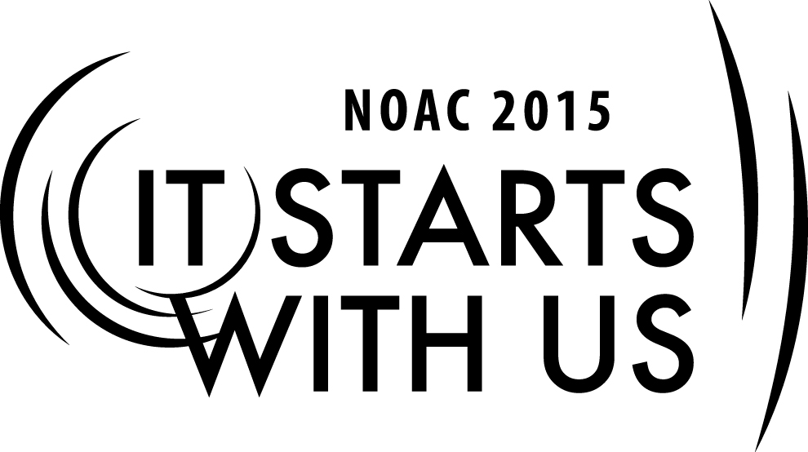
Recruiting and Training Advisers:
Role of the Key Three
2015 National Order of the Arrow Conference
Session Length: 50 Minutes
Through this session, you will:
Explain the basic fundamentals of the role of the key three within the chapter/lodge and how it affects everyone as a whole.
Demonstrate how the key three work to achieve the purpose of the Order of the Arrow.
Guide your guests toward understanding of the role played by each member of the key three.
Enable your guests to fulfill the mission of the key three in their chapter/lodge.

This session will help the Lodge/Chapter with Journey to Excellence Requirement(s): 7, 10, 17

The theme of NOAC 2015 is “It Starts With Us”. This session will relay this theme in the following ways:
- By demonstrating how the role of the key three affects the chapter/lodge as a whole.
- By demonstrating how the key three are effective when everyone works toward a common goal.
SESSION NARRATIVE

Introduction 5 minutes

Good day and welcome to our class on the role of the Key Three. My name is _____________________ and I am from ______________________ Lodge. My role today is to help you understand the value of an effective key three working relationship.

In order for this session to be the most effective, I am going to ask for and encourage the participation of everyone here.
Trainer Instructions: If the class is at an appropriate size for timely introductions, have
guests introduce themselves and their lodge. When calling upon a
guest for a response use their name if visible on nametag or ask for
their name and lodge.

SE
Key Three Leadership 5 minutes

The working relationship of the Chief, Volunteer Adviser, and Professional Staff Adviser is commonly referred to as the “Key 3.” Key 3 leadership is common to all levels of the Order: Chapter, Lodge, Section, Region, and National. The Key 3 should meet regularly at each level to establish goals and to evaluate progress toward those goals.

The Chief, the Adviser, and the Staff Adviser are to work as a team!

Key 3 Job Description (Lodge level):

- Meets prior to each Lodge Executive Committee (LEC) meeting, reviews all operations of the Lodge, and prepares agenda items for the LEC.

- Meets at other times as needed.

- Coordinates and facilitates the planning, approval, and execution of the Lodge Annual Plan that is built in consultation the Council Executive.

- Ensures lodge administrative tasks are completed properly and timely (e.g.; Charter Renewal, Journey to Excellence Program, Annual Budget, National Program Registrations, Award Petitions)

- For the Lodge to be a success, it starts with us!
Trainer Instructions: Ask for questions before moving on.

The Lodge Chief 10 Minutes

The Lodge Chief – A youth, 20 years old or younger during his entire term of office, and is elected from the youth membership of the Lodge.

Job Description:

- Responsible to the Council Scout Executive, through the Lodge Adviser and Staff Adviser, for performance of duties. Serves as a member of the Council Camping or Boy Scout Committee.

- Responsible for adherence to the program and policies of the Lodge. Attends appropriate Council, Section, Regional, and National OA functions.

- Works closely with the Lodge Adviser, seeking advice and training. He does not wait for his adviser to call, but calls the adviser often. Establishes annual goals and objectives for the lodge including attainment of a minimum of bronze level in the Journey to Excellence recognition.

- Attends all lodge activities and Lodge Executive Committee meetings. Promotes attendance and participation of lodge officers and committee chairmen.

- Appoints lodge operating committee chairmen in consultation with the Lodge Adviser and Staff Adviser. Assigns lodge members to operating committees.

- Reminds lodge officers and committee chairmen to attend meetings of lodge operating committees related to their assignments.

- Presides over all Lodge and Lodge Executive Committee meetings. Works from an agenda established by the Key 3. Solicits agenda items from lodge officers and committee chairmen.

- Is responsible for planning and conducting lodge activities.

- Delegates duties to fellow lodge officers and committee chairmen.

- Sees that the chapter program gives complete support to the lodge program.

- Undertakes lodge service projects with the advice and approval of his advisers.
- Appoints the Vigil Honor Nominating Committee.

- Promotes the correct wearing of the Scout Uniform by personal example and special lodge education programs.

- Works with his advisers in providing unit contact information to lodge officers and committee chairmen.

Group Discussion

What qualities should a Chief possess?
Trainer Instructions: Lead a discussion of what qualities a Lodge Chief should possess.
Involve all members of the group. Keep it positive!

Lodge Advisers 10 Minutes

Lodge Advisers are volunteers who are 21 yearss old or older and are appointed by the Scout Executive.

Job Description:

- Becomes a member of the Council Camping or Boy Scout Committee and may be elected to the Council Executive Board. Attends all meetings of the council committee and knows the camping situation of each unit. Knows from chapter reports which units need camping promotion and training.

- Understands the policies and principles of the OA and sees that they are followed in the lodge. Sees that all lodge funds are handled properly. Attends all lodge functions. Attends appropriate Council, Section, Regional, and National OA functions.

- Sees that he lodge officers get the job done by providing them with the tools, opportunities, and necessary transportation. Knows the adult role in the Order of the Arrow and does not wait for the Lodge Chief to call, but is self-motivated and offers help. Assists in establishing goals and objectives, including attainment of a minimum of bronze level in the Journey to Execellence recognition.

- Makes sure that the Lodge Chief conducts the LEC meetings.

- Attends and sits with the Lodge Chief at all meetings and activities.

- Appoints an adult adviser to each lodge officer and committee chairman, in consultation with the Lodge Chief and Staff Adviser.

- Helps every adult in the lodge become a functioning adviser, either as a unit leader or an adult adviser to the lodge or chapter committee or project. There are no honorary adult positions in the Order, the lodge, or the chapter.

- Reminds the adult lodge committee advisers to attend the meetings of the lodge operating committees related to their assignments. Ensures the lodge charter renewal application is processed and submitted on time.

- Aids the Lodge Chief in producing effective agendas for these meetings. Promotes attendance of appointed adult advisers. Encourages advisers to work with officers and committee chairmen prior to the meeting.

- Limits annual activities to four exciting events scheduled each year that involve the entire lodge membership. These activities should be well planned and provide opportunities for the Arrowmen to learn more about the Order and how to provide effective service. Clears all dates with the Staff Adviser.

- Helps the Lodge Chief delegate the full burden of the lodge program so that it is share with the other lodge officers and committee chairmen.

- Understands that the chapter is a division of the lodge for carrying out the lodge program. Understands that the chapter is not a super unit unto itself, but is a camping promotion aid for untis. Every youth in the chapter is a member of a unit and has unit responsibilities. Each chapter activity should result in an enriched program for units. Frequently reviews the goals with officers to see that the Order of the Arrow program is being actively followed in each district.

- Clears all lodge service projects with the Staff Adviser. Knows that the Arrowman is primarily a member of a unit and that Order of the Arrow projects undertaken should be directly related to camping, the Council Cub Scout and Boy Scout programs, and/or the community

- Appoints an adviser to the Vigil Honor Nominating Committee.

- Set the example for youth and adult Arrowmen by correctly wearing the Scout uniform with the proper badges and insignia correctly placed.

- Provides lodge officers and committee chairmen with district rosters of the units so that proper contact can be made for unit elections, camping promotion, etc. As the Lodge Adviser, maintains constant and regular contact with the Staff Adviser so that person can quickly relay any unit personnel changes, etc.
Trainer Instructions: Ask for any questions periodically and maintain an active discussion
with the guests.

Lodge Staff Adviser 10 Minutes

The Lodge Staff Adviser is a profession Scouter, 21 years or older, assigned by the Scout Executive with extensive Order of the Arrow experience.

Job Description:

- Appointed annually by the Scout Executive. If not a member when appointed, participates in the first available Ordeal. Consults with the Scout Executive on annual performance and appointment of the lodge advisers. Understands the policies and principles of the BSA and the OA. Communicates and ensures their application to OA functions. Ensures funds are properly budgeted, reciepted, disbursed, and transmitted according to Council procedures and th accounting manual of the BSA. Attends all lodge functions and other appropriate OA activities.

- Provides Council, Regional, and National information, literature, and correspondence to lodge advisers and appropriate committees. Orders materials and supplies from the National Office and Supply Group.

- Works with the Lodge Adviser to help the Lodge Chief conduct LEC meetings. Attends and sits with the Lodge Adviser and Lodge Chief.

- Recommends and attains Scout Executive approval of prospective adult advisers.

- Encourages appropriate adult participation and support to committees and activities. Informs professional staff associates of OA activities, programs, and correspondence.

- Works with the Lodge Adviser to ensure appropriate adult participations in meetings of lodge operating committees related to their assignments. With the Lodge Adviser, ensures the Lodge Charter Renewal Application is processed and submitted on time.

- Recommends agenda items. Ensures that financial and activity reports required from the council office are printed with timely information. Works with advisers to the Lodge Treasurer and other committees concerning the information in the reports.

- Represents the OA at the Council Annual Planning Conference, coordinating dates with the Council, Section, Region, and National dates. Makes appropriate reservations for council facilities. Works with office staff to ensure timely communications to the membership and units, as well as accurate member records and mailing list. Involves the OA in council programs. Ensures lodge representation at national, regional, and section OA functions.

- Monitors the delegation of responsibilities and assists the Lodge Adviser and Lodge Chief in evaluation, assignments, and follow-up.

- Recommends to the Scout Executive the appointment of Chapter Staff Advisers. Communicates with the Chapter Staff Advisers and ensures appropriate council services to chapter system. Evaluates and makes suggestions for chapter programs.

- Keeps the Scout Executive informed of all OA projects. Recommends potential service projects for OA consideration. Coordinates with the Camp Ranger on Ordeal and other OA projects at camp.

- Administratively supports the functions of the Vigil Honor Nominating Committee.

- Sets the example for youth and adult arrowmen by correctly wearing the Scout uniform with proper badges and insignia correctly placed.

- Secures rosters and reports required by the OA in a timely manner for their use.
Trainer Instructions: Ask for questions and maintain an active discussion with guests.

The Big Picture 5 Minutes

Group Discussion:

How do all the pieces fit together?
Trainer Instructions: Lead an active discussion about how the Key Three works together
in our Guest’s home Lodge. The Trainer should take all answers
and questions and respond accordingly.
Conclusion 5 Minutes

Questions/Comments?

Thanks for your participation!
Trainer Instructions: Trainer should answer every question to the best of the trainer’s ability
and engage the audience in active discussion.

What qualifications should the trainer have to perform this session?
TRAINER PREPARATION

- Experienced Officer/Adviser with a clear understanding of the role of an Adviser
- NLS/NYLATS trained
- Ability to lead discussion groups and keep them on task

Appendix Resources:
- PowerPoint

