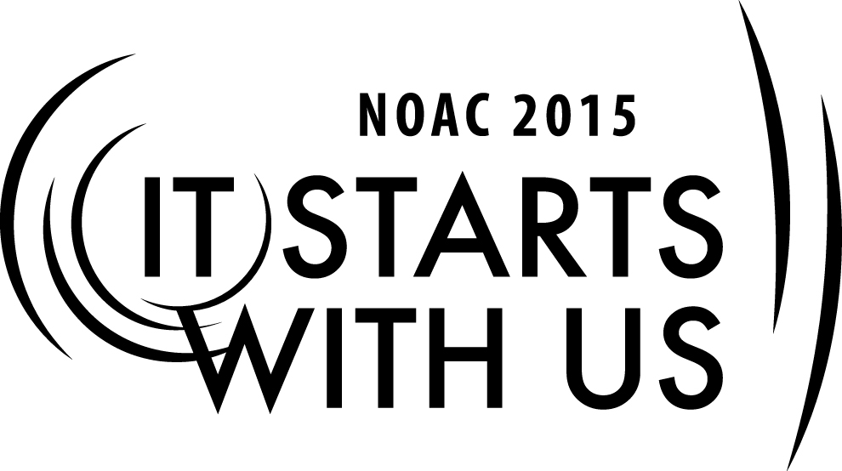
Planning the Gala: Special Events
2015 National Order of the Arrow Conference
Session Length: 50 Minutes
Through this session, you will:
Explain new types of events that a lodge can integrate into its yearly calendar
Demonstrate how special events can fit into your existing events
Guide Arrowman to exchange event ideas
Enable guests to understand the basic challenges of new event planning

This session will help the Lodge with the Journey to Excellence Requirement(s): 7: Event Participation

The theme of NOAC 2015 is “It Starts With Us”. This session will relay this theme in the following ways:
- Enabling Arrowmen to create new special events within the lodge that inspire creativity
SESSION NARRATIVE
Trainer Instructions: Prior to beginning the session, take the opportunity to introduce yourself, including your leadership experiences and positions within the Order. If time and the number of participants allow, give them the opportunity to introduce themselves as well. It is a good idea for the trainer to obtain an idea of the experience level/tenure of the participants, in order to tailor his presentation and the resulting discussions to the needs of the group.

You should also label and hang the giant sticky notes for the discussion segment prior to the session. You also should have the markers available to quickly hand out when the time comes.

INTRODUCTION: 3-5 MINUTES

We can often get stuck in the same old pattern, doing the same old things, year after year. This session is designed to give you some new lodge event ideas for you to be able to break up the monotony and try something new and different, as well as review the decision-making process and some of the factors of creating a special event or activity.

I want to give you some new ideas for lodge events and give you all an opportunity to share ideas that you are already doing that the rest of us may be too scared to try or have not thought about doing.

Looking at our lodge calendar, most of us have either three or four events. More than likely most of us fall into one of the following categories:
- 2 fellowship event; 1 ordeal
- 2 fellowship events; 2 ordeals
- 2 fellowship events; 1 ordeal; 1 banquet

I am not saying these set-ups are bad, but if we keep doing the same thing over and over again, then people tend to get bored and stop coming back. What else is there? What are my other options? Well, today I am hoping to put a new perspective on your lodge calendar and give you some fresh ideas of things you can try to change your same old lodge events. Let’s go ahead and get started.

TRYING SOMETHING NEW 5 MINUTES

When trying something new, often times we find ourselves stuck in a rut. We find obstacles in our way. We find the naysayers. Later, we will discuss the logistics of planning an event. Here is some helpful advice for those of you who are trying something new:

Only those who dare to fail greatly can ever achieve greatly. ~Robert F. Kennedy

Progress always involves risks. You can't steal second base and keep your foot on first. ~Frederick B. Wilcox

Why not go out on a limb? Isn't that where the fruit is? ~Frank Scully

Never be afraid to try something new. Remember, amateurs built the ark; professionals built the Titanic. ~Author Unknown

NEW LODGE EVENTS 15-20 MINUTES

There are several types of new events that your lodge can try. Below is a short list of event types. We will then take a few minutes to discuss each category individually.
- Fellowship Events
- Service Events
- Special Lodge Events
- Lodge Field Trips
- Summer Camp

Almost every lodge has at least two fellowship events a year. If your lodge does the same thing every fellowship event, then I recommend that you mix it up. Nothing is wrong with keeping your traditions that you enjoy, but I do not think that your lodge members want to do the same things every time you get together. Below are some ideas for new fellowship events.

Fellowship Events:
- Change to a new location (Battleship, State Park, Lock In, Historical Site, etc.)
- Themed Events (Spiderman, Movie, Olympics, Pirates, etc.)
- Lock-In (church, laser tag, roller skating, etc.)
- High Adventure Trek
- Backpacking Trip
- Canoeing or Kayaking Trip

Instead of a new event altogether, you can also just spice up and change your current events. For example you can change the schedule, add a theme, change the food, location, and activities.

Spicing Up Your Current Events:
- Schedule
- Food
- Location
- Activities

Activities:
- New Arrowman Crash Course
- VIA Luncheon
- What Is Conclave? Seminar
- The BIG Event – some event that changes from event to event.
- Vigil Rededication / Reception
- Rock-Paper-Scissors-Tag
- Glow in the dark Ultimate Frisbee
- Game Night
- Incorporating Conclave Special Events into Lodge Events

You can have a backwards schedule (have dinner for breakfast, games in morning, training at night, etc.) or just rearrange the activities to get a different event. You can change the food (steaks, all finger foods, all healthy, grill out, backyard BBQ, all go to a fast food place for lunch, etc.). You can change the location of the event to a state park, a local attraction, or local activity that has lock ins.) You can pick new and crazy activities to do at the event.
Trainer Instructions: I would recommend that you mention that you can also spice up the events you already have planned. The trainer can go through several examples. There are other training sessions designed to cover this topic, so I would not spend a lot of time. I would reference the other training session that the participants can look at if they are still interested after this training session.

Your lodge has numerous opportunities to be able to serve both your communities and your own councils. Here are some ideas how we better serve our communities and councils. The Southern Region has a program called “One Day of Service” where the region encourages each lodge to participate in community service projects all on the same day. The lodges all put this date on their calendar and plan quality projects.

I would highly recommend that your community service projects are quality projects that are well planned and worth spending your time completing. Do not plan on a “raking pine straw” or “picking up pinecones” service project. Also, you want to try to conquer a larger project for the lodge and not take away a potential Eagle Scout project.

Community Service Projects
- Habitat for Humanity
- Coastal Clean-Up
- Adopt a Mile
- Speak to City Council for service projects (picnic tables, parks, playgrounds)
- City Parks – trail work, structure repair or building projects
- National Parks Service – trail work, building and campsite repair

Council Service Projects
- Cub Scout Crossovers
- Blue and Gold Banquets
- Cub Scout Day Camps – Lodge planned and put on
- District and Council Camp-o-ree’s (parking, flags, support, teaching classes)
- Council NYLT Course - OA planned and put on
- Scouting for Food – help organize and pick up food
- Popcorn Pick-Up – help hand out and organize popcorn
- Teach Merit Badges (or other program) at camp-o-ree’s
- Council Banquet – park cars, escort guests, flags, cleaning up afterwards
- Ask your Scout Executive how you can help (Journey to Excellence)

The lodge can also have special events. These events are not designed to take up another weekend, but provide opportunities for fellowship during a weeknight or during a Saturday.
Special Lodge Events
- Lodge Banquets (cater/pot luck/restaurant)
- New Ordeal Member Dinner (served by vigils) with New Arrowman Crash Course
- Vigil Work Day
- Vigil Weekend (Workday, Vigil Re-dedication, Vigil Ceremonies, Vigil Steak Dinner, Fellowship)
- Conclave Practice Day
- Lodge Birthday Party
- Beaver Day (council camp workday)
- Game Night (video game tournament/ board games/ patches)

Ask the Audience: How do you make a Summer Camp Workday special?

Lodges do not always have to spend the night at the same old council camp. Why can’t the lodge go out for a fun day event? These events are designed for fun and fellowship just for the day. Why not? Just go out have some fun! I think if our lodges has a sense of friendship and community, I think we are more likely to stick around and happy to serve. Just make sure you are picking activities that everyone can participate (or have alternate activities). These type of field trip events may be a perfect addition to your chapter meetings as well.

Lodge Field Trips
- Dinner and Movie
- Ice Cream Social
- Amusement Park
- Video Game Competition (With giant brackets)
- Goofy Golf / Batting Cages
- Beach
- Canoe or Kayaking Trip or Tubing
- Fishing Trip
- Football/Soccer/Ultimate Frisbee/ Disc Golf/Golf
- Whatever attractions are close to you.

We have a great opportunity to have positive exposure and to serve our council by having a presence at summer camp. Here are some ideas how we can participate at our local summer camp programs.
Summer Camp:
- OA Campfire (skits, dancing/drumming, speech, history, program)
- OA Night (watermelon, ice cream, program, games)
- OA Day (The lodge has a presence all day long, washing dishes in the kitchen, games during down time, etc.)
- Brotherhood Ceremonies
- OA led service project
- OA Teach a Merit Badge or run program area

DISCUSSION: SHARING NEW IDEAS 10 MINUTES

We are now going to split into groups in order to brainstorm and share new ideas. Each group will discuss each category for lodge events (fellowship events, service events, special events, field trips, and summer camp). Each group will brainstorm or share ideas that their lodge does that were not mentioned in the presentation. We will give you about five minutes to quickly share ideas. You need a title with a brief description. Remember we are just sharing ideas, not performing individual training sessions.
Trainer Instructions: You will need to make sure that giant sticky notes or pieces of paper are posted around the room with each category clearly labeled at the top. Each participant will think his idea is the best event of all time. You will need to respectfully move the group along at a reasonable pace. Set a clock and when the timer sounds stop the group discussions. You will need to wander around the room listening for good ideas and guiding discussions. Do not let one individual dominate the conversations. You will need to pass out markers to each group during the discussion time.

After time is called, each group needs to pick their best idea or two for each category and write them on the paper posted around the room. Let’s take just two minutes to write our ideas. I encourage each participant to write down the good ideas that you want to take home.
Trainer Instructions: You will need to go around the giant sticky notes going over the new ideas. Ask participants to briefly explain any ideas you do not know about. Be careful, because they will want to take a lot of time. You may want to ask them specific questions about event instead having them explain the event.

LOGISTICS: TIPS FOR IMPLEMENTING NEW EVENTS 10 MINUTES

Now that we have discussed several ideas, let’s discuss the steps to take to create your special event. The steps to consider are simple, but important. Throughout the planning stages you must answer these questions, perhaps several times!

- Who?
- What?
- When?
- Where?
- Why?
- How?

Let’s take an in-depth look at these questions to determine our plan:

Who?
- Who is planning the event?
- Who will be on the staff?
- Who will attend the event?
- Who will pay for the event?
- Who will lead the event?
- Who’s approval should I seek?
What?
- What are we doing at the event?
- What makes it SPECIAL?
- What materials do we need?
- What has already been planned?
- What is the expected outcome of the event?
- What is Plan B?
When?
- When will we have this event?
- When do we begin planning?
Where?
- Where will we have the event?
- Where do we find the materials we need?
Why?
- Why are we having this event?
How?
- How are we going to accomplish it?
- How long should we wait until we do it again?
- How do we verify success?

These simple questions will provide the important information you need to be successful.

CAUTIONS: 3 MINUTES

Many times we will encounter opposition when we want to try to do something new or something that has never been done before. I would encourage you not to settle, but to try to overcome the obstacles. Try to find a way to accomplish your desired goal. Please understand this does not mean ignore advise or deliberately go against adults decisions. However, do not stop when you encounter “That can’t be done.”, “That is too hard.”, or “We have never done that before.” Find a way to try something new, break your lodge out of the same old cycle, and introduce them to some new entertainment.

“Do Not Try All of These Events In One Year”

It can be complicated or cumbersome trying to add all of these events in one year. Some of the events are intended to be annual events (banquets) and some are not (trip to the amusement park). I would pick one of the events, implement it, and re-evaluate next year.

CONCLUSION: 2 MINUTES

In closing, let’s review some of our major points:
- I hope you were able to write down some ideas for events that you can integrate into your lodge.
- In addition, you should be aware of the major pitfalls or challenges of putting on a new event such as where to find the materials you need, what you are going to do to make it special, and how you are going to accomplish your event.

Good luck putting on these new events. I hope your lodge enjoys them, better serves your council, uses them to develop better leaders, and has some fun with them.

Are there any questions? Thank you.
TRAINER PREPARATION

Type of Trainer: The trainer for this session should be a youth or adult arrowman experienced with planning an event – perhaps someone who has been responsible for an event never done before. Trainers should be enthusiastic, knowledgeable in lodge events, and able to leverage past experience to further develop and personalize the session.

Audience: Any youth or adult arrowmen who is interested in lodge events or taking on a new challenge.

Physical Arrangements: The trainer should allow time before the session to set up chairs in an
arrangement that will be conducive to group interaction and discussion. He also needs to place large pieces of paper posted around the room with the following titles (fellowship events, service events, field trips, special events, and summer camp ) for the discussion break out session. The trainer may want to play exciting up beat music while participants enter the room to set an enthusiastic tone.

Equipment: Trainer should make sure that all electronic equipment is working properly and that he is familiar with its operation. PowerPoint presentations should be open and ready to present as participants arrive. The trainer will also need markers for group to write their ideas on the paper during the discussion break out session.

