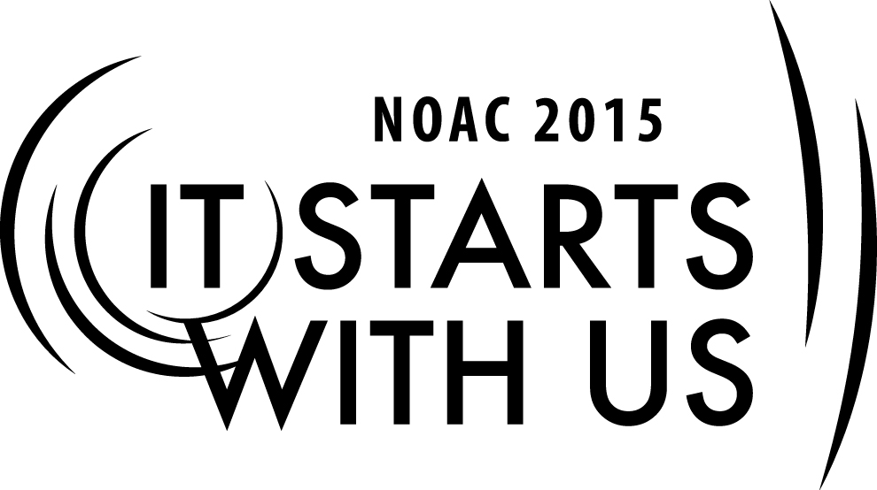
Planning the Gala: Fellowships
2015 National Order of the Arrow Conference
Session Length: 50 Minutes
Through this session, you will:
Explain how fellowships differ from other lodge events.
Demonstrate the importance of fellowship through an anecdote.
Guide participants through creating a fellowship experience.
Enable participants to improve fellowship activities at home.

This session will help the Lodge with the Journey to Excellence Requirement(s): 7: Event Participation.

The theme of NOAC 2015 is “It Starts With Us”. This session will relay this theme in the following ways:
- By demonstrating how fellowship activities were the start of our interest in OA and will be the start of future interest in the order.
- By enabling participants to improve fellowship activities at home.
SESSION NARRATIVE

Introduction 5 Minutes

Think back to the moment you were inducted into the Order of the Arrow. After the pre-ordeal, after the four tasks, and after taking the obligation, what happened? Allowat Sakima took you by the hand, gave the handclasp of the Order of the Arrow, and proudly proclaimed that you were now an Ordeal member in the Order of the Arrow. After this, he invited you to join the circle which had been widened to receive you. Likely, you were congratulated by several new people after this. After spending the day in silence, fasting, sleeping outside, and working all day, you were probably relieved and thrilled to be congratulated in this way – in spite of being dirty, hungry, and tired. Many lodges take it a step farther, and invite new Ordeal members to join in a Cracker Barrel or reception where the new Ordeals can eat and celebrate.

Imagine if the Order treated the process a little differently. What if, instead, Allowat had you recite the obligation, then directed you to the exit to pick up your sash on the way out? What if instead of being invited to join the circle, there was no circle? Do you think you would have stayed involved with OA very long? Likely not.

Fellowship is a vital part of the OA experience, this is why fellowship events deserve special attention. Fellowship activities deserve a special session designed not about planning an event, but on how to add that atmosphere of fellowship. Over the next 45 minutes, we will walk you through fellowship events and discuss ways that you can make your fellowship events even better.

SE
Trainer Instructions: Now would be an appropriate time to introduce yourself and provide a brief overview of why you are qualified to train on fellowship activities.

The Importance of Brotherhood 7 Minutes

Before moving into the how, let’s take a moment to look at the roots of brotherhood in the Order of the Arrow. You know that Brotherhood is part of our Order’s original name – the Wimachtendienk. You likely also know, maybe from visiting the NOAC museum, that the first Ordeal ceremony asked brothers to link arms around a large tree, thus showing that it was only as Brothers that they could complete the task. But did you know that E. Urner Goodman’s history with brotherhood went back further? Let me read to you from the OA History website passage entitled “Goodman and Brotherhood.”

“It must be brotherhood in more than name; it must be real – a brotherhood of co-operation and of work.”

While the above quotation could easily be one from Dr. Goodman himself, challenging the members of the Order of the Arrow on the last day of a NOAC to live up to the vision he held for us, it in fact belongs to an earlier brotherhood to which Dr. Goodman belonged to as a teenager – the Brotherhood of Andrew and Philip. (The quote is from a book published in 1894 titled “Christianity Practically Applied” published by the Baker & Taylor Company (page 46)).

Many of the ideas of Brotherhood, Indian Lore, Fraternity, Service to others and Cheerfulness, that would become the foundations for the future of the Order of the Arrow, can be found in the activities and ceremonies of this church-based brotherhood (named in honor of the first two apostles to bring converts into the early Christian Church).

In June 1907 when Urner Goodman was a 16 year old, the Tioga Church newsletter reported that,
Members of both the men's and boy's chapters . . . at the close of the services formed the Brotherhood Circle.

In the years before Scouting the Boys Brotherhood often went on hikes to their favorite spot, a place called “Indian Rock.” At one meeting “E. Urner Goodman was especially good with his violin. He was so much appreciated that he came near having to play two encores.”

The Brotherhood also organized summer camps that were two weeks long or longer, perhaps fostering the idea of the importance of long-term camping for causing the qualities of cheerful servant leadership, which Dr. Goodman later sought to recognize, to rise to the surface. In a 1908 article, the church newsletter reported that, “The 'Sioux Indians' of our Chapter, will encamp for a few weeks at Walnut Hill.”

By early 1909 an 18-year-old E. Urner Goodman was listed as one of the boys responsible for leading the meetings. That summer saw the organizing of all the boys in camp into a Greek Fraternity, with each tent group as a separate Chapter, and having its own boy representative to the Grand Council, whose business it was to plan the various forms of amusement. Admission to the fraternity was done during a nighttime ceremony.

By September 1911, E. Urner Goodman was 20 years old and made the difficult choice to leave his position as an associate leader of the Brotherhood of Andrew and Philip to accept the commission to become the Scoutmaster of Troop 1, which was also based at Tioga Church.

In his farewell letter to the members of his former brotherhood, Dr. Goodman wrote, in words as relevant today as they were over 100 years ago:

My Dear Boys:

After two years of active service for my Master and the Boy, with your organization, I cannot pass lightly my departure from that work, which has been such a joy to me during those years . . . In leaving may I just cite a couple of things requisite to the welfare of your Brotherhood just now? . . .Lift some of the burdens from your leader . . . Be earnest, boys; be loyal and true; make that Brotherhood of yours a glorious one . . . My own prayer for you is that God's richest blessing, His Guidance, may be with you . . . In closing, will you think me selfish if I ask one thing? If you heed it, it will help me when I can't be with you in your work. Will you sometimes, at home or in your meetings, pray for him who was once your associate leader and whose heart is still full of love for you boys?

Affectionately your friend,
EDW. URNER GOODMAN

As you can see from these early days, Goodman recognized the importance of brotherhood – and Fellowship. You can see from the trips to Indian Rock, the violin playing, just how important it was that the group united in purpose also be united in fellowship. From these early activities, you can learn about fellowship event planning.

Ideas for Fellowship 12 Minutes

Let’s do an exercise together to help us think of ideas for fellowship. We will give you 4-5 minutes to write down every fellowship activity you can think of. Don’t feel like you have to come up with the best idea – write down everything that comes to mind.

Now, trade your list with someone sitting next to you. We would ask that person to read the list, and pick out one or two favorite ideas from the list. Your favorite idea could be a classic fellowship activity, or something new and different. Take a minute or two to do this.

Finally, let’s, as a group, compile a list of activities.
Trainer Instructions: Take the 1-2 top activities from each person and compile a list. Try to not spend more than 3-4 minutes on this, and if you think it will take longer with your group size, choose people at random to contribute.

What a great list! Now that we’ve got some ideas, let’s talk about the magic that makes these more than activities – the magic of fellowship.

Creating the Magic of Fellowship 21 Minutes

We all interact with lots of people every day, but we don’t often think of it as fellowship. Fellowship requires something more than human interaction. It’s hard to describe this feeling exactly, but we all know it. It’s why we sometimes don’t see our friends in Scouting for months or years but can pick up conversation with them like we last saw them yesterday. We all know there is a big difference between walking into an elevator full of people – where there is a lot of human interaction but little fellowship – and walking into a room with one of our closest friends or family – where there is minimal human interaction but high fellowship. Even at the nightly shows, where there are 15,000 people in a crowded arena, there is still fellowship because there is something more than human interaction – there is brotherhood. So how do you make sure that your event is high on fellowship, no matter the amount the number of people there?

First, uniforming can make a big difference. Even if just wearing the same t-shirt, wearing the same thing gives people an instant bond. It’s something that Scouting has recognized for years – uniforms help to erase issues of wealth, class, and status, and put everyone on an equal field. Once everyone feels equal, they feel like they are more able to relate to the people around them.

Next, consider incorporating tradition into your fellowship. Tradition is a loaded term anymore – we value its importance, but moments later lambast those who adhere to tradition too closely as fusty iconoclasts. It is important to change and adapt to new circumstances, but some traditions hold strong. Consider the prayer before meals at Scout Camp – a tradition, but one unites us in reverence. Think also of the OA obligation and the OA song. They may invoke a few odd looks in public, but they provide a way for people to feel connected. Even something as simple as greeting everyone to your event with an OA handclasp reminds them that they are part of a brotherhood and not just a person here to go bowling.

Finally, there are some time honored tricks to making people feel welcome. Simply saying hello to new individuals can be a big one – one that is often forgotten when the “regulars” get together. Avoid the circle of old friends, and set up the room or environment so that new people have an easy time meeting new people. An event host can go a long way – having one or more people designated to incorporate multiple groups, make introductions, and make people feel welcome. This should usually be someone with some connections in the Lodge, but who is also charismatic and friendly – the Kitchkinet of the group, if you will. Saying thank-you is also a big one – even if someone was already going to be at a fellowship event, such as a new Ordeal at a Cracker Barrel in search of food, make sure to thank them for coming and let them know they are appreciated.

Let’s take a challenge: in groups of 3-4 people, I want you to take a common lodge fellowship activity and try to think of ways that you can make it more of a fellowship activity rather than a human interaction – add the magic of fellowship. The scenario is that you are the OA Camp Chief and you are leading a group of Arrowmen on a brotherhood hike to a scenic vista on camp property. The hike is short – only about 3 miles round trip – and takes place between dinner and the evening campfire, a 2 hour window.

How can you add the magic of fellowship to this event?

Trainer Instructions: Give participants about 8-10 minutes to work on this activity, and use the remaining time for this section (about 5-6 minutes) to share ideas. You can modify time if prior sections ran long or short.

Conclusion and Challenge 5 Minutes

In other sessions of this cell, we talk about creating special events – not your typical lodge banquet and induction weekend. We also talked about the keys to event planning. This session was about magic – the magic of fellowship and how every event can be made better with fellowship involved. Even Goodman realized this when designing the first Ordeal ceremony!

In conclusion, we would challenge you to take a few minutes after this session in quiet and think of the next event coming up in your lodge, chapter, or section that you have a role in planning. Try to think of a way that you can bind your members in brotherhood with fellowship!

SE
Trainer Instructions: Quickly join hands and sing the song of our Order to conclude this session. During the break, ask participants individually what upcoming event they have and how they will add fellowship magic.

The ideal trainer is well-versed in planning fellowship events, such as a recent Lodge Fellowship Chair/Adviser, or someone who coordinates the fellowship within the lodge. More important, the trainer for this session should be charismatic and be able to emulate the role of a fellowship event host to participants.
TRAINER PREPARATION

