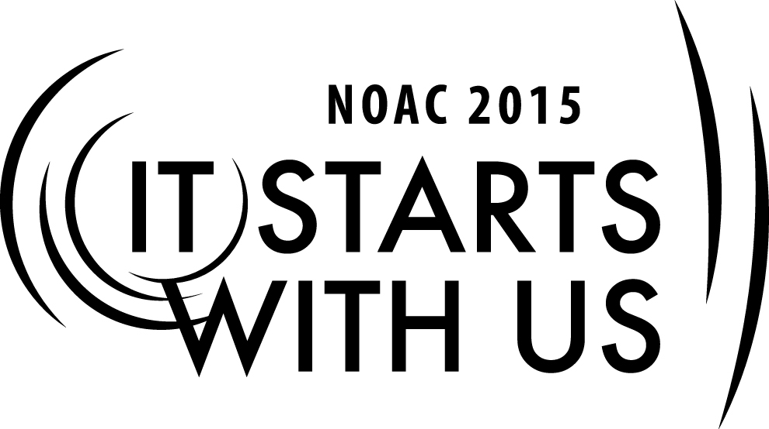
National Scouting Museum – Caring for and Preserving Historical Resources
2015 National Order of the Arrow Conference
Session Length: 180 Minutes
Through this session, you will:
Explain Attendees at this session will learn the basics of preserving historical collections, including archives, artifacts, and photographs. They will also learn about preservation practices in exhibitions.
Demonstrate Basic collections care procedures will be demonstrated to attendees.
Guide Through extended Q&A sessions, attendees will be able to ask specific questions about the care and preservation of historical materials and best practices. A hands-on segment will allow attendees to experience first-hand some basic preservation steps.
Enable Attendees will be equipped with the knowledge and resources to begin establishing or improve historical collection programs at their lodge.

The theme of NOAC 2015 is “It Starts With Us”. This session will relay this theme in the following ways:
- The preservation of our history is essential to understanding the past and passing the legacy and knowledge on to the next generation – with the 100th anniversary of the OA, this session will enable attendees to begin preserving the legacy at the local level.

SESSION NARRATIVE

National Scouting Museum – Caring for and Preserving Historical Resources

- Collections Care 101 – Basics of caring for and preserving historical materials. (20 min.)

- Archives – Learn best practices for caring for paper-based materials, photographs, audiovisual materials, books and other paper ephemera. (20 min.)

- Q&A (10 min.)

- Break (10 min.)

- Artifacts – Learn best practices for caring for three dimensional artifacts including textiles, leather, feathers, metal, wood, and plastic materials. (20 min.)

- Goodman Scrapbook Collection – This case study will look at a large digitization project of complex scrapbooks. The class will learn best practices for project planning a digitization project and have the opportunity to see digital images of the scrapbooks and learn more about the collection (30 min.)

- Q&A (10 min.)

- Break (10 min.)

- Hands-on – attendees will learn how to encapsulate a document, number an object, create a simple box for books, and a simple display method for paper materials. (25 min.)

- Exhibition Best Practices – any overview of what and what not to do in displays of historical materials (10 min.)

- Wrap-Up/Q&A (15 min.)

SE

TRAINER PREPARATION

Appendix Resources:
- List any resources to assist in Training – training will require PowerPoint; ability to play video (with sound) through computer, 4 tables to set up hands on activities.
- There will be paper handouts given out at the beginning of the class.

