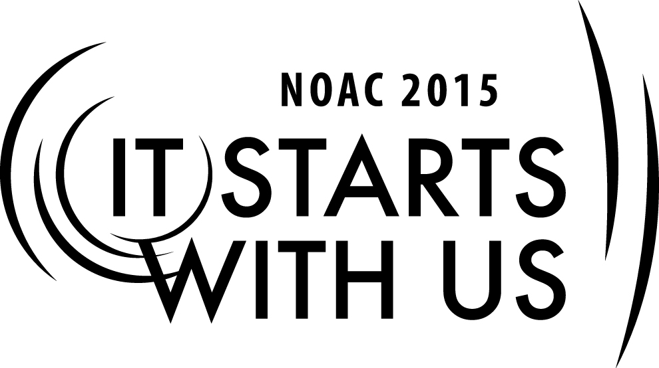
Mentoring Youth Leaders: Mentoring Youth Without Them Knowing It
2015 National Order of the Arrow Conference

Session Length: 55 Minutes
Through this session, you will:
Explain best practices of mentoring of youth leaders
Demonstrate effective communication and motivation techniques
Guide advisers to understand how important good mentoring is to creating an atmosphere that fosters youth leadership and personal growth and in turn strengthen Lodge success
Enable advisers to implement effective mentoring strategies in order to inspire and mentor youth leaders to perform to the best of their abilities

This session will help the Lodge/Chapter/Section with the Journey to Excellence Requirements related to Membership, Program and Unit Service.

The theme of NOAC 2015 is “It Starts With Us”. This session will relay this theme in the following ways:
- In order to effectively inspire and mentor youth leaders an adult leader must first have a passion for the Order and an infectious energy and enthusiasm for working with young people. If we as adult leaders do not model the type of dedication and genuine enthusiasm for the program we expect of our youth leaders then our efforts at mentoring and inspiring youth will not be effective.

SESSION NARRATIVE

Introduction 2 Minutes

It starts with us is the theme of our conference this year. In order to effectively inspire and mentor youth leaders we as adult leaders must first have a passion for the Order and an infectious energy and enthusiasm for working with young people. Inspiring and mentoring starts with us. This session will cover traits of effective mentors as well as mentoring best practices.

Traits of Effective Mentors 10 Minutes

Help the participants to better understand that they have likely given and received good mentoring in their personal or professional lives that they can draw upon as a template for success. Effective mentors are good listeners, give wise counsel, and allow their mentees space to grow.

Trainer Instructions: Solicit answers from the group on traits of effective mentors. Write these answers on a flip chart. Then compare them to the prepared list. Also share with the group an example of an effective mentor from your professional or volunteer experiences that models the type of mentoring we aspire to in the Order. Share how this person helped you grow and develop.

Listening: The Key to Mentoring 15 Minutes

The mentee, here our youth officers, should be active participants in the mentoring relationship. It is up to us as adult leaders to create an atmosphere where youth leaders actively seek feedback and mentoring. Advisers should listen intently to what the youth has to say and when appropriate ask questions that prompt independent thought and discussion on the part of youth leaders. Make sure you correctly understand what the youth leader is communicating. It may be helpful to employ techniques of active listening during some of your conversations. Active listening involves the listener feeding back what they hear to the speaker by way of restating or paraphrasing what they have heard in order to confirm the understanding of both parties. Active listening also involves an awareness of the speaker’s body language and behavior as these may provide a more detailed understanding of the speaker’s message. Make sure to make appropriate eye contact with the speaker and avoid a closed arm position as this indicates an unwillingness to listen to the speaker’s ideas.

Trainer Instructions: Break the group into groups of 2 participants. Have one participant act as the youth officer and the other act as the adviser. The adviser should try employing methods of active listening during the conversation. Participants should then share with the group how active listening helped them to approach the situation. Do they think active listening helped them reach a better solution?

Hypothetical situation: A youth officer comes to you with a difficult situation and needs advice. The youth officer is frustrated with the other youth officers’ lack of commitment to the program as evidenced by their not showing up to meetings prepared or even skipping some events and not promptly responding to communications. The youth officer also shares that he has been extremely busy with school work and other extra circular activities. He feels that he is not receiving enough support.

Answers should include an awareness of the youth officer feeling unsupported and overworked as well as questions that prompt independent thought on how to better inspire and communicate with the other youth officers. The adviser could then share some insights from how he has dealt with similar situations. What did the officer’s body language and behavior indicate to the adviser? Did paraphrasing what they heard help provide a more detailed understanding of the speaker’s message?

Goal Setting and Project Planning 15 Minutes

Goal setting and project planning are vital to the success of any Lodge function. Often times when planning a Lodge function, there are many different stakeholders in the process. Depending on the scope of the project the Council Board, Camping Committee, summer camp staff, and other key Council volunteers could all have a stake in the success of a project. Navigating these leadership layers could be difficult and unfamiliar to a youth officer. The following hypothetical situation will provide advisers an opportunity to mentor youth on how to effectively navigate leadership layers, work with different stakeholders and successfully manage a Council wide project.

As an adviser it is important to guide officers toward using SMART goals during goal setting and project planning. SMART goals are those that are specific, measurable, achievable, realistic, and time based. Youth officers may not initially incorporate each of these criteria without your guidance. During this process, it may be helpful to educate officers on how other council stakeholders’ goals and timelines may differ from the Lodge’s and how, when possible, aligning goals and timelines can achieve an optimal result.

Trainer Instructions: Break the group into small groups of 5-10 participants. Have the group discuss among themselves how they would approach the hypothetical situation given to them. Then have one group member present the groups answer to the larger group.

Hypothetical situation: The Lodge Chief has a conversation with the Council Camping Committee Chair who also is a member of the Council Executive Board regarding the possibility of creating a mountain biking program at the Council summer camp. The project would include trail creation, the purchase of equipment, the hiring of staff to run the program, and ongoing maintenance of the program. The Council Camping Committee Chair wants to know if the local OA Lodge could lead this initiative. He also mentions that he has heard something about the OA Service Grant program and that Council leadership would like the Lodge to consider applying for the grant to help fund this program.

How would you advise the youth officer to proceed? Answers should include proper delegation, how to identify and work with various Council groups, how to budget and fundraise, and how to effectively craft a grant proposal.

Following Up 10 Minutes

How often should you communicate with youth officers? What modes of communication are most effective reaching today’s youth? Help the group to see that phone calls, emails, texts, and social media applications are effective methods of communicating with today’s youth. Further consistent, weekly communication helps to foster the most effective mentoring environment. Over time a mentor-mentee relationship is formed that will benefit the youth leader in their studies, careers, and family life. Today’s youth especially the millennial generation appreciates mentors who seek to know them outside of their volunteer role and on a personal level. When they feel a mentor has truly invested in their success as a person is when the greatest success in mentoring is achieved.

Trainer Instructions: Solicit answers from the group on effective modes of communication and how often the adviser should communicate with the youth officer. Write these answers on a flip chart. Then compare them to the prepared list.

Conclusion 3 Minutes

Thank the group for their input and hard work during the session. Remind them that each of us has received good mentoring during our professional or volunteer experiences and we should draw on these experiences to help us become better mentors. Also remember to incorporate techniques of active listening into conversations with youth leaders to ensure we correctly understand what the youth leader is communicating. Further, the use of SMART goals will create an environment where youth leaders plan events that are exciting and effective. Lastly, remind participants that it starts with them to implement what they have learned today in their Lodges in order to make the program stronger. Only by practicing good mentoring can they become outstanding mentors to our youth leaders.

TRAINER PREPARATION

This session should be taught by an experienced trainer who has held key leadership positions in the Unit, Lodge, or Section. Understanding of the role and responsibilities of Lodge Advisers, the Lodge Key Three and Council Key Three is helpful. The trainer should have experience working with Lodge Chiefs, Advisers, Scout Executives, and Council Officers.
Prior to the course, review of successful mentoring experiences is recommended. Familiarity with mentoring best practices as well as concrete examples of youth mentoring success will prepare you to answer the questions or concerns of the participants.
Appendix Resources:
- PowerPoint Presentation
- Hypothetical situation cards
- 2012 Order of the Arrow Lodge Adviser’s Handbook(http://www.oa-bsa.org//uploads/publications/lodgeadviserhandbook-2012.pdf)
- 2012 Order of the Arrow Guide for Officers and Advisers(http://www.oa-bsa.org//uploads/publications/GOA-2012.pdf)
- Field Operations Guide(http://www.oa-bsa.org//uploads/publications/FOG-2013c.pdf)

