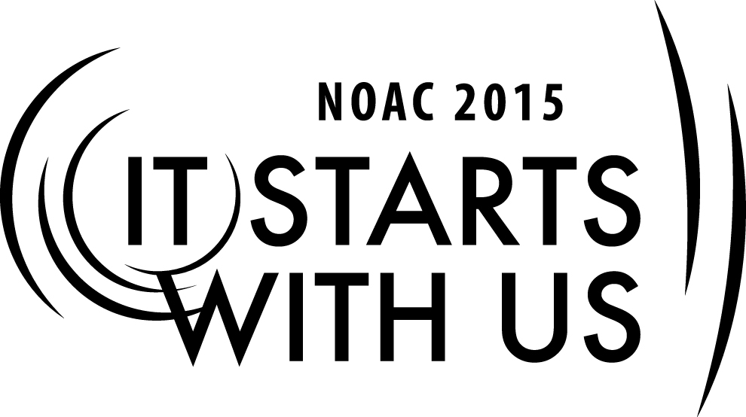
Mentoring Youth Leaders: Creating a Healthy Environment
2015 National Order of the Arrow Conference
Session Length: 55 Minutes
Through this session, you will:
Explain how to create a positive environment where mentoring can take place
Demonstrate best practices of communicating and mentoring youth leaders
Guide advisers to understand how important good mentoring is to creating an atmosphere that fosters youth leadership and personal growth and in turn strengthen Lodge success
Enable advisers to implement effective mentoring strategies in order to inspire and mentor youth leaders to perform to the best of their abilities

This session will help the Lodge/Chapter/Section with the Journey to Excellence Requirements related to Membership, Program and Unit Service.

The theme of NOAC 2015 is “It Starts With Us”. This session will relay this theme in the following ways:
- In order to effectively inspire and mentor youth leaders an adult leader must first have a passion for the Order and an infectious energy and enthusiasm for working with young people. If we as adult leaders do not model the type of dedication and genuine enthusiasm for the program we expect of our youth leaders then our efforts at mentoring and inspiring youth will not be effective.
SESSION NARRATIVE

Introduction 2 Minutes

It starts with us is the theme of our conference this year. In order to effectively inspire and mentor youth leaders we as adult leaders must first have a passion for the Order and an infectious energy and enthusiasm for working with young people. Inspiring and mentoring starts with us. In this session we will discuss the difference between coaching and mentoring, the uniqueness of the millennial generation, and how to create a strong mentoring environment.

The Difference between Coaching and Mentoring 10 Minutes

Help the participants to understand that coaching involves directing the learning process, is heavy on telling with appropriate feedback and focuses on immediate learning opportunities. Mentoring is a collaborative learning process between the mentor and mentee that is based on listening, being a role model, and making suggestions when appropriate. Additionally, mentoring focuses on long term personal development.
Trainer Instructions: Solicit answers from the group on difference between mentoring and coaching. Write these answers on a flip chart. Then compare them to the prepared list. Share with the group some prominent current examples of coaches and mentors in society. Showing video clips of these coaches and mentors may also be effective.

Mentoring the Millennial Generation 15 Minutes

The Millennial generation is different than past generations. Generally, millennials seek regular feedback from their mentors and respond best to a collaborative work environment. Their generation is the most technology fluent generation in history and tends to have an optimistic attitude about others and the future. They trust friends, family and mentors more than they trust traditional institutions.

Trainer Instructions: Break the group into small groups of 5-10 participants. Have the group discuss among themselves how they would approach the hypothetical situation given to them. Then have one group member present the groups answer to the larger group.

Hypothetical situation: Split the group into separate generation groups (Baby Boomer, Generation X and Millennials). Have each group discuss how each generation could utilize their experience and characteristics to best mentor millennials in order to help them reach their full potential.

The Baby Boomer Generation is comprised of those born between 1946 to 1964. Members of the Baby Boomer generation are educated, seek to redefine values, value equality, and are independent thinkers.

Generation X is comprised of those born between the early 1960s to the early 1980s. Members of Generation X are highly educated, active, balanced, happy, and family oriented. They also have the highest volunteer rate of any generation. Further they believe strongly in change, human dignity and freedom.

The Millennial Generation is comprised of those born between the early 1980s to the early 2000s. Members of the Millennial generation are educated, confident, tolerant, civic minded, optimistic, ambitious, collaborative, technology proficient and hard working.

Answers could include ensuring your fluency in current technology and new modes of communication, an understanding of millennials’ need for reinforcement and feedback, and creating a partnership through investing in them as individuals. Millennials often do not wait to receive feedback but seek feedback from their mentors. Be prepared to provide thoughtful feedback during events or after meetings. Additionally, providing materials on leadership and development will likely be appreciated as the millennial generation believes strongly in personal development opportunities. Also, make sure to let millennials know that you value their ideas. The mentoring relationship works best when it is mutually beneficial.

A Shared Commitment to Mentoring 15 Minutes

In order for mentoring to be successful, the adviser corps has to have a shared commitment to mentoring. If some advisers invest in mentoring while others do not the youth leaders will be sent mixed messages and may then question the knowledge or skill of those adults who do not mentor. It is the responsibility of the lodge adviser to set the tone and ensure the other lodge advisers share his commitment to regularly mentor each youth officer.
Trainer Instructions: Break the group into groups of 2 participants. Have one participant act either an effective adviser or an adviser who micromanages or rarely contacts his youth officer. Have the other participant act as the youth officer. The youth officer can be either receptive or unreceptive to the counseling provided by the adviser. After the exercise participants should share what they learned about mentoring with the group.

Hypothetical situation: The lodge adviser is fully committed to mentoring the lodge chief to ensure he reaches his full potential as a leader. He contacts the chief regularly and enjoys a collaborative relationship with the chief. However, some other lodge advisers rarely contact their assigned officer and almost never give advice. Other lodge advisers micromanage their officers and dictate to them what events should be included in a weekend program and leave few if any decisions to the youth officers.

How would you get the advisers to buy into effective mentoring techniques? How would you as lodge adviser ensure a unified mentoring experience for youth leaders?

Answers should include:
- Having a training session/discussion open to only lodge advisers regarding effective mentoring techniques as well as the difference between a coach and mentor.
- The lodge adviser could suggest that the other advisers attend NLATS as this course is designed to cover mentoring as well as provide advisers with the tools to successful mentor youth.
- The lodge adviser could also hold monthly meetings where advisers could update each other on success working with officers as well as concerns or areas where additional help and coordination may be necessary.

Conducting Safe Events 10 Minutes

One of the areas where adults can impart wisdom and guidance is helping youth leaders to understand the process involved in conducting high adventure activities on weekends. For example if youth officers want to include rock climbing as an activity on a fellowship weekend what steps would be necessary in order to safely include climbing in the weekend program? Refer the group to the “Guide to Safe Scouting” for additional information.

Trainer Instructions: Solicit answers from the group on what type of activities could be considered hazardous or high adventure that could occur on an OA event. Write these answers on a flip chart. Then compare them to the prepared list.

Conclusion 3 Minutes

Thank the group for their input and hard work during the session. Effectively mentoring the Millennial Generation will require advisers to constantly work on their mentoring skills and be prepared to provide regular feedback. Remembering that mentoring is mutually beneficial is also important to creating a successful mentoring relationship with millennial leaders. The lodge mentoring initiative will only be successful if each adviser takes this responsibility seriously and commits fully to mentoring the youth they are responsible for. Remind participants that it starts with them to implement what they have learned today in their Lodges in order to make the program stronger. Practicing good mentoring and creating a healthy mentoring environment is the best way to help our youth leaders grow and mature.

TRAINER PREPARATION

This session should be taught by an experienced trainer who has held key leadership positions in the Unit, Lodge, or Section. Understanding of the role and responsibilities of Lodge Advisers, the Lodge Key Three and Council Key Three is helpful. The trainer should have experience working with Lodge Chiefs, Advisers, Scout Executives, and Council Officers.
Prior to the course, review of successful mentoring experiences is recommended. Familiarity with mentoring best practices as well as concrete examples of youth mentoring success will prepare you to answer the questions or concerns of the participants.
Appendix Resources:
- PowerPoint Presentation
- Hypothetical situation cards
- 2012 Order of the Arrow Lodge Adviser’s Handbook(http://www.oa-bsa.org//uploads/publications/lodgeadviserhandbook-2012.pdf)
- 2012 Order of the Arrow Guide for Officers and Advisers(http://www.oa-bsa.org//uploads/publications/GOA-2012.pdf)
- Field Operations Guide(http://www.oa-bsa.org//uploads/publications/FOG-2013c.pdf)
- Guide to SafeScouting(http://www.scouting.org/scoutsource/HealthandSafety/GSS/toc.aspx)

