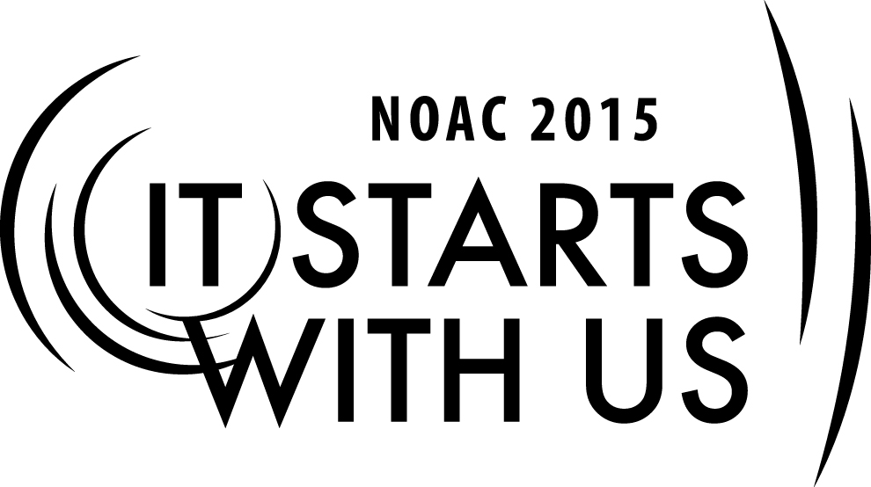
Mentoring Youth Leaders: Inspiring Success in Youth
2015 National Order of the Arrow Conference

Session Length: 55 Minutes
Through this session, you will:
Explain best practices of mentoring and inspiring youth leaders
Demonstrate effective communication and motivation techniques
Guide advisers to understand how important good mentoring is to creating an atmosphere that fosters youth leadership and personal growth and in turn strengthen Lodge success
Enable Advisers to implement effective mentoring strategies in order to inspire youth leaders to perform to the best of their abilities

This session will help the Lodge/Chapter/Section with the Journey to Excellence Requirements related to Membership, Program and Unit Service.

The theme of NOAC 2015 is “It Starts With Us”. This session will relay this theme in the following ways:
- In order to effectively inspire and mentor youth leaders an adult leader must first have a passion for the Order and an infectious energy and enthusiasm for working with young people. If we as adult leaders do not model the type of dedication and genuine enthusiasm for the program we expect of our youth leaders then our efforts at mentoring and inspiring youth will not be effective.

SESSION NARRATIVE

Introduction 3 Minutes

It starts with us is the theme of our conference this year. In order to effectively inspire and mentor youth leaders we as adult leaders must first have a passion for the Order and an infectious energy and enthusiasm for working with young people. Inspiring and mentoring starts with us.

Trainer Instructions: If the group of participants is small enough ask them to introduce themselves as well. [Be aware of the participant’s Lodge/Section roles as this will inform your later discussions]

An Adviser’s Responsibility 10 Minutes

What do you believe is the most important responsibility of an adult adviser? You should help the group to realize that the most important responsibility of an adviser is to effectively mentor youth. Some good answers are to create leadership opportunities for youth, serve as a positive role model, serve as counsel, teach effective communication, help set expectations, and provide prospective.

Trainer Instructions: Solicit answers from the group on the primary responsibilities of an adviser. Write these answers on a flip chart. Then compare them to the prepared list.

Mentoring 10 Minutes

How does the group define mentoring? What traits do you believe the millennial generation looks for in their mentors?

You should help the group to realize that millennial’s looks for mentors who are good listeners, collaborative, and can be reached through a variety of modes of communication.

Trainer Instructions: Solicit answers from the group on mentoring and what the millennial generation seeks from their mentors. Write these answers on a flip chart. Then compare them to the prepared list.

Communication 15 Minutes

Millenial’s looks for mentors who are good listeners and can be reached through a variety of modes of communication. Good communication is critical to successfully inspire youth leaders. Communication is especially important to the millennial generation. They expect their mentors to be available through a variety of modes of communication. When inspiration strikes, they want to be able to benefit from your counsel whether through text, email, phone call, or social media application.

Trainer Instructions: Break the group into small groups of 5-10 participants. Have the group discuss among themselves how they would approach the hypothetical situation given to them. Then have one group member present the groups answer to the larger group.

Hypothetical situation: A Lodge youth officer cannot be reached prior to a meeting or event that needs to be properly planned. You as Adviser have made repeated phone calls and received no answer. How would you seek to get in contact with the officer?

Answers should include utilizing alternative forms of communication such as text, email, or social media application. The adviser should ask the officer at the beginning of his term his preferred methods of communication. Do not assume that your preferred method of communication will be the same as a youth officer.

Hypothetical situation # 2: A youth officer tells you that he does not need or want your opinion on an important Lodge decision. He states that the Order is youth led and therefore he does not require any input from adult leaders.

Answers should include helping the youth leader to understand that the Order is youth led but there is meant to be a partnership with the adults where youth can benefit from our experience and counsel. Sometimes it is best to act as a sounding board for youth. Let the youth use their enthusiasm and creative ideas to strengthen and grow the program. Having a conversation about expectations of both the youth and adult soon after an officer’s election can help create a positive atmosphere of collaboration.

Goal Setting/Planning 15 Minutes

Help the group to understand that proper planning and youth involvement, leadership and camaraderie is crucial to group planning success.

Trainer Instructions: Break the group into small groups of 5-10 participants. Have the group discuss among themselves how they would approach the hypothetical situation given to them. Then have one group member present the groups answer to the larger group.

Hypothetical situation: Your Lodge is holding a yearly Lodge planning meeting soon after Lodge elections. The officers in your Lodge include: Lodge Chief, Lodge Vice Chief- Program, Lodge Vice Chief- Operations, Lodge Vice Chief-Communications, and Lodge Vice Chief- Service. Each officer has an Adviser assigned to them. How would you handle this session? How active do you think advisers should be in the planning process?

Answers should mention that advisers should listen and let the youth run the planning sessions and led the discussion. Advisers should only offer insight when asked or when a safety issue is not being properly addressed. This process helps to establish youth ownership and commitment to the process. If the youth leaders are actively engaged and directing the process they will work harder to ensure a successful and well planned event. If the adults become too active in the planning process it robs the youth of an ability to grow and learn. Additionally, youth camaraderie deepens through the planning and goal setting process.

Hypothetical situation # 2: A youth officer wishes to discuss annual goals with you shortly after being elected. How would you respond to the officer’s inquiry?

Answers should include a discussion of how the youth should present his goals in detail first before the adviser suggests any recommendations or goals he may have. Given that the Lodge is youth led the youth officer should be able to present his own vision. An adviser’s should ask questions that will provoke thought on goals an officer may not have realized should be included. The officer coming to this realization rather than the adviser merely stating the goal helps the youth develop analytical thought and develops greater leadership capabilities.

Conclusion 2 Minutes

Thank the group for their input and hard work during the session. Encourage them to always look for ways to become better mentors. Remember that working with today’s youth is different than working with past generations. Effective listening and communication is essential to inspiring today’s young leaders. Utilizing the preferred communication medium of today’s young leaders will enable you to form a stronger partnership with youth leaders. Always remember that your most important responsibility is to mentor youth leaders. Remind them that it starts with them to implement what they have learned today in their Lodges in order to better inspire youth to grow and fulfill the mission of the Order in their local Councils.
TRAINER PREPARATION

This session should be taught by an experienced trainer who has held key leadership positions in the Unit, Lodge, or Section. Understanding of the role and responsibilities of Lodge Advisers, the Lodge Key Three and Council Key Three is helpful. The trainer should have experience working with Lodge Chiefs, Advisers, Scout Executives, and Council Officers.
Prior to the course, review of successful mentoring/inspiring experiences is recommended. Familiarity with mentoring best practices as well as concrete examples of youth mentoring success will prepare you to answer the questions or concerns of the participants.
Appendix Resources:
- PowerPoint Presentation
- Hypothetical situation cards
- 2012 Order of the Arrow Lodge Adviser’s Handbook(http://www.oa-bsa.org//uploads/publications/lodgeadviserhandbook-2012.pdf)
- 2012 Order of the Arrow Guide for Officers and Advisers(http://www.oa-bsa.org//uploads/publications/GOA-2012.pdf)
- Field Operations Guide(http://www.oa-bsa.org//uploads/publications/FOG-2013c.pdf)

