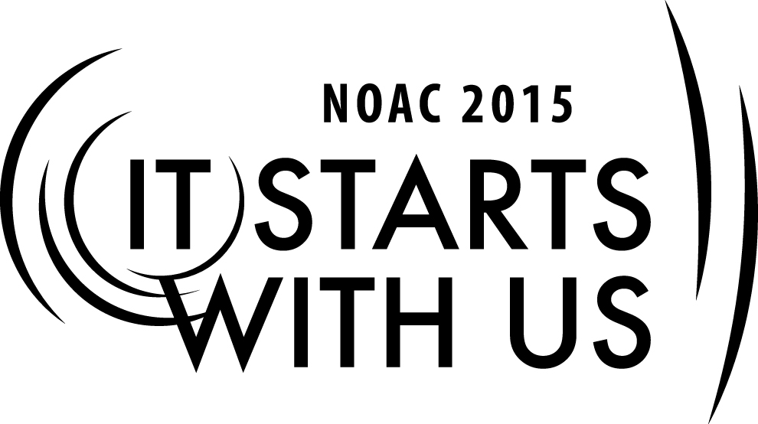
TRAINER PREPERATION

MEDIUM LODGE ADMINSTRATION –MEMBERSHIP UTILIZATION

Session Length: 50 Minutes
The theme of NOAC 2015 is “It Starts With Us”.
This session will relay this theme in the following ways:
Through this session you will:
Explain why it is important to use the talents of your membership to its fullest potential.
Demonstrate ways to discover and utilize your membership’s talent base.
Guide our guests in discussion of best practices to address those issues.
Enable our guests to take back to their lodges ideas that they can actually employ.

This session will help the Lodge with the Journey to Excellence Requirements:
- Membership impact #3
- Membership Retention #4
- Lodge event participation #7
- Leadership Development #16

Required Materials:
- Box of Large paperclips
- Flipcharts (2)
- PowerPoint Presentation file
- Adult & Youth Resource Survey to determine skill set available (HandOut)
SESSION NARRATIVE

Trainer Tip: In improve participation and customize the discussion, ask one member of the lodge represented to write on the board or flip chart in the front of the room 1) Lodge name, 2) Location and 3) How many members in their lodge.

- Use an ice breaker to get the group started.

- One of my favorites is to divide up on groups of 5-7, pass out a large paperclip , then get out a sheet of paper and write down how many ideas you can get with the common paper clip. Have a contest for the most answers…Time them for 90 seconds and in the end , ask each group who had the most.
- Remind them that a “mind once stretched, never regains it original shape”
- So they need to be open minded about this session.

INTRODUCTION 5-7 Minutes

Introduce yourself and share your background and experience. Based on the size of the group and time, have the participants introduce themselves where from, lodge name and how many members.

In this session we will be discussing how the problems and needs of the lodge influence its organization
How the unique character of a medium-lodge can be leveraged to increase member’s interest
The Journey To Excellence provides a clear road map to a path/plan for continuous improvement for the Lodge.

Start with Ice breaker paper clip contest.

There’s a Job to be Done 10-15 minutes

Each lodge has particular tasks that need to be done. Some are handled at the chapter level. Some are handled at the lodge level.

What are some of the things that must happen in a lodge? Take suggestions from the guests about things that could be on this list and write them on the flip chart or white board.

Some that could be included are:
- Unit elections
- Camping promotion
- Inductions (both service and ceremonies)
- Camp service weekends
- Supporting council events
- Friends of Scouting support
- Communications (see how many forgot about this one – might be interesting)

Now, what are some thing that a lodge might like to do (and probably should)? Again, take suggestions and list them.

Some that could be included are:
- Lodge banquet
- Lodge singing and drumming team
- Lodge dance team
- Cub Scout service
- And … ?

Some of these things could be handled by one or two individuals, whether it is the lodge level or chapter level handling the project, but most of them will require a committee, particularly those that involve the word “team” in their functions.

OK, so who is best at doing these things? To find that, we do a …

Membership Inventory

Set up a simple data base for positions needed and member’s prospective positions/skills. Like a Quartermaster in the troop, this info can be in a data base on computer or simple index cards in a box. Pass out the Adult & Youth Resource Survey to determine skill set available
Remember information is power, so keep that information handy to use to recruit and fill position.

Personal Information

Age, school, phone, interest, jobs, talent, address are essential to know in your lodge

Hint: How about manpower committee to do this? Remember for adult’s job type, list of hobbies is very important.

Scouting information

Rank, unit number, position, events attended. Honors held, years in position, training courses attended like JLT, Wood badge, University of scouting, previous positions, and similar information

Order of the Arrow information

Status, position held, previous events attended, staff worked on, ceremony parts, Elangomat, national training and events, other area of interest.

Once inventory is done and resources identify, just connect the dots and have a backup for each position in case they are unavailable or decide on another position.

Remember: National recommends that every member have a role in the lodge. It’s critical to be sure that everyone is assigned to at least one operating committee of the lodge and that those committees actually function.

Also, there needs to be two leaders assigned to each task – a youth to lead the planning and implementation, backed up by a capable adult adviser.

No plan is perfect … so how do we go about this? 15-20 minutes

Now that we know what we are doing, what we want to do, it’s a matter of finding the manpower to make these things happen. But what are some of the snags? Break up the room into small groups and have them brainstorm potential issues that a medium-sized lodge would have with utilizing its membership. What are some solutions to addressing those problems?

Conclusion & Wrap up 5 minutes

This session did address four key components and will help the Lodge with the Journey to Excellence Requirements:
- Membership impact #3
- Membership Retention #4
- Lodge event participation #7
- Leadership Development #16
Remember everyone has an opportunity to serve and with the Membership Inventory you can assign the right person with the right job or jobs.
Any closing comments or questions?
Where can I get more information?

BSA and NOAC resources are listed below.

Appendix Resources:
- 2012 Guide for officers and Advisors
  - Pages 1-10 Organization, Lodge Program
- Order of the Arrow Handbook
- Order of the Arrow National Bulletin – published quarterly and available online
- National Order Of the Arrow –Website
- Lodge Leadership Development, http://lld.oa-bsa.org
- National Boy Scouts of America, http://www.scouting.org

