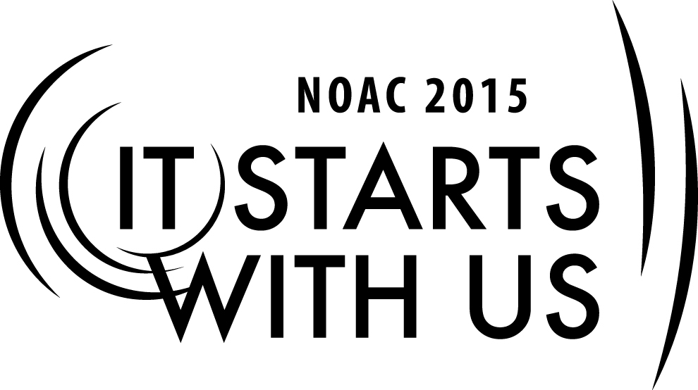
MEDIUM LODGE ADMINISTRATION: COMMUNICATION & FINANCE

2015 National Order of the Arrow Conference

Session Length: 50 Minutes
Through this session, you will:
Explain the proper procedures for medium lodge finances.
Demonstrate the importance of quality communication among lodge members
Guide on innovative ways to raise money and to maintain budgets
Enable guests to learn new methods of written and verbal communication

This session will help the Lodge with the Journey to Excellence Requirements:
- Fiscal Management #1
- Contribution to Council #2

The theme of NOAC 2015 is “It Starts With Us”. This session will relay this theme in the following ways: by providing Arrowman a path to lodge financial success and by providing a method for communication success.
SESSION NARRATIVE

INTRODUCTION 5-10 Minutes
Introduce yourself and share your background and experience. Based on the size of the group and time, have the participants introduce themselves where from, lodge name and how many members.
In this session we will be discussing the importance of your lodge’s finances and the difference good communication within the lodge can make in event participation and member retention.
- Use an ice breaker to get the group started.
- One of my favorites is to divide up on groups of 5-7, pass out a large paperclip , then get out a sheet of paper and write down how many ideas you can get with the common paper clip. Have a contest for the most answers…Time them for 90 seconds and in the end , ask each group who had the most. Remind them that a “mind once stretched, never regains it original shape”
Trainer Tip: In improve participation and customize the discussion, ask one member of the lodge represented to write on the board or flip chart in the front of the room 1) Lodge name, 2) Location and 3) current annual dues they charge.
Lodge Finances: 15-20 Minutes
Explain a lodge must know how much money it has, where it is spent, and when it is used. Knowing how it performs financially helps the lodge plan for the future.
This includes Finance part of the JTE #1 Fiscal management: Develop and successfully execute a lodge annual budget. Bronze is Complete and follow annual budget approved by lodge executive committee. Silver is close the year with a positive operating balance (operate in black). Gold is close with an operating balance < budget projection.
Do we have any Chapter or Lodge treasures represented in the room? If so good we will look to include your input and experiences.
The Journey To Excellence provides a clear road map to a path/plan for continuous improvement for the Lodge.
The lodge finances have to be included in the council treasury and are subject to your council regulations and annual audit. All Order of the Arrow Funds are handled through the council’s regular financial system as outlined in the “Local Council Accounting Manual”
All lodge monies are help in a custodial account within the council system. All money brought in by the lodge is deposited into this custodial account and all checks cut for the lodge are drawn on this account. Most council have a check requisition form and a purchase order system. Work with your lodge staff advisor and council bookkeeper to find out about your councils unique procedure.
Webster’s dictionary defines the word budget as “ A plan for the coordination of resources and expenditures.”
Who knows what the Benefit/purpose of having an annual budget? What is the purpose/benefit of having an event budget? What is the difference?
(Have group discuss the benefits of budgeting using participant’s responses)
Review-A good Budget:
- Let’s you know how much you have to spend.
- Tells you when you break even
- Prevents underestimating your income and overestimating your expenses.
- Serves as a tool for keeping the lodge solvent or in the black.
The benefit of keeping good records now will help with building future budgets.
Depending on your annual budget, the dues that your lodge collects should cover the re-chartering fee, membership cards, and daily operations of the lodge (Mailings, recognition, etc.)
Discuss the average dues nationwide and in the room and why they differ.
Another important topic is discussed how your lodge charges for ordeals. Some lodges charge the cost of brotherhood sash in the ordeal fee as an encouragement for lower brotherhood 10 months later.
Discuss the pros and cons with participant’s answers.
Raising funds is something all lodges must do regardless of size. The smaller lodges may have limited opportunity with smaller councils and many who must wear multiple hats. Many lodges have annual fundraisers throughout the year. A fundraiser could be a profitable event, special patch, run a trading post, or a more traditional program.
(If time permits list some key fundraisers from attending lodges that have been successful.)
Fundraising are also done for special events or projects.
- An example would be making a special lodge flap to sell and use the profits to pay for gas to Summit or Arrow corps.
- Start a museum and take BSA memorabilia donations to sell as cash for council camps
- Selling Red Sashes for NOAC 2015 as Fundraisers
- Another option is to have an ordeal at a state part for reduced camping fees in trade for man hours to clear trails and lakes. The meals can be catered under a big tent if no dining hall is available.
- Other options are patch auctions at annual dinners for limited edition or offer signed items

There are many ways to build District/council goodwill and marketing your lodge. Yes, trading post is the most traditional way, but look for more than just product and merchandise. Lodges seeking to market themselves should consider:
- Visiting Units for Camp promotion and Unit Election
- Cub Scout Crossovers
- Broken Arrow ceremony for past scouts and OA
- Staff for district/council camporees & Summer camp
- Staff Cub day camps
- Ushers for Sports HS, College or Pro
- Lifeguards for local pools
- Participate in scout Sunday
- Providing camperships
- Annual FOS donation
- Press release about major activity
- Using Dance Team and Ceremony team for events
- Sell Christmas trees, wreaths, flowers

Lodge Communication 15-20 minutes
Good Communications with in the lodge can make or break member retention and member participation in activities.
The three main ways of communication are:
Intra-Leadership
- Communication between leaders , LEC and Leader to members

Leaders to members
- Communication from the lodge leaders to the members: Mailing, Website, Text, Facebook, Twitter, Robo Calls

Member to leader
- Communications from the members to lodge leaders, phone calls, event registration, text, ,election scheduling ,mail, post cards, letters, Y Tube

Communication feedback is the key to organizational good health!
Verbally
- At all events
- At all meetings
- During unit elections/Troop visits/camp promotion
- Roundtable
- Phone
- Court of honors
Mail
- Event flyers
- Newsletters
- Postcards
- Broadcast fax

Electronic
- Email group lists
- Twitter
- Text
- Robo call

Websites
Calendar
Events Registration
Documents
Committee Pages
News
Links

Conclusion & Wrap Up 5 minutes
Remember the JTE #1 & # 2 and possibly Retention. Remind Arrowman that the keys to a strong lodge are strong communication and strong finances – without these two, there would be no lodge. These are the keys that unlock the doors to so many other possibilities!
Ask for questions?
TRAINER PREPARATION

Best Trainer:
The optimal trainer is an energetic youth (17-21) or adult who has been involved in a medium sized lodges with about 500 members. They should be creative, motivated, and able to bring insight to training leaders from small lodges.
Prepare and review charts, power point slides, and handouts. This session is designed to be presented in a lecture and discussion format. Be sure to make time to answer the participant questions as they come up and encourage open floor and idea sharing atmosphere.
Review all Source material and resources listed in Appendix. It is always good to have actual book or publication examples to hold up or show screen shots.
Remember you do not have to be an expert, just a resource that knows people and where to get the information.
Always ask if anyone in the room has information on a question you may not know the answer. You never know what resources can be in the room. National officers, Regional officers, Section officers and long term Advisors have known to participate in training classes.

