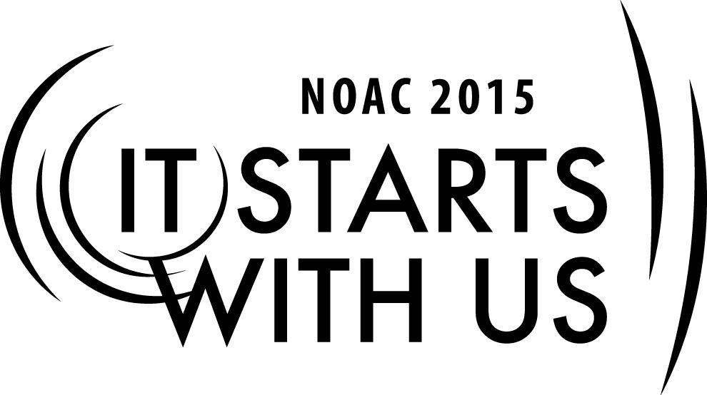
2015 National Order of the Arrow Conference
Lodge Training Program: Building Your Lodge Training Program

Session Length: 50 Minutes
This session introduces the concept of establishing year-round training in Lodges and Chapters.

Throughout this session, you will:

Explain different training needs and audiences.
Demonstrate knowledge of the what, who, and when of training.
Guide participants in listing the various types of training that can occur.
Enable success in meeting Membership, Program, Unit Service, and Council Support requirements.

This session will help the lodge with the Journey to Excellence Requirement #16 - Leadership Development

The theme of NOAC 2015 is “It Starts With Us”. This session will relay this theme in the following ways:
- Letting Arrowmen understand factors to consider in creating their lodge’s training programs

SESSION NARRATIVE

Introduction 10 minutes

- Slide 1
- Introduce training team
- Review Learning Objectives
- Slide 2
- Review topics to be covered
  - Why we need year round Training
  - Who needs to be trained
  - When should the training occur
- Slide 3
- Set the stage for the training: “Every year the Lodge and Chapters welcome new members, elect new officers and chooses new committee chairmen. The Lodge and Chapters set goals for their Journey to Excellence as they serve the council, but may fall short if the leaders and individual Arrowmen are not trained in their roles as officers, committee chairmen or even what it means to be an Arrowman. This session will provide the training to understand the different training needs and audiences that must be addressed in the Lodge training program for a successful Lodge year.”

Topic #1 – What We Need to Train for 15 Minutes

- Slide 4
- Introduce the topic: “The first step in building your training program is to know what you need to train for. Think of all of your lodge or chapter activities and all of the job assignments that occur each year. Those activities and lodge or chapter jobs form the requirements for what should be in the training program.”
- Ask “What are some of your lodge activities?” (the list should include: unit elections, induction weekends, camp promotions, orienting new Ordeal members to the OA, being an Elangomat or Nimat, fellowship weekends, service projects, Lodge Executive meetings, Chapter meetings and activities)

Topic #2 – Who needs to be Trained 10 Minutes

- Slide 5
- Introduce the topic: “Now that we have the activities and jobs, let’s look at who is involved in these and identify those we need to train.”
- Ask “What ‘jobs’ or leadership positions do you have at each activity?” (List should include: Lodge Chief and other Lodge officers and chairmen, Service Chairman, Ordeal Master/Chairman, Elangomat, Nimat, Ceremony team members, Chapter Chief and other Chapter officers and chairmen, etc.)
- Ask “Once you have inducted new Ordeal members, how do they know what the Order is about and what they can do? What about new Brotherhood members?” (listening for a description of an orientation)
- If no one calls out that there should be training for youth and adults, ask “Should the training be the same for the youth and adults or should there be youth leader and adult adviser training sessions – possibly some combined and some separate?”

Topic #3 – When Should the Training Occur 10 Minutes

- Slide 6
- Introduce the topic: “Now that we know what we should train for and who should be trained, let’s look at when the training should occur.”
- If the group does not start listing events or activities, ask: “What are times in the year when you could provide training? Like training between new officer elections and taking office.”
Trainer Instructions: Guide the discussion to link training to key events: train new officers and chairmen between elections and taking office; conduct new Ordeal member orientations at each induction, train Elangomats and Nimats prior to induction weekends

- Ask: “What are other training times?”
- Listen for these (there can be others):
  - Training between new officer elections and taking office (Lodge and Chapter)
  - Training/orienting new Ordeal members after their induction
  - Training/orienting new Brotherhood members after their induction
  - Training Elangomats and Nimats prior to induction weekend
  - Training ceremony teams prior to induction weekends
Trainer Instructions: Write down the list of training opportunities

Topic #4 – Wrap-up 5 Minutes

- Slide 7
- Provide a summary/conclusion linking the what-who-when topics, link to the other two sessions in this training block.

TRAINER PREPARATION

Each trainer should take a few moments to make certain that all computer equipment is properly connected and turned on. Trainers should also know the fastest way to open all programs and files that he or she will be using [I recommend creating shortcuts on the desktop]. It would also be handy to have a hard copy of this syllabus ready and at trainer’s disposal.

Trainer Tip: There is a lot of material to cover in a 50-minute session. Allow for discussion throughout and questions at the end. If you begin to run ahead of schedule, and someone has a question you can take it to stay on track. Explain this in advance so that everyone understands how you are running things. Above all, STAY ON SCHEDULE!

Appendix Resources:
- Training resources:
  - PPT
  - Laptop or computer
  - Thumb drive (used as a backup as well as if there is already a computer in the room)
  - Projector

