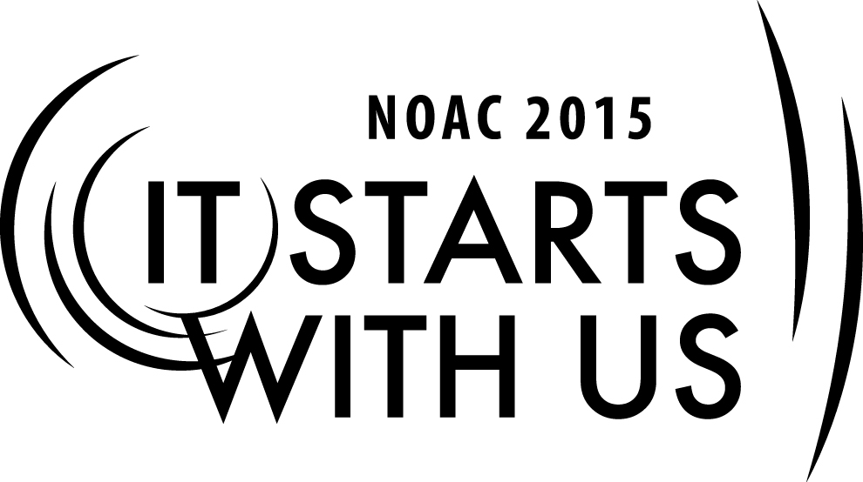
“Panning for Gold, Discovering your Financial Resources”
2015 National Order of the Arrow Conference

Part Three - “Successful and Sustainable Fundraising”
Session Length: 55 minutes
Through this session, you will:
Explain: The importance of regular, successful fundraising activities to fund the Lodges ongoing programs, projects and participation in Section, Region and National training and events.
Demonstrate: Ways and tools necessary to raise funds for the Lodge
Guide: How to utilize resources developed within the Lodge, Council and Community to develop fundraising through means other than product sales.
Enable: Expand and improve the Lodge’s ability to conduct successful annual fundraising

This session will help the Lodge with the Journey to Excellence Requirement(s)
- Fiscal Management – “Develop and successfully execute a lodge annual budget.”
- Contribution to Council – “Contribute cash, materials or both to the council.”

The theme of NOAC 2015 is “It Starts With Us”. This session will relay this theme in the following ways:
- By taking action today to develop and execute an annual, ongoing, successful fundraising
program, Lodges will improve their ability to remain financially sound for the next century of service.
- By starting the process today to know your Members and know your Council and Community better, you will be able to better utilize these resources to support your finances and fundraising.
SESSION NARRATIVE
Part Three. Finances and Fundraising SECTION LENGTH 50 Minutes

Now that we know how to develop and sustain better relationships and understanding of our Members, Council and Community we need to determine the purpose for our fundraising:
I. WHY FUNDRAISE?
Trainer Tip: Try to draw out from the participant’s specific items. The following should be brought up as examples:
Camp service/projects
Training
Scholarships/Camperships
Lodge operations
Recognitions
Endowment (West)
Events (NOAC, Conclave)
JTE Lodge Requirements
Now that we have identified areas of need for fundraising and/or contributions of gifts in kind we are ready to “Make the Ask.” Let’s investigate how to accomplish this.

II. RESOURCES

A. Purpose of “fundraising” to raise funds (money) for the Lodge, but is it just money?
B. Money is fungible – that which is received for one use can free funds for another use
C. Gifts in kind
1. Eagle project materials from Lowes/Home Depot
D. Which stakeholder has which resource
1. Age, demographic, geography

III. “The ASK”
A. Review: Why People Give
1. Because they believe in the organization and its cause or purpose
B. They were asked....
2. The Woodbadge “fist game”

Trainer Tip
This a a game played early in the Woodbadge syllbus where one player makes a fist and the second player attempts to get the first player to open his or her fist. The game is played in pairs.

C. Game Results
1. Who opened when asked?
2. Who required additional incentive?
a. “hot buttons”: an item that causes a strong emotion reaction
i. Often given a negative connotation – an issue or item that obtains and angry reply
ii. Here, seeking a positive reaction, an item that appeals to positive emotions and seeks a positive response.
D. Details of the Ask
1. Who asks?
a. The asker must have a connection to the organization and must have a connection to the asked.
2. How much to ask for?
a. The delusion of simplicity
i. Everybody just gives $10 – nominal, seeming painless
ii. Funding pyramid

Trainer Tip
A powerpoint slide showing the pyramid to be shown.

3. How to ask
a. Letter, email
b. Personal contact
c. Personalize
d. Hot ButtonsSESSION NARRATIVE

IV. SELL STUFF-DO STUFF (OTHER THAN PATCHES)
*FUNDRAISING RULE # 1:

- Don’t spend more in COSTS then you RAISE
- Make a Budget and be realistic in how many you hope to sell or how many people will attend.
- Measure twice / cut once. Make sure of your costs for supplies, tee-shirts, food, etc.
- Get costs – orders in writing and make sure all are reviewed with Fundraiser Chair and Advisor and Lodge Treasurer – Advisor.

What else can you sell or do to raise money?
Trainer Tip: Try to draw out from the participant’s specific items. The following should be brought up as examples:
Trading Post Concessions during OA events
Annual Banquet and Silent Auction
Product sales- Do not compete with Council popcorn or established Unit sales events
Trade-o-ree
Pancake Breakfast / Spaghetti Dinner
Dance team
Write these on a separate flip chart.

V. PATCHES
What can you sell patch wise to raise money?
Trainer Tip: Try to draw out from the participant’s specific items. Write these on a separate flip chart. Do not spend a long period of time on this as most lodges use this as a primary source of fundraising.
- Do Your Research & Know Your Market- make it something people will want or will need to “keep their collection complete”.
- Don’t make too many or they all may not sell.
- Don’t make something with logo, moniker, design, etc. that you do not have written permission to use.
- Make sure it is “Scouting Appropriate”

- Conclusion Section Length 5 minutes

“It Starts With Us.” Fundraising needs to be part of your annual Lodge plan and program. Don’t limit your fundraising just to patches or the one annual event you’ve done for decades. Encourage youth and adult members alike to suggest alternate fundraising ideas and support further investigation and proposals. Encourage collaboration and delegation to multiple members to work on a fundraising event or project to spread the work around, increase review of plans and costs and broaden exposure and participation from your Lodge, Council and Community. And remember…
*FUNDRAISING RULE # 2: “Keep the FUN in FUNDRAISING!”

IV. RESOURCES AND PITFALLS
A. Resources
What resources are available for fundraising information?
- Lodge Finance Manual
- Review Lodge Money Earning Application
- Review Ten Guides to Lodge Money-Earning Projects
- Council conflicts: Caution—Make sure that your have checked with your Council before making the ask

- Other Organization conflicts (i.e. Don’t compete with established Scout Unit or other Community fundraisers (Christmas Trees, Mother’s Day flowers)
TRAINER PREPARATION

What qualifications should the trainer have to perform this session?

Prior to the session, the trainer should print on a chalkboard, flip chart or overhead projector the following information:
The Session name
Trainer’s name
Contact information
Review materials needed for session
Prepared materials for session
Timeline

This session is designed to be in a classroom format.

