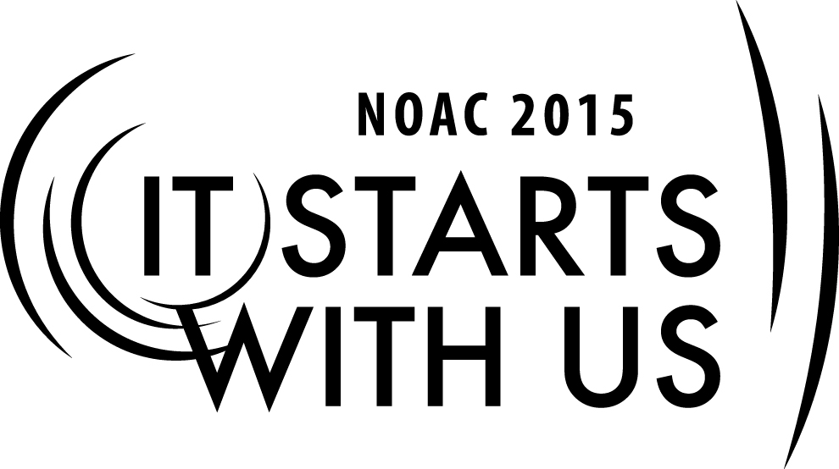
DUCT TAPE Youth Leadership - Section #3
2015 National Order of the Arrow Conference
Session Length: 3 Hours
Although this cell is broken into three sessions they are not independent of each other. Each should be completed in the given order for the participants to get the most out of it.
Through this session, you will:
Explain: Learn some new ideas how to develop youth leadership.
Demonstrate: This session will demonstrate ways to implement these ideas.
Guide: Instructors will guide groups as they develop a purpose statement and SMART goals.
Enable: The participant will develop their own purpose statement and SMART goals.

This session will help the Section/Lodge/Chapter/Troop with the development of future leaders.

The theme of NOAC 2015 is “It Starts With Us”. This session will relay this theme in the following ways:
- 1) Learn some new ideas on how to develop youth leadership.
- 2) Break into groups and create a philosophy for the group
- 3) Develop SMART goals for each individual in the room
SESSION NARRATIVE

Developing A Mission Statement & Philosophy 50 Minutes

FOLLOWING THIS SESSION, EACH PARTICIPANT WILL HAVE PARTICIPATED IN CREATING A TROOP OR LODGE PHILOSOPHY. THEY WILL BE ABLE TO TAKE THIS SKILL BACK AND IMPLEMENT IT IN THEIR OWN TROOP, LODGE AND/OR LIFE.

Lecture: 15 Minutes

We will divide the class into groups of 6 to 10 people and each group will develop a mission statement and a philosophy for their group.

The Mission of Troop 43 is to train our youth in the skills of leadership and self-reliance using the principles outlined in the Scout Oath, Scout Law, the Outdoor Code and the Troop 43 Purpose Statement. The Troop will provide an opportunity and encourage each youth in the Troop to earn the rank of Eagle Scout.

Trainer Instructions:
Participants should be divided into groups of 6 – 10 people.
This session about 10 – 15 3 x 5 cards will be needed for each group. Pens or pencils should be provided so that each group can write on their cards.

Group Development: 15 Minutes

Each group will develop a philosophy
Title – The action that is important
Principle – Why we do it, why is it important
Implementation – How we do it in our group
Rank elements - most important first
One person will share with the class

Example of a philosophy
TITLE: Fun
PRINCIPLE: Scouting is fun with a purpose. Without fun we will loose the support of the youth. Without the youth there is no scouting. This does not mean that there is no work involved. Instead fun the reward for completing a task.

IMPLEMENTATION: Each campout has a set of objectives. When those objectives are completed the youth have free time to use as they please.

You will create your own philosophy

Presentations : 15 Minutes

Each group will be offered the opportunity to present ideas that they developed.

Conclusion: 5 Minutes

Troop 43 Philosophy...

1. FUN
- PRINCIPLE: Scouting is fun with a purpose. Without fun we will loose the support of the youth. Without the youth there is no scouting. This does not mean that there is no work involved. Instead fun is the reward for completing a task.
- IMPLEMENTATION: Each campout has a set of objectives. When those objectives are completed the youth have free time to use as they please.
2. BOY RUN - ADULT SUPERVISED
- PRINCIPLE: One of the main purposes of Boy Scouts is to teach each scout leadership. We are dedicated to making sure that the youth lead the Troop. Some Troops are adult led and this does nothing to further youth leadership. On the other hand some Troops which are “Boy Run” allow the boys to make to many mistakes. Adults should serve as “Trial Markers” along the trail of leadership. They should be silent but constantly pointing the proper direction.
- IMPLEMENTATION: Youth leadership in Troop 43 runs the meetings and teaches Scouting skills. Adults in Troop 43, help keep order in the meetings and teach Merit Badge skills. At camporees adults help run stations and do not generally accompany youth to the stations.
3. ADVANCEMENT
- PRINCIPLE: Advancement is how we measure how the program is working. It is our philosophy that each and every youth who enters Troop 43 will have the opportunity to become an Eagle Scout. We know that nationally only about 2% of youth will make it to Eagle Scout. We expect our average to be much higher.
- IMPLEMENTATION: We have been a Troop for 6 years. We formed the Troop with only 1 member who was not new. We have 10 scouts who have earned their Eagle, with 2 or 3 who will receive their Eagle this year.
4. CAMPING & OUTDOORS
- PRINCIPLE: Being outdoors is what Scouting is all about. It is outdoors where youth learn many of the skills of scouting. It is where they learn about nature and conservation. At Troop 43 we keep the “OUTING” in “scOUTING”.
- IMPLEMENTATION: We have a minimum of one activity each month. Most months more than one. In the winter we sometimes are inside. We participate in all council and district activities. This consists of Spring and Fall Camporees and Klondike Derby. We also have some camp outs that have become traditional.
5. SUMMER CAMP
- PRINCIPLE: Summer Camp is one of the most important camp outs of the year. It is by far one of the major contributions to the Advancement Aim of the troop. It also helps to build stronger bonds as they must interact with each other for a whole week, which is much tougher than interacting for two days. It also gives our youth a chance to make friends with people from other troops as they meet and work with them in merit badge classes.
- IMPLEMENTATION: We go to summer camp the 1st full week after the 4th of July. This is also the week of the 3 Rivers Festival (actually this is currently not true). This is one of two events which scouts can apply money from their fund raising accounts.
6. HIGH ADVENTURE
- PRINCIPLE: One problem scouting seems to have is retention of older boys. One way to keep older youth interested is to offer challenging and dramatic events. Many troops offer such trips but limit them to only older boys. We try to offer such trips and events without limiting them to older boys.
- IMPLEMENTATION: We have hiked the Appalachian Trail for 3 years. We hike a little over 50 miles so that each youth will earn his 50 miler patch. We also set aside a day to do a whitewater rafting trip.
7. INTERESTING TRIPS
- PRINCIPLE: Another way to keep youth coming back is to provide interesting trips. Youth need to be exposed to challenges to their minds as well as their bodies.
- IMPLEMENTATION: We regularly hike the Appalachian Trail which provides an opportunity for long term hiking and to provide activities to explore in the area. We also regularly visit Buffalo, NY and Niagara Falls and sleep on the USS Little Rock in the Buffalo Harbor.
8. OA
- PRINCIPLE: Order of the Arrow is the “Brotherhood of Cheerful Service”. This organization provides another outlet for rounding out the youth to become a valuable member of society. It teaches youth how to work together to give service to others.
- IMPLEMENTATION: Our troop is very active in the OA. Troop 43 has provided the a Lodge Vice-Chief; Chapter Chief, Vice-Chief and Secretary. We have provided a ceremony team to do the Pre-Ordeal and Ordeal Ceremonies and done several Cub Scout Crossovers.
9. GOOD REPUTATION
- PRINCIPLE: A true measure of how well any program is doing, is to see how others measure your results.
- IMPLEMENTATION: We have placed in the Top Ten of Boy Scout Troops for the Thunderbird District in every year since it has been formed. We have been asked to represent the council at the Kid’s Fun Fair, represent the council at Red Cedar Camp for their Handicap Camp Day, and to do the flag Ceremony at the opening game for the Fort Wayne Fury. We have also ran the Fall Camporee in 1998, 2006, 2008, 2013 as well as the Klondike Derby in 1999, 2000, and 2015.
10. HIGH PARENT INVOLVEMENT
- PRINCIPLE: Time is the one thing that we have no control over. For a parent to invest time with their child is better than all the money in the world. When a parent takes the time to invest in the scouting program, the youth will see it as more important as well.
- IMPLEMENTATION: Parents are encouraged to attend all camp outs, to attend meetings and to teach merit badges. They are also encouraged to take leadership roles in the troop. This should be done in a way not interfere with the youth leading the troop. On most trips adults do not pay anything when they drive.
11. SERVICE
- PRINCIPLE: Another major goal of scouting is to teach youth the personal esteem boosting that comes with helping others. This is reflected in our slogan, “Do a good turn daily”.
- IMPLEMENTATION: We do various projects throughout the year. These include work on Eagle projects, projects for Brookside Church as well as other churches, and other miscellaneous projects such as helping a person move into a new house.
12. FUND RASING
- PRINCIPLE: Another way to build a sense of worth is to have youth raise money to help build the troop.
- IMPLEMENTATION: We have several fund raising projects during the year. We sell popcorn in both the spring and the fall. We also work at the Black Forest in October. For each of these events the youth receives half of the amount that the troop receives which is placed in an account that can either be used for Summer Camp or the Appalachian Trail.
13. UNIFORM
- PRINCIPLE: The uniform is used in scouting to remind each of us that we are a part of an organization much larger and bigger than ourselves. It makes us remember that we must live up to the high standards and ideals of scouting. It also shows others who see us in our uniform that we are a part of scouting.
- IMPLEMENTATION: All youth are expected to have the uniform from the belt up. Adult leaders are also expected to wear the uniform as well. While Scout pants and socks are optional, it is strongly encouraged that they own and wear them at all meetings and outings. Uniforms are expected to be worn at all meetings and during travel to outings. Uniforms are also expected to be worn during events on Camporees. Usually we are more casual on the trip home
14. BOYS’ LIFE
- PRINCIPLE: Boys’ Life has been the magazine for scouting for 80 years. It is filled with ideas for new trips and reinforces the principles of scouting. It is important for all boys to be exposed to Boys’ Life.
- IMPLEMENTATION: All families are required to get Boys’ Life. It is figured in as part of the dues. It is hoped that the youth of the troop will take the time to read it.
15. MONEY
- PRINCIPLE: A scout is thrifty. Each scout should do as much as possible to pay for his own scouting. The implementation for this is left up to the parent.
- IMPLEMENTATION: Generally, a fee is collected for each camp out. While we try to keep the fees as low as possible, no youth will be turned away because he or his parents cannot afford it. The two most expensive trips, Scout camp and the Appalachian Trail can be paid for by money raising on the part of the scout himself. The council also provides money for camperships for those scouts that cannot afford to go to camp otherwise.
16. GO BAGS
- PRINCIPLE: Go bags are bags that contain stuff that scout s will need for every campout and in emergency situations.
- IMPLEMENTATION: Each scout is expected to have his own personal go bag and bring it to all meetings and campouts.
TRAINER PREPARATION

The trainer should have a complete grasp and a strong belief of the DUCT TAPE principles. The trainer should be well spoken and very knowledge of effective youth leadership operations.
Appendix Resources:
- Computer and projector
- DUCTTAPE3.ppt – Power Point Presentation
- Rolls of duct tape to make name tags
- 10 to 15 - 3 x 5 cards per group.
- Extra pens or pencils that might be required.

