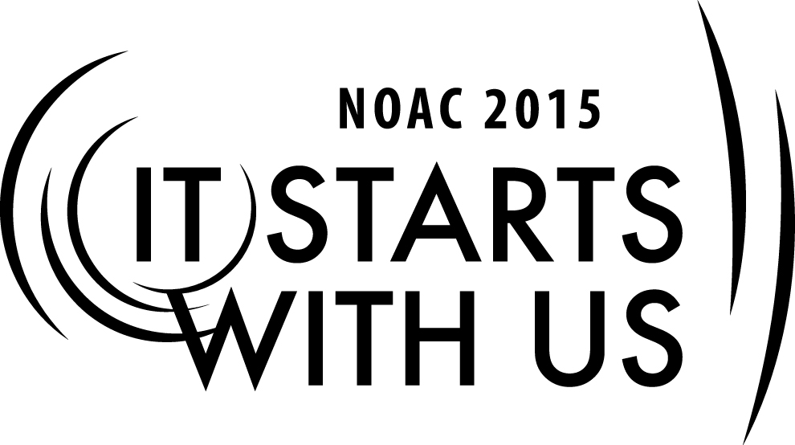
Dynamic Inspiration: Recognition
2015 National Order of the Arrow Conference
Session Length: 50 Minutes
Through this session, you will:
Explain the different recognition awards in the Order.
Demonstrate how effective recognition is key to retention.
Guide participants through ways recognition is used.
Enable participants to know the meaning and purpose of recognition.

This session will help the Lodge with the Journey to Excellence Requirement(s): 3: Membership Impact, 4: Membership Retention, 16: Leadership Development.

The theme of NOAC 2015 is “It Starts With Us”. This session will relay this theme in the following ways:
- By teaching how to use recognition as a motivation and leadership tool for building better teams.
SESSION NARRATIVE

INTRODUCTION 7 MINUTES

Trainers will introduce themselves to the group. The first step to understanding recognition and how an organization can benefit from it is to understand what recognition is. Who is it for? Is it simply for the person receiving it? Aside from the obvious, recognizing the efforts of an individual, what purpose to recognition have in our homes, our schools, our jobs, our society? [Whiteboard is labeled with four columns “Home, School, Work, Society.” The group is prompted to provide examples for each category.]
The list can contain any number of items. Ones to steer towards “The Home Refrigerator, Honor Roll, Employee of the Month, The Academy Awards.” For each item listed, ask the group why that award exists, and what it does for the individual and the group. The discussion should steer towards three key points: Reward, Inspire, Pride. [Write on the whiteboard, “Reward, Inspire, Pride,” in three rows.]
Trainer Instructions: This is an appropriate time to introduce yourself to the group. Only list accomplishments relevant to the training at hand – this is not a time to list your entire Scouting history.

THE KEYS OF RECOGNITION: 5 MINUTES
Trainers explain the three key elements of recognition:
- Reward: Recognition is often given to reward an individual or a group for the work they have already done. It can be given for uncommon effort or for a prolonged period of unsung heroism. The reward can be bestowed either privately or publicly, in small or large actions.
- Inspire: Recognition serves to inspire both the person receiving it, as well as the people around him or her. To recognize the simple things a person does will help motivate them to build, grow, and advance themselves. To make a public display of a person’s achievements, inspires other members of the group to achieve themselves.
- Pride: Recognitions give pride to the individual as well as the group. For the person receiving recognition, it boosts self-esteem and morale. For the group, seeing others or the group receive recognition makes the body of members feel collective pride.

In any environment, recognition is important to keep the group motivated and morale high. But recognition doesn’t always have to come in the form of shiny plaques or fancy awards. The simplest form of recognition costs nothing and comes with a speech of only two words. “Thank You.” Gratitude is the simplest and most effective form of recognition and should be constant. For those in leadership roles, never forget the power and importance of being grateful for the work your fellow lodge members do.

OA RECOGNITION: 30 MINUTES
Break the group into smaller buzz groups, making sure that each group has at least three members. Assign each group a national award from the below list:
- Vigil Honor
- Distinguished Service Award
- Founder’s Award
- Lifetime Achievement Award
- Red Arrow Award
- E. Urner Goodman Camping Award
- E. Urner Goodman Scholarship Fund
- Leadership in Service Award
- National Service Award
- OA Triple Crown Award
- Innovation Award
- Maury Clauncy Indian Campership Fund
- OA Service Grant

Give them five to seven minutes to come up with a mini-presentation (2-3 minutes) for the whole group using any resource they can find – many of these awards are described on the web, or you can bring in materials for them to consult. Each presentation should hit the following points:
- What is the background of the award? (When was it founded and why?)
- Who is eligible for the award?
- How and why is it awarded?
- What does the award do to inspire and motivate the individual and the group?

Make sure the groups know each member will have to contribute in some way. Inform them that there will be recognition for the best presenter of each group as well as the best group presentation, so be creative and have fun.

After the prep time is complete, have the groups present. [Award the best presenter of each group with a piece of candy and the best presentation group with a whole bag.]

DISCUSSION AND WARNING: 8 MINUTES
After the presentations, open up a group discussion for additional forms of recognition their lodges use. Creative awards, thank you letters, special dinners for committees. Do not let this discussion go for more than a few minutes.
Lastly, the warning on recognition: Recognition can have undesired side effects. It can divide the group by drawing attention to an individual. It can create unhealthy competition among group members or even different groups. It can create “Award Hawks” or people who only do what they can to receive awards and do not have the interests of the group at heart. All of these can contribute to the double-edged sword of recognition. This can be avoided by making sure that recognition is a constant process, given to all individuals, not just a select few at awards banquets. A thank you, a handshake, an email can go a long way in ensuring that all members feel appreciated and motivated. Make sure that the individuals you do single out for awards are worthy, that they are in it for the right reasons, and that bestowing that honor will inspire their service to continue, not give them a reason to bail out. Recognition should be a good thing for everyone, is a vital component to running a volunteer organization, and should never be divisive or create jealousy in the group.
TRAINER PREPARATION

Trainers should compile the complete list of recognition awards given across the OA, and have packets ready with information on each award to be given to the participants. They will be broken into smaller groups and use these packets to present to the rest of the session the background of each award. The list should include: The Founder’s Award, Leadership in Service Award, Vigil Honor, Distinguished Service Award, E. Urner Goodman Camping Award, Josh Sain Memorial Scholarship Fund, Lifetime Achievement Award, Maury Clancy Indian Campership Fund, National Service Award, OA Service Grant, and the Red Arrow Award. Information on each can be found at www.oa-bsa.org.

Trainers should also familiarize themselves with the concept of recognition and how it helps with advancement and retention.

