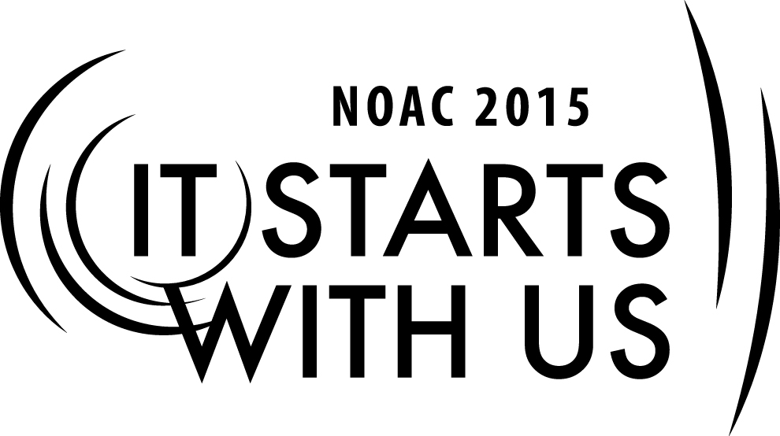
Creating the Cutting Edge Conclave – Incorporating Thematics

2015 National Order of the Arrow Conference
Session Length: 50 Minutes
Through this session, you will:
Explain the importance of, and how to develop an exciting Conclave theme
Demonstrate how to integrate your theme into all elements of your Conclave
Guide brothers in designing the thematic elements for a simulated Section Conclave
Enable Arrowmen to create a cutting edge Conclave that educates and inspires

This session will help your Lodge/Chapter/Section understand how to develop and integrate an exciting theme into your Conclave that will make it enjoyable, fun and memorable for years to come.

The theme of NOAC 2015 is “It Starts With Us”. This session will relay this theme in the following way:
- An essential element of a cutting edge conclave is the central theme which unites the whole event. As each Arrowman leaves their Conclave, they bring home new ideas, inspired to lead and serve. By implementing and communicating these learnings with other brothers in their Chapter or Lodge, a ripple effect takes place. Chapters improve, which enhances the Lodge, and leads to a better Section

Trainer Tip: Each Section runs their Conclave differently. It’s important for you to be open to different ideas from around the country. When a discussion occurs, please keep in mind there are no wrong ideas – only lots of right ones. Keep the conversation going forward. You’ll find people are taking notes and capturing new and exciting ideas they can bring back to their chapters and lodges
SESSION NARRATIVE

Introduction to Themes 10 Minutes

This session is titled, “Shows and Thematic Elements”. Let’s begin with a simple question. Who can tell me the definition of a “theme”?

Ask a few brothers and then suggest the following possible answers taken from different dictionaries:
- a unifying or dominant idea
- the subject of a talk, a piece of writing, a person's thoughts, or an exhibition
- the main subject that is being discussed or described in a piece of writing, a movie, etc.
- the particular subject or idea on which the style of something is based

With the different definitions of a theme in mind, let’s apply it to a Conclave. To start off, here are some Conclave themes from different sections around the country.
NE-2A From the Island to the Summit, the Legacy Lives On
NE-6A A Future Founded in Tradition
NE-1 The Spirit Lives On
C-6A In the Spirit of the Past
W-1N A Journey's End, A New Beginning
SR-9 You Will Need a Brighter Fire

On a larger stage, here are the themes for NOACs dating back to 2000.
2000 Bound in Brotherhood, Led By the Spirit
2002 Test Yourself, and So Discover
2004 Chosen to Serve, Inspired to Lead
2006 The Legend Lives On
2009 The Power of One
2012 United, We Leave a Legacy
2015 It Starts with Us

Let’s take a closer look at how to develop an exciting theme by using a couple of NOACs as examples.

In 2009, the theme was “The Power of One”. It took a lot of thought by a lot of different people to finally decide on the theme and put the whole event together. But how did it all start?

The first step is to identify the “learning objective” for the event.

For NOAC 2009, the objective was that “one person has the power to make a difference.” Does anyone remember the Liberty Mutual commercials from a few years ago? They show a series of one person helping someone else, and then that person helps someone else. You see several of these commercials now with the underlying theme that a helping hand is contagious. Giving is receiving. From this objective, a theme of “The Power of One” was born.

For NOAC 2015, the conference’s learning objective is to create tomorrow with action today. Our actions, or inactions, define what tomorrow looks like. The book on the OA’s first 100 years is written – but what the OA, Scouting, and the world looks like tomorrow is based completely on what we choose to do today.

The theme this week, “It Starts with Us”, is a message to all of us that we are the beginning of something bigger; a drop in a large ocean of humanity, from which ripples extend in every direction. The nature of that ripple: singular, collaborative, positive or negative, is entirely up to each of us.

Developing a Theme 5 Minutes

We’ve taken a look at a great collection of themes from different Conclaves and NOACs. Now let’s examine and list some of the important aspects of a theme.

A Conclave theme should:
- Establish a unifying idea for the whole weekend
  - It unites everyone’s thoughts and expectations for the weekend. Each successive activity should reinforce or build on the theme as the weekend progresses.
- Pass on a Scouting or OA ideal
  - A good theme teaches Arrowmen one or more Scouting ideals. It can be a line or phrase from the Ordeal ceremony or some other ideal in the OA that the audience has already encountered. Choosing a phrase the audience is already familiar with helps them realize and understand what the line meant when they heard it for the first time.

    - NOAC 2004 – “Chosen to Serve, Inspired to Lead” reminds us that we were chosen from amongst our peers, and still have an obligation to them and through this experience in the OA many have been inspired to lead others

- Provide a practical application of a Scouting or OA ideal
  - The best way to relate an ideal to a group is present an example that they can relate to in their everyday life (at work, school, sports, etc.).
- Be easily understood and related to often throughout the weekend
  - Abstract themes are difficult to apply.

Incorporating the Theme into your Shows 10 Minutes

One important aspect of a successful Conclave is the opening and closing shows. The purpose of a show is to relate the theme of the weekend and pass OA and Scouting ideals back to Arrowmen, all while having fun. Talk about a win-win situation!

On Friday night, brothers from all Lodges in the Section arrive with great anticipation and energy. The opening show funnels everyone’s excitement by setting the stage for the weekend. The Conclave theme should be on display and apparent. All the promotion and advertisement leading up to the Conclave has been great, but the opening show brings it all to life. The learning objective may not be apparent at this point, but will be reinforced throughout the weekend.

After an action-packed weekend, the closing show is a perfect opportunity to put a ribbon on the whole event. Baden-Powell called Scouting, “a game with a purpose”. Each Conclave activity had a purpose which tied back to the learning objective. Sometimes it was just to have fun, improve Lodge spirit with inter-Lodge competitions, or learn new tools in the training cells. The closing show may be an end, but it’s also a beginning. Arrowmen are going home with new skills, friends and memories that can be shared with the other brothers in their chapters and lodges.

Ask a few different brothers in the session the following questions. Move onto the next question once you’ve heard a few good answers.

Raise your hand if you’ve been to a Conclave.
- Has anyone ever attended a memorable Conclave show – either the opening or closing?
- What is it that you remember?
- What made it good, or what made it bad?

Now let’s consider what makes a fantastic show. A quality Conclave show is one that relates the theme for the weekend in a creative way, and is fun and informative for everyone. When you enjoy a show, you’re more likely to remember it for years to come. When designing your shows, they should include the 2 S’es – showmanship and spirit.

Showmanship and Spirit – remember the CIA
- C = creative
  - Keep the show from being a repetition of something that’s been done before. Stay away from things the audience may find boring. You want them to remember and talk about this Conclave for years to come. Forget about the food, it’s the shows they’ll remember.
- I = interesting
  - The show shouldn’t be too much like a lecture. Incorporate subtle hints and references to the theme throughout the show that can be summed up and made clear at the end.
- A = action
  - The more action there is, the more they’ll remember the show. Try to make good use of the elements of any good movie or play such as conflict and plot. Use theatrical elements such as music, sound, props, costumes, scenery, and lights. The Conclave show should be a step above a regular campfire program.

Integrating your Theme 20 Minutes

The learning objective and resulting theme becomes the central hub of a successful, memorable, and integrated Conclave. Each committee and all aspects of the Conclave are impacted by the theme. Think of it as a giant wagon wheel with the theme in the middle and each of these areas at the end of the spokes.

Trainer Instructions: The following exercise enables the class to take a sample theme and apply it to the various components of a Conclave.

It begins with a group exercise of listing the different areas of a Conclave. These will be divided up and assigned to the sub-teams in the next step.

Now we’re going to do an exercise which enables you to take a sample theme and apply it to the components of a Conclave.

To begin, let’s create a list of the various areas that need to be considered and planned for a successful event. A couple of examples to get us started include training, publications and branding. (5 minutes)

- Publications – all printed materials
- Training
- Activities and program
- Registration
- Physical arrangements
- Trading Post
- Patches
- Signage – all visuals
- Quotes
- Video / audio
- Promotion
- Branding
- Meals – napkins, decorations, banners, food, kitchen decorations
- Guest speakers
- Staff, Lodge Chiefs wear something related to the theme
- Songs, music
- Videos/skits at meals
- Shows

Trainer Instructions: After the class has exhausted their list, you can identify any areas not mentioned.

Pass out the Exercise handout which lists the areas above, along with blanks for additional areas identified by the class.

The handout you just received lists some of the areas we identified. We’ll use these in our Conclave planning, along with a sample learning objective and theme. We’ll break up into groups for the next part of the exercise.

The assignment is to document ways to apply the theme to each area. Some examples are provided on the handout to get you started.

You’ll have 10 minutes for this part and 10 minutes for the team reports.

Trainer Instructions: Divide the class into groups and assign each team a number. Write the team number in front of each area so you know which team was assigned each area.

After 10 minutes, ask one person from each team to report their work. (10 minutes)

The Exercise results sheet shows possible answers to share as part of the report out.

This exercise was meant to show everyone how the theme can be incorporated into all elements of your Conclave. These different thematic elements all support the event’s learning objective.

Summary 5 Minutes

The Conclave has been a complete success! The food was great, the weather was perfect - everything’s gone as planned. Months of preparation by all the Lodges, and especially the host Lodge, has resulted in a Conclave to remember. The training cells, games, activities, competitions and fellowship have all been a home run.

Everything began almost a year ago with a learning objective, which led to a theme for the event. This theme has been at the center of all planning – a backbone for success. All the events, activities, shows and competitions were related to and reinforced the theme.

Arrowman are leaving with many takeaways – handouts, patches, awards, memories and new ideas. The task now falls to each of the brothers who attended. Take your experiences and make a difference. Share them and more importantly – use them. Your actions will have a major impact on what our tomorrow looks like.

TRAINER PREPARATION

The trainer selected for this session should have experience as a Section Chief, Section Vice Chief, or
Conclave Vice Chief. The trainer should also be able to relate personal experiences from designing and running a training program, and should have knowledge of the many different types of trainings available.

Create slides of the required presentation materials using the templates included in the appendix.
They can be input into a PowerPoint presentation, typed onto transparencies, or written on flipchart pages.

Review the different sections in the narrative below, and create note cards or pages to use during the session. Do not work directly from the narrative as it will detract from the session.

Trainer Tip: When creating your notes, be sure to include the guiding principles and headlines (noted in bold in the narrative) and specific phrases that should be conveyed (noted in italics in the narrative).

You may wish to have sample training schedules and session lists available, as well as lists of activities and show outlines. These items aren’t required, but will help enhance the participant’s experience and ensure they leave with plenty of ideas.
Appendix Resources:
- Flipchart and markers.
- Laptop and LCD projector with Power Point presentation (or alternately an overhead projector with transparencies)
- Exercise and Exercise Results handouts
- Liberty Mutual Commercials
  - Example #1: https://www.youtube.com/watch?v=wMwoexR1evo
  - Example #2: https://www.youtube.com/watch?v=Iw97CfZtyGw

