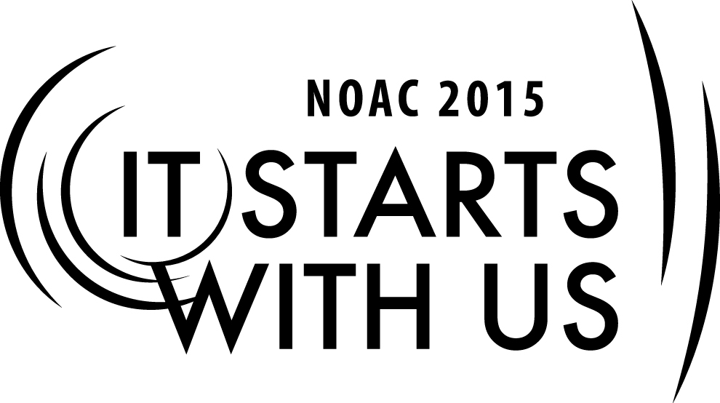
Cell Name: Creating the Cutting Edge Conclave – Planning and Developing Conclave
2015 National Order of the Arrow Conference
Session Length: 50 Minutes
Through this session, you will:
Explain the importance of, and how plan and develop a Conclave and all that it entails
Demonstrate how to plan specific areas of a Conclave program (i.e. activities, training, shows)
Guide brothers in the areas to focus on, the questions to ask, and where to go to get help
Enable Arrowman to create a cutting edge Conclave that educates and inspires

The theme of NOAC 2015 is “It Starts With Us”. This session will relay this theme in the following ways:
- An essential element of a cutting edge conclave is the central theme which unites the whole event. As each Arrowman leaves their Conclave, they bring home new ideas, inspired to lead and serve. By implementing and communicating these learnings with other brothers in their Chapter or Lodge, a ripple effect takes place. Chapters improve, which enhances the Lodge, and leads to a better Section

Trainer Tip: Each Section runs their Conclave differently. It’s important for you to be open to different ideas from around the country. When a discussion occurs, please keep in mind there are no wrong ideas – only lots of right ones. Keep the conversation going forward. You’ll find people are taking notes and capturing new and exciting ideas they can bring back to their chapters and lodges
SESSION NARRATIVE

Getting Started
To begin the session, introduce yourself, lodge name, council name and state.

Next have everyone introduce themselves. Each Arrowman should share their name, lodge, home council and state. (Note – you may skip the participant introductions if it’s already been done in the earlier sessions of the cell.)

Introduction 5 Minutes

Aside from NOAC and the jamboree, section conclaves are one of the largest scout gatherings for both the Boy Scouts and for the Order of the Arrow.

What is the purpose of the conclave? What are the benefits to the lodge?
Trainer Tip: At this time, flip to a clean flipchart page, and field responses. When pages are full, post them around the training room to remind participants of the purposes

Some of the purposes of the conclave are to:
- Provide a plethora of training opportunities to lodge leaders.
- Provide a forum for lodges to share ideas and best practices.
- Provide ideas and information on new programs developed by the Order.
- Provide lodge members to an opportunity to meet section, regional, and possibly national officers.
- Provide an opportunity for lodge officers and members to have fun and memorable weekend.

It is very important to remember that the activities that take place at the conclave and the knowledge imparted on its participants have a significant impact on lodge program.

Planning and Schedule 5 Minutes

With so many things to plan and so many people involved, it is important to develop and strictly follow a back-dater in planning the conclave. A back-dater is a schedule which counts backwards from the conclave (day 0) to the date conclave planning begins. Advise that it’s necessary to have a long term plan and a back-dater is a most useful way to facilitate planning.

What are some important events or key planning dates that would be included on a back-dater?

Accept 5-10 answers from the participants, then continue below.

We can’t possible present all of the different schedule options that different sections across the country use, so we’re going to give you a couple samples, and though the times may not be what your section uses, it will serve as a good example for us.

Before we hand them out, though, let's brainstorm important events that need to be on our schedule.
While you may think your section’s schedule is set, it probably isn’t and changes can bring new life to a
Conclave. So what occurs Friday night?

Accept a few answers from the participants, then request ideas for Saturday, and then Sunday morning, and then continue below. Then review the sample schedule and see if anything was missed. Hand out one or two sample schedules, quickly review the important parts, and point out anything the group may have missed. Be sure to take any questions.

Helpful hints for planning a successful conclave:
- Regular communication (Communication Plan)
- Conclave promotion (Marketing and Promotional Toolkit)
- Develop and foster a “Conclave Culture” within the Section
- Define roles and expectations of Section Officers, Council of Chiefs, Conclave Vice Chiefs, and Service Lodge

Program (Training, Activities, Shows) 10 Minutes

Program is the heart of every conclave, and during this session we’re going to talk about three key portions of that program: training, activities, and shows. Each of these things can make or break your conclave.

Whether it’s training or activities, the one thing you’ll hear me repeat throughout this session is you must have something for everyone. Though the conclave is really for the youth, there should be training and activities for the adults too. For the youth, there should be options for both younger and older scouts. Similarly, there are different types of adults (some active, others less active); your conclave program should have activities to support all types of Arrowmen and foster their development.

To start the session off, I’d like to hear some memories of things that have gone wrong with training, activities or shows at past conclaves you’ve attended. You don’t need to give us a whole story, just a couple words which describe the problem.

Keep these bad memories in mind as we spend the next 45 minutes planning these portions of the conclave. They help to highlight what will happen if you don’t take the plans that we’ll discuss today and carry through on them.

Training 5 Minutes

Training isn’t always the thing participants leave a conclave remembering, but it is the one thing that can help strengthen our lodges and build better leaders. To make sure all the lodge leaders, both youth and adult, young and old, are interested and have new ideas to bring back to their lodges, it is important make sure the training sessions cover a wide variety of topics and knowledge levels.

There are two different ways training can be run, and though it may be unlikely your section will change, it is important to understand both options. The first is simple open sessions; a certain number are offered each hour and participants can select a completely different class each hour.

The second used by about half of the sections is ‘university’ style training. In this setting, participants select a path, usually containing set classes on similar subjects and sometimes containing some options, called ‘electives’. At the end of training, depending on the path they selected, participants can earn a ‘degree’ in that subject.

In this session, we just want to provide an overview of training programs to consider. We will do a deep dive into each training program type during a separate focused training session

Activities 10 Minutes

The next area of the conclave we are going to discuss is activities. Some sections have a show on
Friday night while some run activities then, and all sections have activities on Saturday afternoon. You should use the ten minutes that we spend discussing this topic to gather as many ideas as you can to bring back to your section. New activities are always exciting and can bring new life to a conclave which has had the same activities for years.

Since this is all about you sharing your ideas and experiences, we’re going to break into different groups now, and I’m going to give you a type of activity. You should report back with a list of activities (around five) you have come up with for that topic, and a short description of each.

Assign each group a type of activity:
- American Indian
- Camp-related (swimming, etc.)
- Game shows
- Food competitions
- Sports, lodge competitions, etc.

Give the groups five to eight minutes to choose their activities, then have each group share their plan with the group. When all the groups have presented, continue below.

Shows 10 Minutes

Our last topic in this session is shows. This can be the most memorable part of the conclave or it can be the biggest flop – I’ve seen both and you probably have too. It can be a very simple show like a
Camporee would have or it can be as elaborate as a NOAC stage show. It is important to provide the right kind of show for your audience and to do something different each year. Let’s start by listing the broad types of shows you can have.

Accept 5-10 answers from the participants, then reveal the full list and point out any types the group missed.

Now that we have some types of shows, let's share one or two ideas in each of these categories. Who has an idea?

Accept a couple answers for each type, then move onto the next until the list is completed, then continue below.

Conclusion and Questions 5 Minutes

We’ve talked about training, activities, and shows. Hopefully everyone has a list of new ideas to bring home to use at your upcoming conclave. We’ve talked about many different types of things you can do at a conclave, but it’s important to remember that when you’re planning any of these areas, you should provide a well-rounded list that is fun and engaging to everyone who is in attendance. If you do this, everyone will have a great time and it will be a conclave to remember.

TRAINER PREPARATION

The trainer selected for this session should have experience as a Section Chief, Section Vice Chief, or
Conclave Coordinator. The trainer should also be able to relate personal experiences from designing and running a conclave, and should have knowledge of the many different types of conclave events available.

Create slides of the required presentation materials using the templates included in the appendix.
They can be input into a PowerPoint presentation, typed onto transparencies, or written on flipchart pages.

Review the different sections in the narrative below, and create note cards or pages to use during the session. Do not work directly from the narrative as it will detract from the session.

Trainer Tip: When creating your notes, be sure to include the guiding principles and headlines (noted in bold in the narrative) and specific phrases that should be conveyed (noted in italics in the narrative).

You may wish to have sample training schedules and session lists available, as well as lists of activities and show outlines. These items aren’t required, but will help enhance the participant’s experience and ensure they leave with plenty of ideas.
Appendix Resources:
- Flipchart and markers.
- Laptop and LCD projector with Power Point presentation (or alternately an overhead projector with transparencies)
- Back-dater/schedule examples handouts
- Exercise and Exercise Results handouts

