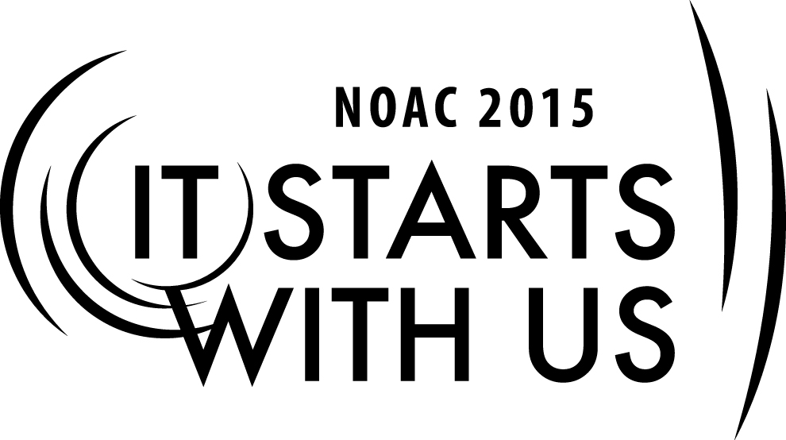
Chapter Operations: OA Involvement in the District
2015 National Order of the Arrow Conference

Session Length: 50 Minutes
Through this session, you will:
Explain what a BSA District structure is and how your OA Chapter fits in and what your Chapter’s responsibilities are within your District.
Demonstrate how your Chapter can find new opportunities or enhance existing programs within your District.
Gain an understanding of areas that OA members can enhance the program of your District’s Cub Scout Packs, Boy Scout Troops, Venturing Crews, and Ships
Enable participants to make a visible difference with how their chapter participates in their district

This session will help the Lodge with the Journey to Excellence Requirement #11

The theme of NOAC 2015 is “It Starts With Us”. This session will relay this theme in the following ways:
- By challenging the guests to develop future activities in the District that will involve the OA

SESSION NARRATIVE
Introduction 2 minutes
Who we are and why we are here.
Brief introduction of the presenters and where they are from as well as their OA and Scouting backgrounds
Who are you and why are you here.
You are Arrowmen, just like us, who are ready to learn more about OA within their district.
It Starts with Us.

Topic #1 BSA District Structure - What it Contains 5 minutes

- First, understand that your district is one of several that belong to a council
show a couple of example councils and how the districts are divided between them on extra slides
- A District contains Scouting Units such as Cub Scout Packs, Boy Scout Troops, Venturing Crews and Ships. These scouting units are normally serviced by one or more DE’s (District Executives) that work for the local council as well as dozens (if not hundreds) of volunteers that provide the scouting experience at the unit level or as a district volunteer.
show extra slide of example district structure

Topic #2 BSA District Structure - The OA Chapter 5 minutes

- Your Chapter is a part of a District and covers the exact same scouting units.
- It is run by elected youth volunteers with the backing of volunteer advisors who are guided by the lodge as well as the district committee.
- Each scouting unit that participates (not Cub Packs for example) will have one or more youth leadership positions established as the OA Troop Representative as well as an assistant scoutmaster who is assigned as that troop’s OA advisor.
- These representatives normally attend chapter meetings and are the communication pipeline back to the units.

Topic #3 BSA District Structure - Chapter Responsibilities 5 minutes

- Number one responsibility is to promote camping.
This is accomplished in several ways such as promoting at district roundtable meetings, during unit visitations and by the nature of our membership eligibility rules and induction methods.
- Promote OA Troop Representative Leadership Position and encourage each troop to participate in chapter activities.
- Provide “loaner” leadership teams to give struggling troops a boost
- Additional responsibilities include helping with district program.

Topic #4 Discover New Opportunities within your District 15 minutes

- What else? There are endless possibilities.
- Volunteer to help or better yet run district events
- Camporee or Klondike Derby
- Staff Cub Scout Day Camp
- Run the annual District Pinewood Derby Race
- Provide training and demonstrations at district roundtable meetings
- Help serve and cleanup during annual district volunteer recognition dinner

- Make a visible difference as an Arrowmen during these events

Topic #5 Discover New Opportunities within your District’s Units 15 minutes

- What about our district’s scouting units? Again, there are endless possibilities for arrowmen to make a difference.
- How?
  - Provide temporary leadership for new or struggling boy scout troops
  - Provide a unique activity or game to a troop during a unit visitation
  - Provide the go-to ceremony team for Cub Scout programs such as award presentations, webelos awards and crossover ceremonies.
  - Visit a cub scout pack meeting and provide or assist with opening flag ceremony
  - Provide tailored leadership training to new troop leadership

Conclusion 3 minutes
- It Starts with Us
- Maybe your chapter isn’t doing all of these items for your district or units; or maybe you aren’t doing any of them.
- Choose one or two that you can tackle in a given timeframe. AND
- Do a good job at them.
- Stage your effort so that OA will be the go-to group of scouts to keep these OA sponsored activities or service projects going year-after-year.
- It Starts with Us

Activity / Challenge Remaining time
Trainer Instructions: break the class into groups that will contain 4-6 members.
Challenge each group to come up with two additional district or unit activities that would be appropriate for an OA Chapter to assist with or run. These are ones that are not on the previous slides and haven’t been mentioned or discussed yet.

TRAINER PREPARATION

