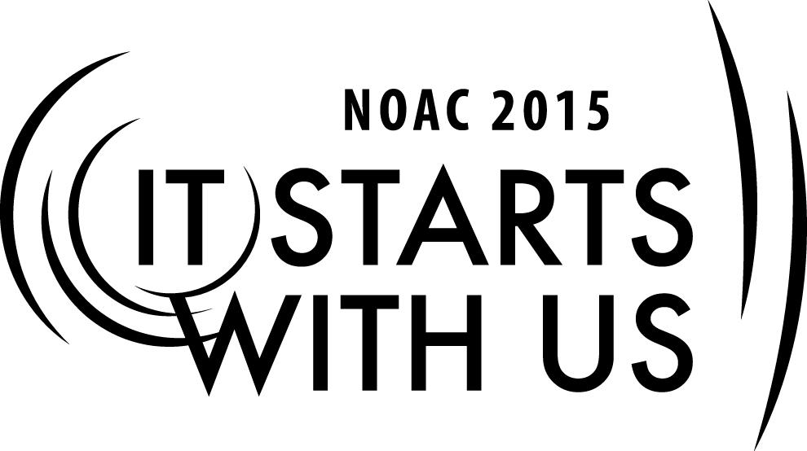

**Chapter Operations**: Chapter Leadership Experience

2015 National Order of the Arrow Conference

**Session Length: 50-55 Minutes**

Through this session, you will:

**Explain:** the roles of leaders within the Chapter, modes of effective communication, and how to access resources.

**Demonstrate** how to effectively communicate with others.

**Guide** guests in developing positive interactions between Leaders and advisers, and in mapping out the role of youth leadership.

**Enable** guests to develop chapter leadership models that best suit their own chapter.

This session will help the Chapter with the Journey to Excellence Requirement(s)

Item #4: Membership Retention - Improve the retention rates of lodge members.

Item # 16: Leadership Development - Conduct at least one LLD during the year with qualified instructors using current materials.

The theme of NOAC 2015 is “It Starts With Us”. This session will relay this theme in the following ways:

* You will reexamine the Purpose and Mission of the Order of the Arrow, in how it relates to your own chapter’s leadership.
* You will develop an understanding of the chapter structures and leadership roles, and will be able to share this knowledge with others.
* You will learn about effective modes of communication, which can be used in your own chapter.
* You will explore resources to enhance and maintain leadership in your own chapter.

**SESSION NARRATIVE**

**Introduction 6 Minutes**

-Introduce trainers (names, hometown, OA involvement)

-The mission of the OA is to fulfill its purpose as an integral part of the BSA through positive youth leadership under the guidance of selected capable adults.

-The Purpose of the OA, as Scouting’s National Honor Society is to:

* Recognize those who best exemplify the Scout Oath and Law in their daily lives and through that recognition cause other to conduct themselves in a way that warrants similar recognition.
* Promote camping, responsible outdoor adventure, and environmental stewardship as essential components of every Scout’s experience, in the unit, year-round, and in summer camp.
* *Develop leaders with the willingness, character, spirit and ability to advance the activities of their units, our brotherhood, Scouting, and ultimately our nation*.
* Crystallize the Scout habit of helpfulness into a life purpose of leadership in cheerful service to others.

**Trainer Instructions:** Write “*Develop leaders with the willingness, character, spirit and ability to advance the activities of their units, our brotherhood, Scouting, and ultimately our nation*.” on whiteboard or flip chart

-These elements are very important to consider in regards to the leadership of an Order of the Arrow Chapter. Leaders should strive to meet these outlined elements and we will give you some tools that can help in achieving this goal.

**Topic #1: Chapter Structure/Leadership Roles 10 Minutes**

-In order to have strong leaders within a chapter, it is important to first understand the structure of a Chapter, as well as the leadership roles within it.

* Explain equivalence between troops/districts/councils/areas and chapters/lodge/section/region and how the “chain of command” or offices are very similar.

**Trainer Instructions:** Ask guests what positions/officials they think should occur in a chapter, write them down. Good answers might include Chapter Chief, Vice Chief, Adviser, Ceremonies VC, Dance Team VC, Secretary, Treasurer, etc.

* Build flowchart of leadership showing how the chapter chief oversees vice chiefs, who each oversee their areas/committees. Also, secretary/treasure and other officers may report directly to Chapter chief or a VC.
* Describe relationship between Advisers and Officers. Chapter Adviser should work closely with the Chapter Chief in planning and normal chapter operations. Vice Chiefs should have an adviser specifically assigned to them as well. These advisers should report to the Chapter Adviser.
* Discuss responsibilities of various officers: Chapter Chief, Vice Chief, Secretary, Adviser
  + Chapter Chief: Oversees all other officers, leads chapter in day to day operations, creates agendas and works with other officers to plan meetings, attends district roundtables as a representative of the OA, acts as a role model for all other Scouts, corresponds closely with the lodge
  + Vice Chief: Assists the Chapter Chief, assumes duties as assigned, fills role of Chapter Chief in absence, may work directly with other committee heads or officers and report to Chapter Chief, serves as a role model for all other scouts
  + Secretary: records minutes at meetings, distributes information/agendas/minutes to chapter members, assists with communications
  + Adviser: Guides and works closely with the Chapter Chief, enables the Chapter Chief to run the chapter, holds discretion in regards to safety, finances, etc. Works with other advisers to ensure youth are properly supported and operations are within the guidelines of the OA and BSA
  + give other officer examples (VC of ceremonies)
  + explain that the structure is not a requirement, but rather a template
* Key 3 meetings (Chapter Chief, Adviser, D.E.): can be held to discuss the Chapters role within a district. Also can help to ensure that the Chapter is operating within the guidelines of the BSA

**Topic #2: Communications 7 Minutes**

-Communications are an element that many leaders and groups recognize as often being a weakness. Here are a few tips that can help chapter leadership establish effective communication methods.

* What makes an effective message
  + Clearly present facts, attention getter, keep it to the point, appropriate timing
    - Avoid excessively huge messages lacking content, people will skim it or overlook it entirely
    - Avoid sending out text messages during dinner time or very late at night.
* Phone tree example
  + Chapter Chief contacts vice chiefs, who contact members in their own committees or teams
  + Personal contact, but breakdowns can occur very easily if one person misses the message or forgets to make a call.
* Remind texting demo
  + confidential texting service available as an app or online. Send group messages with option to schedule times
  + option to use confidential chat
  + Free to use and to subscribe to
  + Classes (or chapter in our case) can have as many members as needed and all can be messaged at once
* Email
  + Pros: group emailing, easy to reply when convenient
  + Cons: no way to know that everyone saw the message, emails are often glanced at and forgotten
* Social media
  + Facebook or Twitter posts about events/activities that are upcoming. Easy to notify members prior to the event
  + Not private, so don’t post personal information
* Agendas/distribution
  + coordinated with officers to plan what should occur at the meeting and distributed 1 week before meeting to all members
  + Agendas can be posted online (dropbox, google docs, etc) so members can view or download them easily.
  + Distribute detailed minutes within 1 or 2 days of the meeting so members can recall what they may have signed up for, or mark down important dates.

-Effective communications can be the difference in a successful and struggling chapter. If members feel like they are included and knowledgable about what is occurring in the Chapter, they are more likely to be involved in its events.

**Activity 7 Minutes**

* Trial 1: select a “Chapter Chief” to organize the group based on a physical trait. Have that person tell the trainer what trait they have selected, and trainer immediately asks the Chapter Chief to organize the group starting now.
* Trial 2: Select a “Chapter Chief” to organize the group based on a different physical trait. Have the person tell the trainer what trait they have chosen, and the trainer will offer guidance/support to help the group do this. For example, the trainer may suggest where the group will be lined up
* For example, the chapter chief may choose to organize the group based on hair color. The adviser may suggest that they will help to discern where blond hair and brown hair members will gather, while the chief will discern where black hair and red hair members will gather. The chief will explain the task, and the adviser will help answer questions while the chief is working.
* Recap: which worked better? The role of the Adviser is not to do the job of the Chief, but to assist him and to offer guidance in his tasks. The Chief and Adviser may work closely as a team in a given task to ensure that it is completed as efficiently as possible.

**Topic #3: Running Meetings 10 Minutes**

-An effective meeting will help to retain members. If members feel valued and important within the chapter, they are more likely to continue attending chapter events, and event to invite other OA members to join them! Here are a couple ways to run an effective meeting:

* Get everyone engaged
  + Talk to members individually; Leaders showing interest in other and younger members can really make a difference in how the members feel valued within a chapter.
  + Begin the meeting with a brief activity that gets people moving and interacting.
* share responsibility
  + Give others opportunity to lead discussion
  + Vice Chiefs present info on their pre-assigned topics. Don’t surprise people, coordinate prior to the meeting.
* Encourage participation
  + ask people what their opinion is individually
  + Have all members vote on chapter decisions
  + Respect the opinions of others, to encourage others to participate. No one will want to voice their opinion if they are ridiculed.
* Plan with a plan
  + Outline what needs to be accomplished prior to the meeting.
  + move meetings along without needless delays, people get bored of stale conversations quickly.

-Effective meetings not only allow you to share information and make plans more efficiently, but it also encourages all of the members of a chapter to be involved and invested in the operations of the chapter.

**Topic #4: Resources 5 Minutes**

-Just knowing what resources are available to can enable a chapter leader to be knowledge about how the chapter is supposed to work. Additionally, leaders will be able to use these resources to help answer questions that they may not know.

* Chapter Operations Guide- Provides descriptions of officer responsibilities, chapter policies, and tips for running a strong chapter. Reference this for any questions you might have, especially about policies
* OA Handbook- provides history and context of the OA. Also gives descriptions and some policies related to the chapter and individuals membership.
* <http://www.oa-bsa.org/pages/content/publications> - website with all of the publications made by the Order of the Arrow. It also provides the option for downloading or purchasing publications such as scripts and handbooks.
* Lodge Officers and Advisers- These individuals are tasked with supporting each chapter. Talk to them to inquire about resources, opportunities, or events related to the chapter.
* other discussion
* LLD/NLS/Conclave training- Provide valuable insights from other OA members about a variety of elements related to the chapter, as well as many other topics.

**Conclusion 5 Minutes**

Recap objectives, answer any questions.

Trainer/session assessment if provided?

**TRAINER PREPARATION**

-Trainers should review this syllabus and Powerpoint presentation.

-Trainers should be familiar with the leadership positions commonly held within an Order of the Arrow Chapter.

**Appendix Resources:**

* Chapter Operations Guide: <http://www.oa-bsa.org/pages/content/publications>
* Effective Email Communication: <http://writingcenter.unc.edu/handout/effective-e-mail-communication/>
* Remind Texting System: <http://www.remind.com>