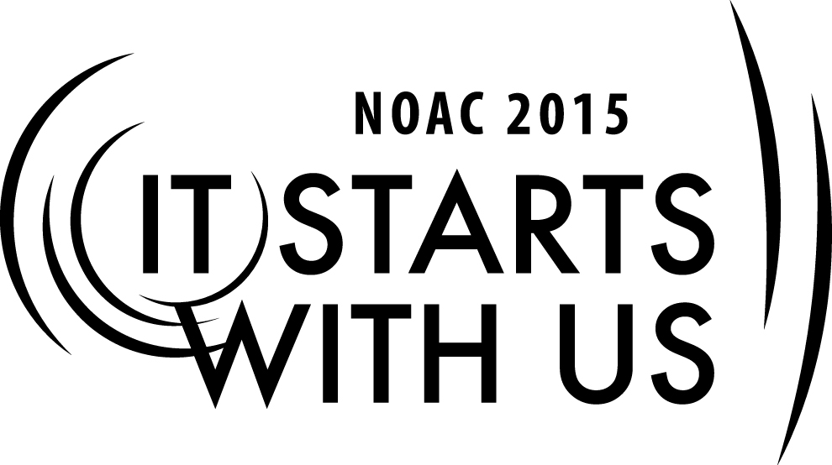
Chapter Participation in the Lodge
2015 National Order of the Arrow Conference
Session Length: 50 Minutes
Through this session, you will:
Explain -
- The importance of member participation in Lodge Chapter
- How the Lodge Chapter relates to the Lodge.

Demonstrate-
- Chapter structure and lodge structure and how they can work together with member participation.

Guide
- The participants, through lecture and discussion will learn about Chapter events, Lodge events and their roles in member participation.

Enable:
- The participants will understand and explain the role of the Chapter and Lodge in strengthening member participation.

This session will help the Lodge/Chapter/Section with the 2015 Journey to Excellence Requirement 14: Council program support: Provide OA Member staff support for council and district program events.

The theme of NOAC 2015 is “It Starts With Us”. This session will relay this theme in the following ways:
- It starts with us to understand the roles of the Chapter in member participation at both the Chapter and Lodge level.
- It starts with us to understand by various program activities and how they relate to member participation.
Introduction
SESSION NARRATIVE
5 Minutes
Is anyone here a student of United States History? For those of you who aren't, let me fill you in on something cool about the United States, a feature which has actually been copied several times across the world.
The United States is actually made up of split governments: we have the federal government and the state governments. Though it's power has expanded over time due to its size, the federal government is actually very limited in the things it can do. It can assist the states in many functions, such as setting up schools, firefighting districts, and building roads, but ultimately each state is given control over everything the federal government is not specifically told to do in the constitution. While its not a clear line, the United States still operates as a group of united, but individual, states over 200 years after its creation.
Lodges are similar: Each is composed of chapters that perform everything the lodge does not do. In each lodge that is different, and the role of the lodge over the chapters is modified heavily. However, the basic principle remains the same: chapters exist to perform the functions that lodges do not, whether because the lodges choose not to or because the lodge cannot do it. This session will discuss how Chapters participate in the lodge and the chapters unique opportunity to provide something extra for arrowmen.
The Dividing Line: Functions of a Chapter
10 Minutes
The truth is that we could not come up with a list that is universal to each lodge: every lodge treats chapters differently. However, we can probably think of a few things that every lodge does (with a few exceptions). By a show of hands, lets see how many lodges:
- Elect Lodge Officers
- Conduct an Annual Banquet
- Conduct ceremonies (possibly through a summer camp)
- Organize attendance at national events
- Represent the OA to the council
Now we start to get into the gray areas. How many lodges have the lodge (not the chapter) do the following:
- Conduct call-out ceremonies
- Coordinate unit elections
- Schedule chapter officer elections
Finally, there are a few things we can probably safely assign to the chapters. How many lodges have the chapter, not the lodge:
- Elect chapter officers
- Represent OA to the District
- Schedule Chapter meetings and activities
Is there anything you would add to the above lists? Anything you would change?
- The Chapter in the Lodge
10 Minutes
Our next topic of this session is a little more difficult to discuss, because not all lodges treat chapters the same way. Therefore, this will be a more open-forum topic. We would like to know your thoughts on how lodges can integrate chapters into lodge events.
- Trainer Tip: Some ideas to get the group started could be to talk about a lodge that asks chapters to rotate dining hall duty at fellowship weekends, hosts a chapter mid-way at the annual banquet, or holds a chapter chief's meeting before each Lodge Executive Committee meeting. Get the conversation going, but try to not dominate the open-forum time.
Chapter Organization
10 minutes
Let's take a more in-depth look at the chapter's organization. Unfortunately, no one organization will perfectly match every chapter in the nation. However, it gives us a good start.
Starting at the top, we have the Chapter Chief. The Chapter Chief is nearly universal. The Chapter Chief likely has experience in the chapter but is probably getting his first taste at leadership. He is advised by a Chapter Adviser. Because we talk about the chapter chief and adviser in more depth in their own session, we won't spend much time here.
Next, let's take a look at the Chapter Secretary. We skipped to the chapter secretary because he has a more universal role than the chapter vice-chief, and some chapters do not have their own treasurer because of lack of youth or because the lodge handles all finances. The chapter secretary plays an important communications function in the chapter. Like the Chapter Chief, the Chapter Secretary is unlikely to have highly developed communication skills- in fact, it may be common to find that the Chapter Secretary does not even have his own e-mail address yet. This is an important conversation to have with the Secretary's parents if he does not, as this may be a good opportunity for him to learn to responsibly use e-mail.
Some chapters may have a treasurer, though many do not. This is because the lodge typically handles all of the chapter's finances - in fact, chapters are not supposed to have their own bank accounts.
Finally, we have two different forms: either a chapter with one or more vice-chiefs handling several duties, or a chapter with only one vice-chief and several committee chairs. Depending on how big your chapter is, you may experiment with leadership structures. However, the functions that need to be covered depend on your lodge. These could include:
- Planning activities
- Coordinating Unit Elections
- Coordinating a Chapter Call-out
- Working with the district
Are there other chapter functions you would add? Let's take a few minutes to explore how 2 or 3 different chapters have structured their leadership.
The Chapter Meeting and Adviser's Minute
15 Minutes
Up until now, this session has been largely about running a chapter and about the role of a chapter versus the role of the lodge. The next section will be geared largely at Chapter Advisers.
Many chapters have monthly or quarterly meetings. While the meeting itself should be a fun, productive meeting run by the youth, this also provides an opportunity to provide advise to the youth. Unlike an adviser's minute at a lodge function, many of the Scouts at a chapter meeting have only ever heard their Scoutmaster give a minute before. This is an important time for them to experience another adult's guidance.
For many of you, you will turn to books and online resources for minutes each month. However, because the Order of the Arrow is a unique organization, you have a unique opportunity to really make an impact on the youth in your chapter each meeting.
Because we want you to leave this session prepared to be an adviser, we want you to have time to write at least one chapter adviser's minute. Some of you may be familiar with the idea of the last lecture - what would a college professor say to his students if she knew it was the last lecture she would ever give? We will dim the lights and put on some music for the next fifteen minutes, and we challenge you to prepare an advisers minute - or at least the start of it - that you would give if you knew you would die the next day and never give another adviser's minute.
- Trainer's tip - an inspirational song, turned low, is appropriate here. Some advisers will not want to participate in this exercise, and that is okay. Encourage them to not distract others or step out to the restroom for a minute if you see these advisers. However, for most advisers, this exercise should give a good chance to prepare an adviser's minute - something they may typically do at the last minute before a meeting.
Thank you all for the great participation! As you can see chapter participation in the lodge is a diverse topic, but there are common features and ideas for more ways to participate in your lodge back home after NOAC.

TRAINER PREPARATION

What qualifications should the trainer have to perform this session?
- Facilitation skills
- Technology skills to load and run PowerPoint Program

Appendix Resources:
Guide for Officers and Advisers #24-413 (2012) http://www.oa-bsa.org/pages/content/publications#goa

Chapter Operations Guide (2012) http://www.oa-bsa.org//uploads/publications/cog-2012.pdf

Best Practices from around the Nation http://www.oa-bsa.org/pages/content/best-practices

