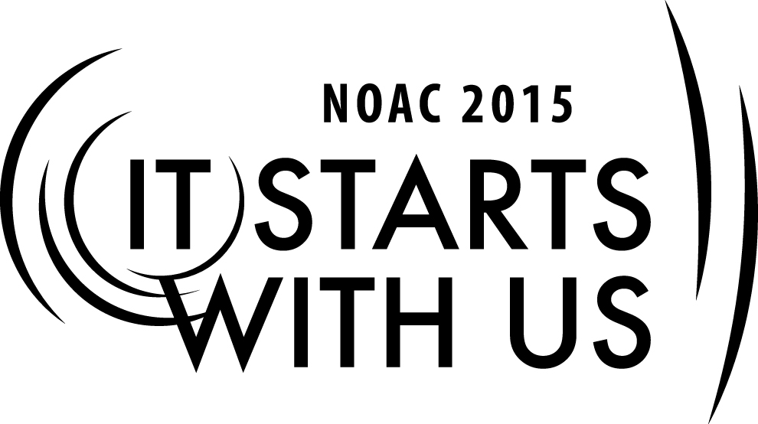
Understanding the Roles of the Chapter Officers and Advisers
2015 National Order of the Arrow Conference
Session Length: 50 Minutes
Through this session, you will:
Explain

- The roles of OA Chapter Officers and Chapter Advisors.
- How Chapter officers and advisors relate to Chapter program and program planning.

Demonstrate
- Chapter program and program planning and the roles of OA Chapter Officers and Chapter Advisors and how they relate to program planning.

Guide
- The students through lecture and interactive learning the roles of OA Chapter Officers and Chapter Advisors and how they relate to Chapter program and program planning.

Enable:
- The participants understand the role of the Chapter officers and advisors and their relationship to each other and to the Lodge.

This session will help the Lodge/Chapter/Section with the 2015 Journey to Excellence Requirement 14: Council program support: Provide OA Member staff support for council and district program events.

The theme of NOAC 2015 is “It Starts With Us”. This session will relay this theme in the following ways:
- It starts with us to understand the roles of the Chapter Officers and Advisors.
- It starts with us to understand how the Chapter Officers and Advisors relate to program and program planning.
Introduction
SESSION NARRATIVE
5 minutes
Before we begin, I want to announce that a very special guest is with us today - he advises the top youth leader in the entire Order of the Arrow. In his role, he directly works with Arrowman on a day to day basis, acts as the adult face of the Order of the Arrow to countless Scouts and Scouters, and presents a positive model of leadership and mentorship to the youth he advises that I am sure everyone in this room can emulate. Could I have all current Chapter Advisers stand up?
- Trainer Tip: If no one stands up, play it off as if the most important person in the OA must have had other plans come up.
That is right: the most important adviser in the Order of the Arrow is the Chapter Adviser. I bet many of you thought I was going to say the National Chairman, but the truth is that Chapter Advisers play a much more important role. Chapter Advisers, by mentoring their chiefs, are much better poised to be the face of the Order of the Arrow because they work with people who are new to the Order of the Arrow and oftentimes are new to Scouting.
In the first session of this cell on Chapter Advisers, we will seek to understand the role of Chapter Advisers and officers. It starts with us to understand these roles not only for our own benefit, but for the benefit of our current chapter officers - and next year's chapter officers, and the next year's, and the next...for the next 100 years and beyond.
- Trainer Tip: This would be an appropriate time to introduce the training staff. Keep it brief! Stick to names, current OA experience, and why you are qualified to teach a class to Chapter Advisers.
The format of this first session is largely discussion based. While the trainers will seek to facilitate discussion, your participation is vital to a productive session!
Role of the Youth
15 minutes
Let us start with the most important role: that of the youth Chapter Officer. While each lodge and each youth is different, we can develop some common characteristics of a youth chapter officer. What characteristics would you assign to the youth?
- Trainer Tip: ideally, the group will agree that most chapter officers are young (13-15), an Ordeal or new Brotherhood member, unlikely to have NOAC or national event experience. Developmentally, a chapter officer is likely to have wavering motivation and wavering commitment: he will go through spurts where he wants to do the work, and he will go through spurts where he is absent. He is still at a point in his life where he is given discreet assignments to work on in school, and is only beginning to understand what it means to "See the forest through all the trees."
Knowing what our typical chapter officer looks like, we need to decide what his role is in the chapter, as well as what is role is in the lodge and in the districting. Grab a piece of scrap paper, and draw a line down the middle - top to bottom. Now work with a neighbor to think of a short phrase describing the chapter chief's role is in the chapter, the lodge, and the district and write those on the left side of your paper. Take a minute for each group, then we will come back together to share.
- Trainer Tip: Your job as trainer is not to criticize the phrases participants provide, but to tie the participants thoughts back to the developmental profile of a youth chapter officer. For example, if a pair suggests a chapter officer's role in the lodge is to "represent the voice of the chapter," suggest that this may be a challenging and intimidating job for a youth will little public speaking experience. The next section will tie these suggestions to the role of the adviser
Great work, everyone! Now that we have developed an idea of what the chapter officer does, let's move on to what the chapter adviser does.
Role of the Adviser to the Youth
15 minutes
We could probably wrap this session up by simply saying that the role of the adviser is to support the youth in his various roles, but the answer is more complicated than that. Just as a 14 year old Chapter Chief is dynamic and transient, so too is the role of the adviser.
Take a look back at your paper. Working with your partner again, try to think of one phrase for the adviser to describe how he supports the youth in his role in the chapter, the lodge, and the district. Write that phrase on the right side across from the youth role. We will give you about 5 minutes for this exercise and then come back together.
- Trainer Tip: Once you have come back together, assume the same role as before: tie back the Adviser's phrases to how this aids in youth development, but be supportive of all answers. For example, if the youth role was to represent the voice of the chapter, and the adult phrase was to "help the youth prepare remarks to give to the lodge," encourage Advisers to see that they have stepped in the role of a public speaking coach.
With these roles in mind, let's come back to where we started: the developmental level of a chapter officer. But this time, let's look at what role a chapter adviser plays in supporting that developmental level. As a group, let's develop a profile of a chapter adviser supporting a youth officer. What characteristics would he or she have?
- Trainer Tip: Ideally, the group will paint a picture of an adviser who is supportive, but understands to break up tasks into small pieces. A chapter adviser is likely good at understanding the woes of youth - likely a parent, a teacher, a youth minister, or similar who understands that chapter officer aged youth are still trying to work out life obstacles such as increasing school work, dating, coping with the flexibility that comes with high school schedules and increased homework demands. A chapter adviser is also willing to let the youth provide make decisions, while understanding that they must still provide direction and cover for a youth who may go absent every once in a while.
This has been productive - we have developed a picture of a youth chapter officer, sought to understand his roles, thought through how a chapter adviser supports those roles, and then developed the characteristics of a good chapter adviser. But what about everything else?
Role of the Adviser for Everything Else
10 minutes
Whether we think about it or not, the chapter adviser also holds a few roles that the youth is simply not present for. For one, the chapter adviser is often a member of the district committee. In some councils, the chapter adviser may also be asked to assist with a council level committee, such as the camping committee or program committee. This is where a chapter adviser often ends up wearing several different hats - or at least several different badges of office on the sleeve.
As a group, let's talk about challenges and opportunities from our own experiences as we have worked through the multi-faceted role of a chapter adviser.
- Trainer Tip: This is a good time to share your own experiences. Have you ever had to deal with a politically charged situation? Have you been able to serve on a District Committee? What does your chapter do to support Roundtables or other District programs? Provide examples and participants will follow! Additionally, this section is designed to be more fluid in case the other sections ran long.
Conclusion
5 minutes
As we wrap up, let's review what we discussed:
- Trainer Tip: Embellish with class discussion.
The chapter officer is likely a younger arrowman with less experience and still early in the developmental stages of adulthood. He has multiple roles within the chapter, the lodge, and the district. The chapter adviser serves as his counterpart - providing guidance and direction to each of his roles. The chapter adviser is likely someone who is good at working with youth and willing to provide more direction than most advisers - someone willing to provide leadership when needed, but never by pushing the youth to the side. Additionally, the chapter adviser wears several other hats as discussed today, and he must balance those roles with his support of the youth officer.
Great work! Let's take a break before our next session.

TRAINER PREPARATION

What qualifications should the trainer have to perform this session?
- Facilitation skills
- Technology skills to load and run PowerPoint Program

Appendix Resources:
Guide for Officers and Advisers #24-413 (2012) http://www.oa-bsa.org/pages/content/publications#goa

Chapter Operations Guide (2012) http://www.oa-bsa.org//uploads/publications/cog-2012.pdf

Best Practices from around the Nation http://www.oa-bsa.org/pages/content/best-practices

