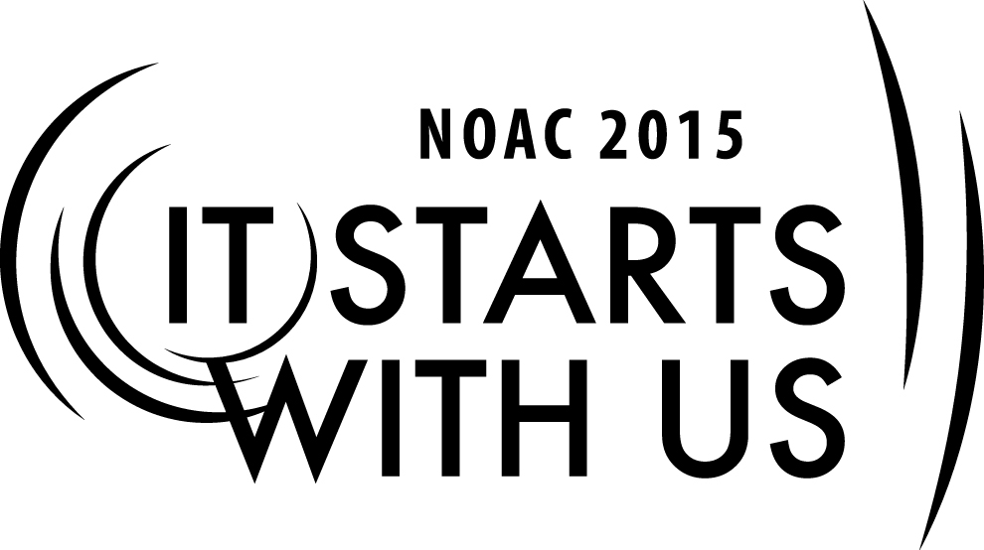
Building Your Team: Achieving the Mission
2015 National Order of the Arrow Conference
Session Length: 55 Minutes
Through this session, you will:
Explain: Methods to develop a team, strengthen the team through training, and explain effective
ways for setting goals in order to achieve a mission.
Demonstrate: Smart Goals
Guide: We will guide participants through the process of assembling a group and strengthening
the group through training and goal setting in order to achieve a mission
Enable: Through this training cell, we will enable the group to effectively build, train and motivate a team in order to achieve a mission.

This session will help the Chapter, Lodge, and Section with the Journey to Excellence Requirement(s)
Chapter: 1, 2, 5, 6, 7, 8, 9, 10, 12, 14, and 15.
Lodge: 3, 4, 5, 6, 7, 8, 9, 10, 11, 12, 14, 15, and 16.
Section: 2, 3, 4, 5, 7, and 10.

The theme of NOAC 2015 is “It Starts With Us”. This session will relay this theme in the following ways:
- It only takes one person to start to build a team, “It Starts With Us”
- With the team built, goals are set and the team begins to work towards goals.. It starts with the Team; “It Starts with Us”

SESSION NARRATIVE
TITLE 5 Minutes

As participants arrive, have them pick up the handouts entitled “Seven Steps to Setting Successful Goals” and “Accomplishing Your Goals: Eight Steps to the Prize.”
After introducing themselves, the session leader should briefly discussion the session objectives of the previous two sessions, “Recruiting Allies” and “Synergism and Problem-Solving”
Make sure the “Title Slide” is displayed on the screen as participants enter the room.
Provide personal introductions to participants and classroom rules.

CELL GOALS 1 Minutes

- Learn how to identify individuals who share a common view and recruit them to join your team.
- Learn to set goals and how to achieve them
- Create an environment that encourages and motivates each member of the team to commit to achieving the mission.

LEARNING OBJECTIVE 1 Minutes

- Know what resources are available to develop the teams’ abilities
- Understand the importance of goals and why they are necessary
- Learn how to successfully set and accomplish specific goals
RESOURCES 5 Minutes

Briefly review information from cell session B - Recruiting Allies as building a strong team is extremely important to Achieving a Mission

Try to keep the answers flowing and encourage the participants to actively participate. List answers on the flip chart.
• What resources are available to lodges, chapters or committees to develop their team?
• What does your lodge do to develop their teams?
• What are the most frequently encountered challenges or obstacles teams face when trying to develop?
• How do we address these obstacles? How can we use our available resources to successfully develop our teams?

IMPORTANCE OF GOALS 5 Minutes

Why do we need goals?
What do we try to accomplish by setting goals?
What are some of the different kinds of goals?
How do situations or personnel impact the kinds of goals we set?

Try to keep the answers flowing and encourage the participants to actively participate. List answers on the flip chart.
SMART 15 Minutes

SMART goals are goals that employees can realistically and consistently reach and therefore provide crucial motivation. SMART is an acronym for Specific, Measurable, Attainable, Relevant, and Timely, each of which plays an important part in the creation of one single goal. A SMART goal provides an individual with more direction and a better ability to achieve the goal by the targeted completion date.

Be SMART!
• Specific: Clearly define what is trying to be accomplished. 5Ws
• Measurable: A plan with targets and milestones that you can use to make sure you are moving in the right direction. EXAMPLE: Do not use “increase Brotherhood conversion significantly”. Instead use “increase Brotherhood Conversion by 40%”.
• Attainable: People are motivated by accomplishment, so ensure that goals are achievable and won’t overwhelm the individual. Be realistic and include a plan that breaks your overall goal down into smaller, manageable action steps that use the time and resources available to you within the timeline you have set.
• Realistic: Is the goal do-able?
•Timely: Limited by a defined period of time and includes a specific timeline for each step of the process. By setting a deadline, you are more motivated to take action to attain this goal rather than putting it off for as long as you can.
Trainer Instructions: Reform the lodges from the “Recruiting Allies” session. Give each Lodge Chief and Advisor a couple of minutes to review the “Fuzzy Situation” from the previous session (Syngerism and Problem-Solving) with the group, and to re-examine the solution the lodge selected to address the situation.

Using the completed Resource Survey sheets from the “Recruiting Allies” session, the materials from the “Synergism and Problem-Solving session”, and the information presented in this session, have the lodge identify what resources are available to the group, and then set goals to successfully meet the challenge.

After 7 minutes, each group presents their goals to successfully meet the challenge facing the lodge. Solicit input from other groups.

8-STEPS TO THE PRIZE 10 Minutes

  - Desire: How bad do you want it?
  - Belief: Do you really believe in the goal?
  - Imagination: Be creative – don’t be afraid of the big idea!
  - Planning: The 7 P’s! Proper Prior Planning Prevents Pitiful Poor Performance
  - Elephant Bites: How do you eat an elephant? One bite at a time.
  - Review: Keep track of your progress.
  - Persistence: Winners never quit; quitters never win!
  - Enthusiasm: Attitude, excitement, fun.

TRAINING 5 Minutes

Discuss the importance of training:
•Why
•Who?
•When?
•Resources?
•Venues?
•Rules?

TUCKERMAN’S STAGES OF DEVELOPMENT 5 Minutes

Always remember when building a team, it will go through many changes. In OA’s National Leadership Seminar or National Youth Leadership Training, we learned that groups or teams go through different stages of team development. Those stages are known as Tuckman’s Stages of Group Development:
Forming, Storming, Norming, and Performing.

Forming: In this stage, most team members are positive and polite. Some are anxious, as they haven't fully understood what work the team will do. Others are simply excited about the task ahead.
As leader, you play a dominant role at this stage, because team members' roles and responsibilities aren't clear.
Storming: Next, the team moves into the storming phase, where people start to push against the boundaries established in the forming stage. This is the stage where many teams fail.
Storming often starts where there is a conflict between team members' natural working styles. People may work in different ways for all sorts of reasons but, if differing working styles cause unforeseen problems, they may become frustrated.
Some may question the worth of the team's goal, and they may resist taking on tasks. Team members who stick with the task at hand may experience stress, particularly as they don't have the support of established processes, or strong relationships with their colleagues.
Norming: This is when people start to resolve their differences, appreciate colleagues' strengths, and respect your authority as a leader. Now that your team members know one another better, they may socialize together, and they are able to ask one another for help and provide constructive feedback. People develop a stronger commitment to the team goal, and you start to see good progress towards it.

Performing: The team reaches the performing stage, when hard work leads, without friction, to the achievement of the team's goal. The structures and processes that you have set up support this well.

QUESTIONS 3 Minutes
Trainer Instructions: At this point, ask for any remaining questions and thank the participants for their attention and participation. Dismiss the session and collect evaluations.

Review the session objectives and session highlights. Restate the objective of the training cell, and briefly review how each session relates to the overall goal of the cell.

TRAINER PREPARATION

Appendix Resources:
- Required Materials:
  - Video Projector
  - Laptop with PowerPoint
  - Order of the Arrow Handbook
  - Guide for Officers and Advisers
  - Prepared PowerPoint Slides
  - Easel/Flip Chart or White Board and Markers
- Handouts: Seven Steps to Setting Successful Goals and Accomplishing Your Goals: Eight Steps to the Prize

- Physical Arrangements:
  - Classroom or Lecture Hall
  - Video projector and screen should be clearly visible to all participants

- Prepared Slides:
  - Slide 1: Title Slide
    - Your name and hometown
    - Your Lodge name, Council name, and Council Location
    - The title of the session
- Slide 2: Cell Goals
- Slide 3: Learning Objectives
- Slide 4: Resources
- Slide 5: Importance of Goals
- Slide 6: SMART Goals
- Slide 7: Importance of Training
- Slide 8: 8-Steps to the Prize
- Slide 9: Group Development
- Slide 10: Tuckman’s Stages of Group Development
- Slide 11: Questions

- Source Materials and References:
    - Lodge Leadership Development Course CD-ROM/OA Training Website
    - 1998 National Order of the Arrow Conference Training Syllabus
    - 2002 National Order of the Arrow Conference Training Syllabus

