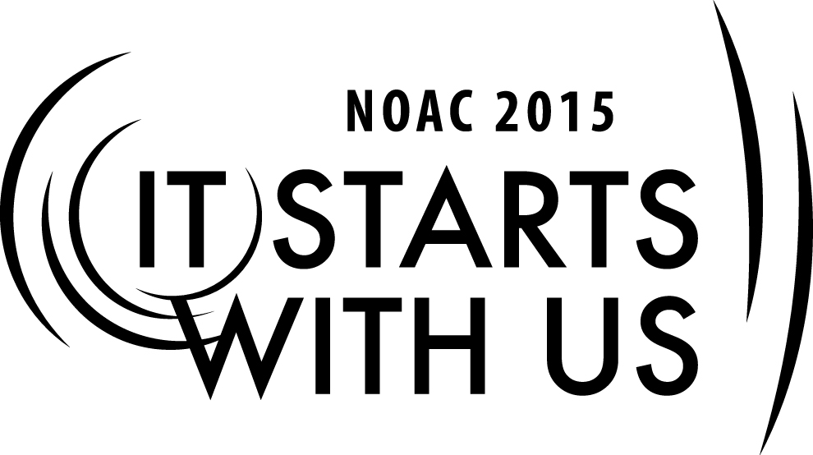
Building Your Team: Synergy and Problem Solving
2015 National Order of the Arrow Conference

Session Length: 65 Minutes
Through this session, you will:
Explain: What Synergy and Problem-Solving is and how to work through both.
Demonstrate: How to successfully work out problems with problem-solving techniques.
Guide: Guide them to use the tools taught in this session through role-playing.
Enable: Use the tools taught in this session back in their units, chapters, lodges, etc.

This session will help the Chapter, Lodge, and Section with the Journey to Excellence Requirement(s)
Chapter: 1, 2, 5, 6, 7, 8, 9, 10, 12, 14, and 15.
Lodge: 3, 4, 5, 6, 7, 8, 9, 10, 11, 12, 14, 15, and 16.
Section: 2, 3, 4, 5, 7, and 10.

The theme of NOAC 2015 is “It Starts With Us”. This session will relay this theme in the following way:
Empowering youth and adults through cohesive team work to problem solving through difficulties to reach their goals.

SESSION NARRATIVE
TITLE 2 Minutes

Provide personal introductions to participants and classroom rules.

After personal introductions, the session leader should briefly discuss the session objectives of the previous session, “Recruiting Allies”. Review how the teams’ prospects were identified and recruited, then move into introducing this session.
Make sure the “Title Slide” is displayed on the screen as participants enter the room.
LEARNING OBJECTIVE 1 Minutes

- Learn how to lead your team away from political infighting to concentrate on achieving the mission.
- Know how to identify underlying problems, and judge best solutions moving forward.
- Understand why proper recording of situations, problems, and solutions is important to the long-term growth of the team
- Develop the skill of turning criticism into a positive and useful tool.
INTRODUCTION 2 Minutes

In keeping with our words of wisdom from Hall of Fame football coach Vince Lombardi, the Packers legend once said “It’s not about whether you get knocked down. It’s about whether you get back up.”
What is true about adversity and overcoming challenges for a sport like football is also very true for volunteers in Scouting. Troops, crews, chapters, and lodges are successful when we can figure out ways to look beyond internal obstacles and differences toward the broader mission of our organization. This session is designed to help you identify ways to stay committed to your team’s vision, while developing helpful tools for problem-solving along the way.
In this session, we’re going to talk about two concepts that will help us get over the proverbial humps that our teams may face: Synergy and Problem Solving.
DEFINING SYNERGY AND PROBLEM SOLVING 2 Minutes

SYNERGISM
- The interaction of elements that, when combined, produce a total effect that is greater than the sum of the individual elements, contributions, etc.
- That which combines or cooperates with another or others to enhance an effect.
- The power of a team versus oneself.
PROBLEM-SOLVING
- A process by which any question, uncertainty, or difficulty can be alleviated by understanding the underlying or root cause of a problem, and then selecting and implementing the best solution from a choice of alternative actions.
VALUE BASED LEADERSHIP 7 Minutes

Value-based Leadership is leading by staying true to one’s values. It is the foundation of Servant Leadership.

A leader must align his/her values with the organizations values.

- Key Qualities of Value-based Leadership:
  - Self-reflection: a trait required for a person to identify and evaluate his/her fundamental values.
  - Balance: a person’s ability to view a situation from different perspectives. Remain open minded and consider all opinions before making a final decision.
  - Self-confidence: is essential for leaders to truly believe in themselves.
  - Humility: person’s ability to remain grounded and keeps life in perspective. Remain humble in his/her assessment of the situation.

The Ordeal’s pledge of silence emphasizes the continuing need to spend time in thoughtful reflection. Difficult decisions will face you now and in the future, and you will need to search your heart and spirit deeply to find the resolution that will guide you onward successfully (OA Handbook page 52).
- What is your personal mission?
  - The biggest obstacle to synergy is often yourself.

- What is the mission of the Order of the Arrow?
  - Look to the Obligation, Scout Oath and Law.
  - The need for thoughtful silence.
  - Helping the team remember our purpose.

DIVERSITY = STRENGTH 7 Minutes

Diversity is what builds teams — a collection of individual experiences, backgrounds, and cultures that can view problems and challenges from a wide-variety of lenses.

Diversity is about empowering people. Diversity is understanding, valuing, and using the differences in every person. It makes a team effective by capitalizing on all of the strengths of each member. Embracing diversity is the first item for building teams.

In the Ordeal, you worked with the help and cooperation of other candidates and members, but now you must be ready to serve without the help and cooperation of others (OA Handbook Page 53).
- If we both are working towards the same goal, have can we have such different points of view?
  - Take the time to understand each other
- How can you, as a leader, motivate someone who disagrees with you to achieve a gain for the team?
  - Understanding enables you to be flexible.
  - Incorporating Ideas: A personal stake is a powerful motivator.
- How can those who disagree work together effectively?
  - Developing mutual respect.
  - A balance of give and take.
THE ART OF PROBLEM SOLVING 10 Minutes

Jidoka: Japanese term for the art of problem solving. It is a method of spotting problems as they arise by stopping, analyzing, and spending time to resolve that issue so it doesn’t happen again.

How many of you have attend the National Youth Leadership Training or NYLT? My next question to you is, how do we eat an Elephant?

We eat an elephant one bite at a time. This same concept holds true in problem solving. We must attack a problem step by step to create a solution at all levels instead of one solution to the upfront problem at hand.

The roadmap to problem solving is in 5 steps:
1. Identify the problem
2. Identify the root causes
3. Brainstorm the solutions
4. Select the appropriate solution
5. Implement and check the impact of the solution

The Ordeal’s test of scant food illustrates self-denial. Often you will find it necessary to abandon mere personal comfort or desires if you are to fulfill your Obligation (OA Handbook Page 53).

- Roadmap to problem solving:
1. Identify the problem
-Are we seeing the same problems? Is there a problem at all?
-The benefit of experience: ask everyone, especially your advisors or fellow advisors.

2. Identify the root causes
-Chains of causation.
-The links of the chain are as important as the source.

3. Brainstorm the solutions
-Is it safe to disagree? The dangers of group-think.

4. Select the appropriate solution
-Define the criteria that will lead to success.
-Commit to the best solution before it is chosen!
-Then let the team decide.

5. Implement and check the impact of the solution

LEADING AND FOLLOWING 7 Minutes

As you create your team and work through problems, a few things to keep in mind to make the team a success whether a leader or follower are:

  - Transparent communication: everyone’s concerns and points of view are freely expressed
  - Breakdown silos: removing hidden agendas and focus on the betterment of a healthier whole.
  - Open minded people: working together for a common cause to making it better.
  - A solid foundational strategy: without a strategy, change is merely substitution, not evolution. Connect the dots and map-out a realistic plan of action in advances.

The Ordeal’s night alone focuses attention on your need for courage and self-reliance on the trail ahead. You must be willing to accept individual responsibility for your own thoughts and actions. You will find that your course will set you apart from your friends to the extent of isolation, but you must act according to your resolution regardless of what others do or fail to do (OA Handbook page 52).
- When should you defend the course of action you see as right when the group chooses a different path?
  - Where do you draw the line when learning from mistakes?
- What right do you have to express your point of view?
  - Good will is a complete defense.
- What’s the proper audience for a debate?
  - New Business = Public
  - Old Business = Private
- What is your debate based on: emotion or logic?
  - Know the facts beforehand. Don’t ignore facts that point to the contrary conclusion!
- When to follow and when to lead.
  - Will your choice cause a net gain or net loss?
  - For most positions you need only consider the short-term.

CRITICISM 3 Minutes

- Constructive: the process of offering valid and well-reasoned opinions about the work of others, usually involving both positive and negative comments, in a friendly manner rather than an oppositional one.

- Destructive: with the intention to harm someone, derogate and destroy someone’s creation, prestige, reputation and self-esteem

- Nothing is perfect. All things can be improved.
- Low self-esteem and criticism never mix.
  - Motivation
  - Appreciation
  - Recognition
- Arrogance equals ignorance.
- On war and peace.
- Utilizing a problem generator.
- Unbiased mediators.

BREAKOUT GROUPS 15 Minutes
Trainer Instructions: Re-form the lodges from the “Recruiting Allies” session.
Have prepared on the slide: A Fuzzy Situation (For applying the problem solving process).

With your new Lodge Adviser and Chief in place, your next step is to find why you didn’t meet JTE goals. While reviewing records you notice out of 150 Brotherhood eligible Arrowmen, there was only a 10% conversion rate. Why?
Trainer Instructions: Each lodge should brainstorm possible underlying problems. It is important to be open and accepting of all ideas, no matter how odd or strange. It is possible one strange idea could lead to several excellent underlying problems through piggyback brainstorming. Try to avoid falling into a rut where all the problems follow a single line of thinking.
After 5 minutes, each group presents the two or three problems they feel to be the strongest underlying problems. For example, if a lodge is not earning Journey to Excellence distinction because of how inadequate brotherhood conversation numbers, the underlying problem must be a cause of the low conversation numbers. To find the strongest underlying problem consider which problem if corrected would yield the greatest improvement. Solicit input from each group.
By a show of hands, vote on the underlying problem.
Each lodge can now brainstorm possible solutions that directly address the underlying problem. Each solution should be developed, step-by-step, until the ultimate objective is achieved. In the brotherhood conversion example, each solution should at least partially solve the underlying problem. The solution should show how it will lead, step-by-step, to the lodge earning JTE distinction.
After 5 minutes, each group can present one or two of their best solutions.
Ask all participants to list some factors that will determine whether any of the solutions ultimately chosen will be a success. These will become the criteria against which the solutions will be judged.
Rank the solutions by the criteria to choose the best solution

The final session in Building Your Team will dwell on how to address the best solution chosen by the lodge.

SOURCES 1 Minutes

For addition information on the topics we spoke about in this session, review the following resources:
    - Value Based Leadership Website: http://www.saylor.org/site/wp-content/uploads/2013/02/BUS208-3.3.9.1-Values-Based-Leadership-FINAL.pdf
    - The 4 Most Effective Ways Leaders Solve Problems: http://www.forbes.com/sites/glennllopis/2013/11/04/the-4-most-effective-ways-leaders-solve-problems/
  - Order of the Arrow Handbook
    - 2002 National Order of the Arrow Conference Training Syllabus

SUMMARY 2 Minutes

- Synergy/Problem Solving
- Value-based Leadership
- Diversity builds a stronger team.
- Criticism should be constructive to make an effective impact on the team.
- Roadmap to Problem Solving
1. Identify the problem
2. Identify the root causes
3. Brainstorm the solutions
4. Select the appropriate solution
5. Implement and check the impact of the solution

Review the session objectives and session highlights.
Restate the objective of the training cell, and briefly review how each session relates to the overall whole the cell.

QUESTIONS 3 Minutes
Trainer Instructions: At this point, ask for any remaining questions and thank the participants for their attention and participation. Dismiss the session and collect evaluations.

TRAINER PREPARATION

Appendix Resources:
- Required Materials:
  - Video Projector
  - Laptop with PowerPoint
  - Order of the Arrow Handbook
  - Guide for Officers and Advisers
  - Prepared PowerPoint Slides
  - Easel/Flip Chart or White Board and Markers

- Physical Arrangements:
  - Classroom or Lecture Hall
  - Video projector and screen should be clearly visible to all participants

- Prepared Slides:
  - Slide 1: Title Slide
    - Your name and hometown
    - Your Lodge name, Council name, and Council Location
    - The title of the session
- Slide 2: Learning Objectives
- Slide 3: Introduction
  - Vince Lombardi Quote
- Slide 4: What is Synergism?
- Slide 5: What is Problem-Solving?
- Slide 6 and 7: Value Based Leadership
- Slide 8 and 9: Diversity = Team Strength
- Slide 10 and 11: The Art Of Problem-Solving
- Slide 12 and 13: On Leading and Following
- Slide 14: Criticism
- Slide 15: A Fuzzy Situation (Break-Out Groups)
- Slide 16: Sources
- Slide 17: Summary
- Slide 18: Questions

- Source Materials and References:
    - Value Based Leadership Website: http://www.saylor.org/site/wp-content/uploads/2013/02/BUS208-3.3.9.1-Values-Based-Leadership-FINAL.pdf
    - The 4 Most Effective Ways Leaders Solve Problems: http://www.forbes.com/sites/glennllopis/2013/11/04/the-4-most-effective-ways-leaders-solve-problems/
  - Order of the Arrow Handbook
    - 2002 National Order of the Arrow Conference Training Syllabus

