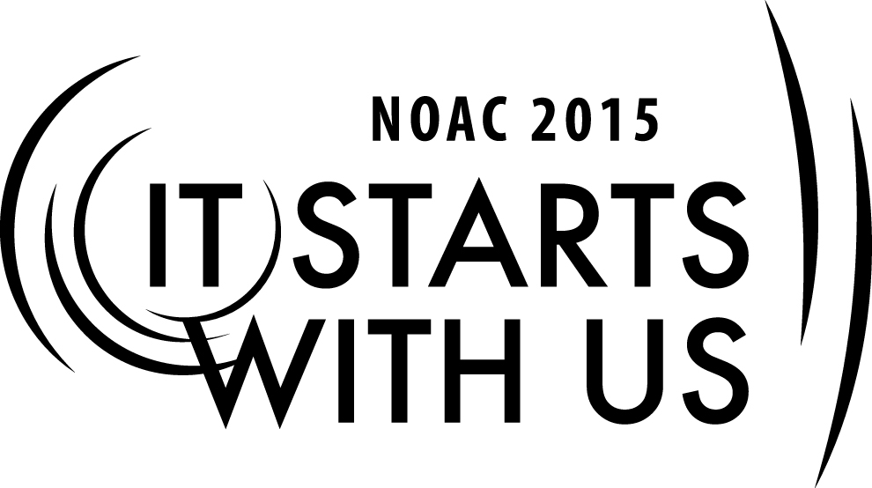
Building Your Team: Recruiting Allies
2015 National Order of the Arrow Conference
Session Length: 55 Minutes
Through this session, you will:
Explain: The methods to successfully recruiting others.
Demonstrate: How to successfully recruit others through role-playing.
Guide: Guide them to use the 8-steps to successful recruiting through role-playing.
Enable: Use the 8-steps to successful recruiting back in their units, chapters, lodges, etc.

This session will help the Chapter, Lodge, and Section with the Journey to Excellence Requirement(s)
Chapter: 1, 2, 5, 6, 7, 8, 9, 10, 12, 14, and 15.
Lodge: 3, 4, 5, 6, 7, 8, 9, 10, 11, 12, 14, 15, and 16.
Section: 2, 3, 4, 5, 7, and 10.

The theme of NOAC 2015 is “It Starts With Us”. This session will relay this theme in the following way:
Empowering youth and adults to build cohesive teams for successful goal setting and accomplishing tasks to reach those goals.
SESSION NARRATIVE
TITLE 1 Minutes

As participants arrive, have them pick up the handouts entitles “Resource Survey” and “Steps in Successful Recruiting”.

Ask participants to find a seat and spend no more than 5 minutes completing the Resource Survey.

Make sure the “Title Slide” is displayed on the screen as participants enter the room.

Provide personal introductions to participants and classroom rules.

LEARNING OBJECTIVE 1 Minutes

- Learn how to identify individuals who share a common view and recruit them to join your cause
- Create an environment that encourages and motivates each member of the team to commit themselves to achieving the mission
- Know the steps necessary to recruit help, what resources are available to select candidates, and what it takes to select and retain team members.
INTRODUCTION 5 Minutes

Hall of Fame football coach Vince Lombardi once said, “In order to succeed, a group will need to build a singleness of purpose. They will need a dedication, and they will have to convince all of their prospects of their willingness to sacrifice.”

What is true about commitment to a collective purpose for a sport like football is also very true for volunteers in Scouting. Troops, crews/ships, chapters, and lodges are successful when everyone who’s brought on board can commit to a single purpose. This session is designed to help you sell your team vision to others, in order to get that commitment that’s so crucial to our success as a movement.

Selecting volunteers can be a very rewarding experience and is an important task for the continuation of a quality Order of the Arrow program. It is a personal achievement. There are certain principles to follow, but you must maintain your own style or personality during the entire course of the process.

STEPS IN SUCCESSFUL RECRUITING 10 Minutes

There are 8 specific steps utilized by the Boy Scouts of America in the recruiting process.
- Determine what volunteer positions are needed.
- Determine the best prospects for the job.
- Research the prospect list.
- Make an appointment.
- Make the sale.
- Ask for a commitment.
- Have a fall-back position in mind.
- Follow-up.
Trainer Instructions: Divide the participants into 8 break-out groups, one for each step. Allow them 3 minutes to detail how to accomplish their break-out group’s step. After 3 minutes, ask each group how they would accomplish each step.

RECRUITMENT ROLE-PLAYING 15 Minutes
Trainer Instructions: Upon completion of this review, break up the participants into groups of 6 to 8. Assign each group a lodge totem and ask them to select a lodge name.

Allow 10 minutes and have two or three of them sell one person into becoming the next Lodge Adviser and one into the next Lodge Chief in a role-playing exercise. The remaining 1 to 2 people should take notes on what went right and wrong.

Utilize the Resource Survey as the research needed to recruit. The first 5 minutes should be used by the recruiters to review the Resource Survey and plan the pitch.

Provide each group with a copy of the Lodge Adviser position patch, to be given to the successfully recruited participant.

DEBRIEF 15 Minutes
Trainer Instructions: After the 15 minutes are concluded bring them back together, ask what pitfalls were experienced by the sellers in attempting to get the commitment? (Write these on the flip chart/white board). Ask how these could have been avoided (allow 5 minutes).

Solicit how volunteers become members of the successful team (write these on a new flip chart page). Look for answers like training, and quarterly team meetings where: continuing training occurs, successes and failures shares, goals and tasks are re-evaluated, recognition is given, brainstorming for growth occurs, and information is shared (allow 5 minutes).

At this point, open the floor for questions and discussion. The session is about to conclude, so make sure to give participants an opportunity to express any thoughts they may have or engage their fellow Arrowmen on issues they may have encountered in recruiting allies to join their team.

SOURCES 1 Minutes
For addition information on how to successfully recruit others, review the following resources:
    - Selecting District People, No. 34512
    - Commissioner Administration of Unit Service, No. 34128
    - Continuing Education for Commissioners, No. 33615
    - College of Commissioner Science: Recruiting New Commissioners, MCS-312
    - 1998 National Order of the Arrow Conference Training Syllabus
    - 2002 National Order of the Arrow Conference Training Syllabus

SUMMARY 1 Minutes

Recruiting volunteers is a very important and rewarding job. There are specific methods for successful recruiting that are outlined in the publications of the Boy Scouts of America. The process of building your team continues past the point when a prospective volunteer says “Yes”. Regularly schedule team meetings and training have proven track records of retaining the volunteer.

QUESTIONS 5 Minutes
Trainer Instructions: At this point, ask for any remaining questions and thank the participants for their attention and participation. Dismiss the session and collect evaluations.

TRAINER PREPARATION

What qualifications should the trainer have to perform this session?

The trainer should have previous experiences in recruiting others to assist in a project or task.
Appendix Resources:
- Required Materials:
  - Video Projector
  - Laptop with PowerPoint
  - Order of the Arrow Handbook
  - Guide for Officers and Advisers
  - Prepared PowerPoint Slides
  - Easel/Flip Chart or White Board and Markers
  - Handouts: Resource Survey and Steps in Successful Recruiting

- Physical Arrangements:
  - Classroom or Lecture Hall
  - Video projector and screen should be clearly visible to all participants

- Prepared Slides:
  - Slide 1: Title Slide
    - Your name and hometown
    - Your Lodge name, Council name, and Council Location
    - The title of the session
- Slide 2: Learning Objectives
- Slide 3: Introduction
  - Vince Lombardi Quote
- Slide 4: Steps in Successful Recruiting
- Slide 5: Recruitment Role-Playing
  - Instructions for role-playing
- Slide 6: Debrief
- Slide 7: Sources
- Slide 8: Summary
- Slide 9: Questions

- Source Materials and References:
    - Selecting District People, No. 34512
    - Commissioner Administration of Unit Service, No. 34128
    - Continuing Education for Commissioners, No. 33615
    - College of Commissioner Science: Recruiting New Commissioners, MCS-312
    - 1998 National Order of the Arrow Conference Training Syllabus
    - 2002 National Order of the Arrow Conference Training Syllabus

