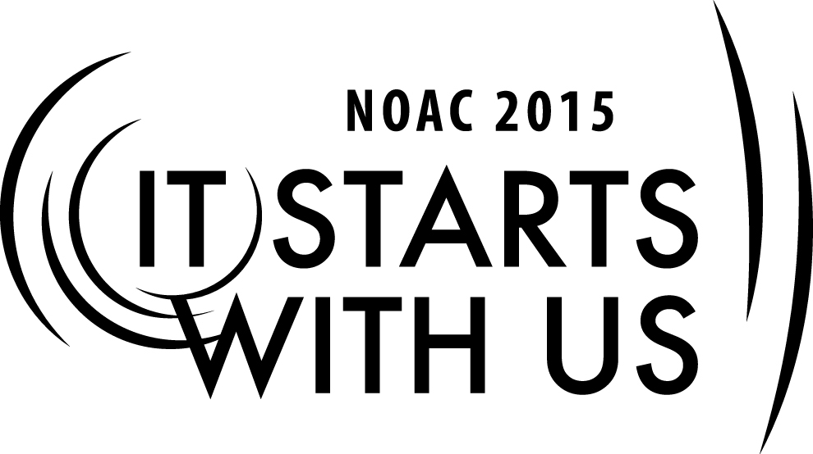
Cell Name: BUILDING THE TEAM
Empower the Team
2015 National Order of the Arrow Conference
Session Length: 50 Minutes
Through this session, you will:
Explain: Tools Necessary for a Team to Succeed
Demonstrate Formulation of a Vision and Planning to Achieve
Guide the development of a Vision
Enable Guests to Develop and Achieve a Vision through Proper Planning

This session will help the **Lodge/Chapter/Section** with the Journey to Excellence Requirement(s): All requirements relating to Finance, Membership and Participation, Program, Lodge and Unit Service, Council Support and Leadership Governance

Learning Objectives
To Empower a Team, the Team must know “where they are going” and “how they are going to get there” The purpose of this session is to empower the team by focusing on the development of a “Vision”, based upon “Values”, and proper planning to achieve the Vision.

Materials Needed
- Outline for Project Planning handouts for each participant
- Key points of the session, presented as PowerPoint® slides, overhead projections, or flip-chart pages

The theme of NOAC 2015 is “It Starts With Us”. This session will relay this theme in the following ways:
- Developing a Vision Based upon Values
- Planning to Achieve the Vision
SESSION NARRATIVE

EMPOWER THE TEAM:
TRAINER INSTRUCTIONS

Values, Mission and Vision
Learning objectives
As a result of this session, participants will
- Understand what is meant by values, mission, and vision.
- Review the values, mission, and vision of Scouting.
- Consider values, mission, and vision in the context of leadership.

Presentation Procedure
Introduction: a Story of Values, Mission, and Vision

(The presenter can share this story in his or her own words and emphasize the story is a legend.) As the legend is told, in the 1300s at Cambridge University in England, a chapel was constructed for one of the colleges. The vaulted roof was supported by huge beams fashioned from old-growth oak. Seven hundred years later, the beams had so deteriorated that the roof was in danger of collapsing. The building required extensive renovation, including replacing the beams. But where, in our time, could those repairing the building find giant oak trees of such an age and quality as had been available to the original builders?
The answer lay right outside the chapel door. The original builders of the chapel had known that at some point far in the future, the structure would need new oak beams, and so they had planted acorns in the churchyard. Over the centuries, a grove of oak trees had grown to full maturity.
- The vision of those chapel builders, to ensure the survival of the chapel, extended hundreds of years into the future.
Ask: How do you define vision? Summarize with, “Vision is a picture of future success.” This simple definition is what we teach our youth; it captures the essence of “vision.”

Here is the vision statement of the Boy Scouts of America:

- The Boy Scouts of America will prepare every eligible youth in America to become a responsible, participating citizen and leader who is guided by the Scout Oath and Scout Law.
Values
Values are core beliefs or desires that guide or motivate our attitudes and actions. When surveys ask “what are the most important characteristics of a great leader,” that the person holds strong values is always mentioned.
Values can take a variety of forms. For example:
- Principles or Standards
“Service Above Self” (Rotary Club International)
“Do a Good Turn Daily”
- Personal Qualities
Honesty
Loyalty
Ability to listen
- Character Traits
Being organized
Enthusiasm
Openness to others
- Codes of Ethics
Hippocratic Oath
Ten Commandments
BSA’s Outdoor Code
The Scout Oath and the Scout Law are statements of Scouting’s values.
“Acting in accord with our beliefs and values is one of the greatest challenges each of us faces every day. It’s true for individuals in all aspects of life . . . and equally true for organizations of every kind and size.”
—Eric Harvey and Alexander Lucia
Mission

A mission is the purpose of the organization—why the organization exists.
A mission is a calling to pursue long-term objectives that typically reflect or support the core values of an individual or an organization—it is the purpose of a person or an organization, or why the organization exists.
Routinely, an organization’s mission is formalized in a mission statement. A mission statement is often confused with a vision statement. For this session, we will use the following simple definitions.
Mission: Why we exist
Values: What we believe in and how we will behave
Vision: What success looks like

A brief corporate mission statement is often supported by a list of corporate values.

“The mission of the Boy Scouts of America is to prepare young people to make ethical and moral choices over their lifetimes by instilling in them the values of the Scout Oath and Law.”
—Mission Statement of the Boy Scouts of America

Vision

A vision is a picture of future success. Ask yourself, “What does success look like?”
A vision forms when we think far enough ahead to realize there will be important challenges that we can prepare for now, perhaps by doing something as simple as planting a few acorns.

“Nothing happens unless first a dream.”—Carl Sandburg
Think of young people who are currently involved with Scouting and imagine them years in the future.
- That’s how vision begins—thinking about what we can offer young people today through Scouting that will have a positive impact upon their lives in a decade, in 20 years, in 30 years, or more.
- That’s a vision that challenges each of us to do something of value for the future. Through Scouting, that vision encourages each of us to plant acorns.

Consider these visions.

- Dr. Martin Luther King Jr., August 28, 1963: “I have a dream.”
(He envisioned a nation where children would be judged by the content of their character and not by the color of their skin.)

- Lord Baden-Powell: Baden-Powell believed that a common moral code, shared by Scouts around the globe, eventually could lead to world peace.

Ask: What was President Kennedy’s vision? (To land a man on the moon and safely return him to Earth by the end of the decade.)
What was Martin Luther King’s vision? (I have a dream that all men will be judged by the merit of their character, not by the color of their skin.)Did they achieve their visions?

Baden-Powell’s Vision

Note: The presenter may wish to elaborate upon Baden-Powell’s vision. The following background material can be incorporated into this session to the degree the presenter feels is appropriate.
Baden-Powell served as a general during the Boer War, a campaign that was a dismal failure for the British military. Returning to England from Africa after the war, Baden-Powell began searching for ways to provide the British army with young men who were better prepared, both in character and ability, to serve their country. Through his books and the establishment of the Boy Scout movement, he felt he was succeeding in fulfilling that vision.
The first world jamboree took place in 1920. Baden-Powell was invited but was initially not enthused. He went anyway, and while he was there, his vision changed. Why? What had happened in recent English history? World War I had taken the lives of hundreds of thousands of soldiers on both sides of the lines.
At the world jamboree, Baden-Powell saw boys from many nations living together in harmony. His vision for the future of Scouting evolved, and for the rest of his life he put his heart and soul into promoting the world brotherhood of Scouting.
In 1937 there was a world jamboree in the Netherlands. Just before it opened, one nation sent word that its boys would not be attending. That nation was Germany. Scouting had been disbanded in Germany, and many of its members had joined the Hitler Youth.
Baden-Powell died in 1941, greatly disappointed that he had not realized the fulfillment of his vision of a world brotherhood of Scouts living in peace.
Did Baden-Powell’s vision die with him? No, of course not. To this day we continue to work toward that ideal.
Criteria for a Meaningful Vision
- A vision engages the heart and spirit.
- A vision leads toward a worthwhile goal.
- A vision gives meaning to an effort.
- A vision is simple.
- A vision is attainable.
- A vision can change over time.
Effective leaders have the capability to create compelling vision, but they must also be able to translate that vision into reality.

The Challenge of expressing Values and Visions

Articulating personal values and visions is not an easy task. It requires lots of thought, some personal examination, and perhaps getting feedback from others.
For example, the first drafts of the Scout Oath and Scout Law, as written by Baden-Powell, read this way:

THE SCOUT’S OATH IN BADEN-POWELL’S SCOUTING FOR BOYS, 1908
“On my honour I promise that—
- I will do my duty to God and the King.
- I will do my best to help others, whatever it costs me.
- I know the Scout Law, and will obey it.”

THE SCOUT LAW IN BADEN-POWELL’S SCOUTING FOR BOYS, 1908
- A Scout’s honour is to be trusted.
- A Scout is loyal to the King, and to his officers, and to his country, and to his employers.
- A Scout’s duty is to be useful and to help others.
- A Scout is a friend to all, and a brother to every other Scout, no matter to what social class the other belongs.
- A Scout is courteous.
- A Scout is a friend to animals.
- A Scout obeys orders of his patrol leader or Scoutmaster without question.
- A Scout smiles and whistles under all circumstances.
- A Scout is thrifty.
In describing the process of formulating these guidelines, Baden-Powell explained:
“Now I know that a real red-blooded boy is all for action, ready for adventure. He just hates to be nagged and told ‘You must not do this—you must not do that.’ He wants to know what he can do. So I thought why should we not have our own Law for Scouts, and I jotted down ten things that a fellow needs to do as his regular habit if he is going to be a real man.”1

Values—Core beliefs or desires that guide or motivate our attitudes and our actions
Mission—Why we exist
Vision—A picture of success and the related plan of action

A vision without a mission is just a dream . . .
A mission without a vision just passes the time.
A vision with action can change the world.
—Joel Barker
Goals should be SMART:
  - Specific
  - Measurable
  - Attainable
  - Relevant
  - Time-Based

- For each task, you will also indicate
- Who
- What
- Where
- When
- Why
- How
— How you will determine the task is complete
Project Planning

Learning Objectives
As a result of this session, participants will be able to
- Identify the five stages of team-based project planning.
- Understand the importance of selecting an appropriate approach or method.
- Avoid the “activity trap.”
- Develop a work breakdown structure.
- Implement and track a project plan.
Materials Needed
- Outline for Project Planning handout
- Key points of the session, presented as PowerPoint slides
Introduction
Introduce this topic with some personal experiences of projects and include the objectives of the session. It might go something like this:
“Projects! They seem to be never-ending, starting in grade school with the science fair and history fair and following us the rest of our lives into our professional, personal, and volunteer lives. How many times have you been asked to serve on a committee to celebrate an organization’s significant anniversary or to plan a special event for your community? Or perhaps you were asked to help introduce a new activity or product for your company. Or to help lead a camporee. Projects are everywhere, and their success depends on the team working together.”
This session should help you understand the five stages involved in team-based project planning. It should enable you to create a project overview that will guide you through the process. You will understand the importance of selecting the correct approach or method to implement your project. You will learn about the “activity trap” and how to avoid it as well as how to develop a work breakdown structure. We also will discuss the importance of implementing and tracking a project plan.
Five Stages of Team-Based project planning
Many of the activities we undertake as a group can be considered team-based projects of a small to moderate size. A five-stage approach has been shown to be particularly effective for such projects. These stages include:
- Prepare a project overview that summarizes the specific goals and objectives of the project.
- Develop a work breakdown structure that identifies the tasks to be completed and the order in which they should be done. (This leads to the writing of a detailed project plan.)
- Assign responsibilities for specific activities or tasks to each project team member.
- Put the plan into action and track its progress.
- Prepare a closeout report that compares the original goals and objectives to the final outcome.
STAGE ONE: PROJECT OVERVIEW
The team’s initial planning should be summarized on a one-page document called the “project overview”. The overview is just that—an overview of the project in broad, general terms. It should be clearly written—so much so that someone not involved in the team will understand what the project is all about. The team leader completes the project overview with the help of the project team.
The first item to be identified is the problem, opportunity, or situation that is to be changed. The project overview should state the scope of the project—just what is the team trying to accomplish? How big will the project be? The overview also will include one or two clearly stated goals and a limited number (three or four) of high-level objectives. These goals and objectives will drive the planning process.
In addition, the overview should state how the team will measure the success of the project. If the team is successful, what will success look like? How can it be measured? The overview should include the method or approach the team will take in the project. Lastly, the overview should consider any risks or assumptions in place that might prevent the success of the project.
Let’s do a project overview together. Let’s assume that we are the district training team and we have determined that there is a need for leader-specific training.

Place before the participants a flip chart or over­ head projector with the following outline. Leave appropriate spacing so that the outline can be filled with comments.

Project Overview
Problem, opportunity, or situation to be changed: Project goals:
Objectives: Measure of success:
Approach or method: Assumptions and risks:

Let’s explore each section one at a time. In this case, what is our problem, opportunity, or situation to be changed? What is our assignment? (Statements like untrained leaders or need essentials and position-specific training would be appropriate.)
Project goals and Objectives
Before focusing on the details of a project, it is important to establish straightforward goals and important objectives. These define the project and influence how we measure success. To be sure that the goals and objectives are clearly written and appropriate, it is important to subject them to the “SMART” test.
S—Specific: Is it specific in targeting an objective?
M—Measurable: What are the measurable indicators of progress or success?
A—Attainable: Is it attainable by someone on the team?
R—Relevant: Can it be achieved within the resources and time allowed? If not, then the goal is irrelevant to project success.
T—Time-based: When will the project be completed?
Going back to our assignment of leader-specific training, what should our project goals be? (To train a certain percentage of new leaders or Offer training a certain number of times by a certain date would be appropriate responses.) Write down one or two goals.
What are our most important objectives? (Informing all units of the training; personal invitations to leaders needing training; offer training at a variety of times; etc.) Write down several objectives as the guests respond.
Measure of success
The goals and objectives should be measured to help determine success. The team must choose some measurable criteria. It might be the number of participants, a change in the frequency of a given activity, or a change in behavior. Remember that it is difficult to measure intangibles like attitude or knowledge without some formal assessment or test. Goals that use qualifying words like “all” or “never” also are difficult to achieve.
How will we measure success for our project of leader-specific training? (X number of participants; X percentage of untrained leaders attend; certain number or percentage complete the course; certain quality of evaluations.)
Approach or Method
How will we tackle this project? It is important to consider the assumptions and risks to success before making this decision. Often the approach or method chosen is a direct result of what the team thinks is the best way to overcome those roadblocks to success. In addition, the team needs to consider if the usual way of doing this type of project is the most effective.
We may sometimes work on a project that has never been done before and that causes the team to consider several approaches or methods. Use this opportunity to “think outside the box” to come up with novel approaches to a problem.
When we work on something we have done before, we tend to use the same methods that have been used in the past. But there is an old saying: “If you keep on doing what you have always done, you will keep on getting what you’ve always got.” Frankly, “what we’ve always got” isn’t always what we want. If new- leader training has been poorly attended in the past, why would we want to keep utilizing the same methods?
The selection of the best possible approach or method may well constitute the most important decision made during the early stages of project planning. That selection influences everything that follows. Therefore, special consideration should always be given to this decision.
Here are some guidelines to consider when choosing an approach or method:
- Focus on project goals and high-level objectives.
- Challenge assumptions regarding previously employed approaches and methods.
- Explore out-of-the-box solutions.
- Do not hesitate to invent new methods when appropriate.
While we aren’t trying to send anyone to the moon, our task of trying to get adult leaders trained often seems just as difficult. What will be our approach or method?
Assumptions or risks
Identifying assumptions and risks associated with the objectives and the chosen approach or method of the project helps the team understand the project’s implications and assists with planning and completion. Assumptions are attitudes that are widely held concerning the project. Some of them may be true and valid— others may not be true and dictate a plan of action on the part of the team. Risks are those things that could undermine the success of the project. To help the team identify assumptions or risks, answer the following questions for each objective.
- What resources are required to realistically complete this objective?
- What risks are associated with obtaining these resources in a timely manner?
- What problems or delays are likely to occur in completing this objective?
- What effect will delays have on the overall project plan and schedule?
With this information in hand, the team should take a fresh look at the chosen method or approach it has planned to use to implement the project. Will it push the project forward, or should another approach be adopted? Remember that the approach is often the key to a successful project. Be sure that the chosen approach is the right one for the project in light of the objectives, assumptions, and risks.
Let’s take a look at our chosen approach. What risks and assumptions do we face? Have we chosen the right approach to the project? (Be sure to address promotion of the training event and common assumptions that everyone reads the council newsletter or every unit leader knows who needs training and encourages them to get it. Be sure to review the group’s chosen method or approach.)
Checklist
There is a checklist for the project overview in your handout. With that tool, you can review your project overview.
Review
Why have we gone through this process? We have defined the scope of the project, listed goals and objectives, decided how we will measure success, listed risks or assumptions, and determined the method we will use. It seems like a lot of paperwork when we could just start right in on our project. Why is it important to go through this process? (We can figure out all the problems before we start and be better prepared; we could use this tool to “sell” the district committee on committing to the project; it gives us an idea of how feasible the project is, helps ensure success, and is the basis for a more detailed plan.)
A project overview is important for many reasons. Perhaps the most significant one is that it helps ensure success. The two biggest traps in project planning are more easily avoided when the team uses a project overview. The first trap is the “activity trap.” That is where the team jumps in and begins action and assumes that it can figure out what it needs to do after the first task. This often wastes time and resources, to say nothing of the frustration and disappointment team members feel. The second trap is called “scope creep.” That is where the original scope of the project is not clearly defined and someone says, “Oh, while you’re at it, do this, too.” Such “add-ons” can escalate the investment of time and other resources. A clearly defined project helps the team determine when add-ons are not a part of the project.
STAGE TWO: WORK BREAKDOWN STRUCTURE
The work breakdown structure is just what it says it is. Teams use it to identify, define, and distribute the workload of the project. Break down each objective into separate activities that will be necessary to accomplish it, and then put the activities in order—what must be done and when. A charted objective would look like this:
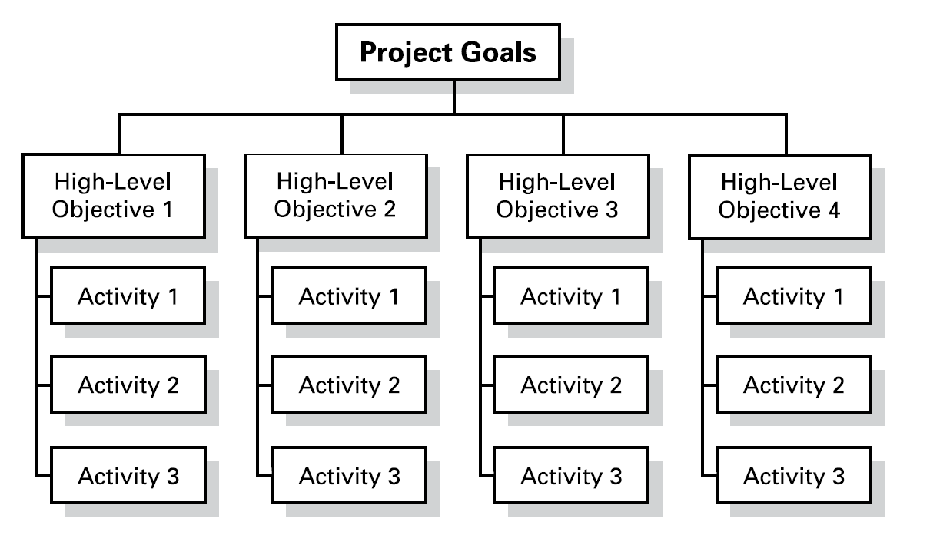
The activities should pass the “SMART” test. Each activity should have a definite start and stop time. The activities may be linked to one another, but they should not overlap. The time and cost of each activity should be easy to define. Every activity should be assignable to a team member and easily accomplished by that team member. If not, the activity should probably be broken down further.
What activities must we accomplish in presenting the basic leader training? Record responses on the self-adhesive notes—one item per page so that the items can be moved around later. Your responses should
- Identify a place, time, and date.
- Determine the cost.
- Recruit staff members and determine who will teach what.
- Acquire audiovisual support.
- Have a training team meeting.
- Promote the training.
Giving careful thought to the order of project activities can be critical to the success of the project. Putting all the activities in random order often makes the project last too long and doesn’t utilize the power of the team. While some things cannot be started until another part of the project has been completed, often several activities can be accomplished simultaneously. Ordering the activities helps facilitate linking.
For example, which of our activities listed in connection with basic leader training can be done simultaneously? Which ones cannot be started until others are finished?
Using their responses, reorganize the self-adhesive notes into several lines of activities much like the diagram previously shown. With a marker, draw lines between activities that are linked to one another (those that can’t be started until the previous one is finished).
Any project usually has one or more sets of linked activities. The longest one of these is sometimes called the critical path—that is, the set of linked activities that the leader wants to watch closely. A holdup along the critical path will most likely lead to a delay with the overall project.
Sometimes, a team must utilize new and innovative approaches and solutions to problems? Remember the old adage: “If you keep on doing what you’ve always done, you will keep on getting what you’ve always got.” Let us not fall into that trap!
STAGE THREE: ACTIVITY ASSIGNMENTS
We are now all on familiar territory—this is the old “You do this, and I’ll do that.” What is important for us to remember when assignments are made? Responses might include the following:
- Each member must understand his or her assignment.
- The leader must be sure that everyone understands the purpose of the project, the details of each assigned activity, the availability of resources, and the proj- ect’s duration.
- Team members’ skills and resources must be matched to activities.
- Goals to be accomplished and regular reporting times must be established so that the team leader is informed as to the project’s progress.
When assigning activities to team members, keep the following things in mind.
- Each team member must have a clear understanding of the purpose of the project.
- Each member must understand exactly what his or her assignment is, the details of each assigned activity, and the availability of resources (including how much time the activity is expected to take).
- It is important to match each team member’s skills and resources to the activities—be sure you have the right team member for the task.
Establish milestones or specific activities to be accomplished as well as regular reporting times so that the team leader is informed on the project’s progress.
STAGE FOUR: PUTTING THE PLAN INTO ACTION
Finally: Let the project begin! Once the project is in the hands of the team members, it is vital for the team leader to provide leadership to the team. There may be times when it is important for the team leader to provide information about resources or further clarify the assignments or project. Support and encouragement may be needed at one time or another, and it may be necessary to help with decision making or problem solving when asked.
Remember the characteristics of a high-performance team as well as those stages of development. With each new project, the team—even if it has been together before—may change its position on the development scale. To remain on schedule, the team leader should focus on the activities that are on the critical path and provide additional resources when needed to help ensure timely completion.
Trust is one of the most important characteristics of a high-performance team.
Therefore, while the team leader should monitor performance or the end results, team members should have the freedom to work within their own boundaries. Micromanaging or monitoring the work method implies that the team member is not trusted.
STAGE FIVE: PROJECT CLOSEOUT
When the project is complete there are still two important things to do. One is to recognize your team members. Remember, celebration is an important part of a high-performance team. The second is to make a postmortem report. This evaluation should be written and include an analysis of several things.
- Were the goals and objectives met?
- Was the project completed on time?
- How might we make things run better next time?
This written report will enable you or your successor to remember what happened and how to avoid some of the pitfalls you may have encountered.
Conclusion
Let’s review the five stages of project planning: (1) project overview, (2) work breakdown structure, (3) activity assignments, (4) putting the plan into action, and (5) project closeout. This five-stage method of project planning will enable teams to achieve greater success. Key elements are the project overview and the detailed plan. Execution of the plan relates back to high-performance teams and situational leadership. The postmortem report is a time to reflect on what was learned and serves as a basis for the next project.
These five stages are applicable to every project you encounter whether it is at work or for Scouting.
TRAINER PREPARATION

What qualifications should the trainer have to perform this session?

A commitment to work as a team in developing, practicing and presenting the material

Appendix Resources:
- Wood Badge Syllabus
- The Revised and Expanded Book of Raccoon Circles, Dr. Jim Cain and Dr. Tom Smith
- The One Minute Manager Builds High Performance Teams, Ken Blanchard

