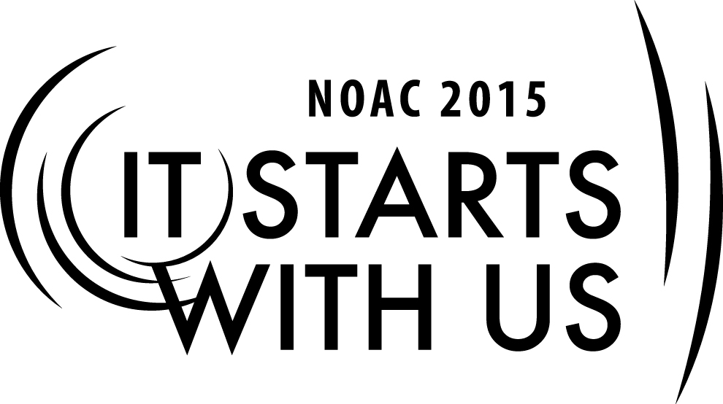
Arrowman 101: Brotherhood Bound
2015 National Order of the Arrow Conference
Session Length: 50 Minutes
Through this session, you will:
Explain the history of the Brotherhood, and how it relates to each Arrowman.
Demonstrate how important Brotherhood is to health and future of the Lodge.
Guide Ordeal members in preparing to undertake the Brotherhood.
Enable current Brotherhood members to seek the tools to increase Brotherhood conversion within their own Lodges.

This session will, through individual development, directly help the Lodge with Requirement 8 for the Journey to Excellence Workbook. It will also indirectly impact Requirements 4, 7, 9, 10, 14, 16.

The theme of NOAC 2015 is “It Starts With Us”. This session will relay this theme in the following ways:
- Brotherhood is an individual degree, and as such, it is up to each Ordeal member to decide for him or herself whether to grow within the Order or to just to maintain the status quo.
- In order to grow Brotherhood conversion and increase service provided by the Order, those Who Have Seen The Arrow must stand up and contribute to secure the legacies of our own Lodges.
SESSION NARRATIVE

INTRODUCTION 4 Minutes

Both trainers split this time to introduce themselves to the class. Each should speak about their journey as Arrowmen, and how they came to be at that point. Emphasis should be placed on individual growth in Brotherhood.

Trainer Instructions: After introductions, the primary trainer will lead the class through joint program until breakout session.

JUST ANOTHER STOP ALONG THE WAY 3 Minutes

“AWAKE, my Brothers”. When Nutiket said these words, we were scared and unsure of what was to come. But after that night, something awoke within us that said “selfless service is the way.” That was the start of the road we find ourselves on.

Since those words were spoken at our Ordeal, we have continued to embody that mantra, not only within Scouting, but also in our daily lives. We have continued displaying leadership within our units. But what is the next step? How can we take this road that we’ve gone down even further?

Attaining Brotherhood helps us to search within ourselves to decide where we want to go. By going through the Brotherhood we are reaffirming those principles which we learned in our Ordeal and expanding upon them.
We are saying to ourselves and others that we are willing to grow, and continue down the road Scouting brings us. Brotherhood isn’t the destination, just another stop along the way.

HISTORY OF THE BROTHERHOOD 3 Minutes

When the Order of the Arrow was founded in 1915 there were only two membership levels, a First and Second Degree. The First Degree combined the aspects of present day Ordeal and Brotherhood, while the Second was an early adaptation of Vigil.

It wasn’t until the 1920 constitution that the new Second Degree was formalized, and the highest level was renamed the Third Degree. The 1925 constitution finally gave names to all three, the Ordeal Degree, Brotherhood Degree, and Vigil Degree. Two other degrees were also considered but ultimately abandoned.

As an Ordeal Degree member during this time, one would wear the sash over their right shoulder, while a Brotherhood Degree member wore it over his left. It wasn’t until 1949 that the National Committee decided that all sashes would be worn over the right shoulder, and in 1950 that bars were added to either side of the arrow, thereby creating the Brotherhood sash of today.

WHAT IS THE PURPOSE OF BROTHERHOOD? 6 Minutes

What is the purpose of Brotherhood?

Trainer Instructions: Trainer should pause for responses. Reward those who participate with small candies to increase student participation. What follows can either be a prompting for students to participate, or to elaborate upon if a student gives it as an answer.

Brotherhood was started with a few goals in mind:

1.) To strengthen a member’s commitment to the Order. By undergoing a second oath, a member can reaffirm what was taught in to him or her in the Ordeal.

2.) To increase membership retention. An Arrowman more involved in the Order, or deeper, is more likely to keep coming to local and Lodge events.

3.) To increase amount of service provided to council and community. An Arrowman who becomes Brotherhood pledges him or herself to future service with the Lodge.

Trainer Instructions: Trainers will now break the class between Ordeal and Brotherhood members. Ordeal session continues to utilize projector and PowerPoint, while separate Brotherhood session employs white board or flip chart to write group ideas.

Due to breakout sessions designs, primary trainer will guide Brotherhood class as a round robin discussion of best practice’s for Brotherhood conversions. Questions to be asked are given, as well as leading suggestions. Secondary trainer will walk Ordeal members through challenges for Brotherhood candidacy.

Ordeal breakout session is described first; Brotherhood breakout session trainer skips to Brotherhood section.

ORDEAL BREAKOUT SESSION 30 Minutes

If you are an Ordeal member in this class then you are asking, “What does it take for me to become Brotherhood?” Continued selfless service; that is the cornerstone upon which our Order is founded. By reaffirming what we learned in our Ordeal, and by increasing our service to the Scouting program, we can become eligible to undertake the challenge of Brotherhood. By acknowledging that you want to become Brotherhood members, you are getting out of the passenger seats and taking the next step in being a driver in your journey.

FIVE CHALLENGES OF BROTHERHOOD MEMBERSHIP

1.) Memorize the signs of Arrow membership:
- Obligation
  - I do hereby promise, on my honor as a Scout, that I will always and faithfully observe and preserve the traditions of the Order of the Arrow, Wimachtendienk, Wingolauchsik, Witahemui. I will always regard the ties of brotherhood in the Order of the Arrow as lasting, and will seek to preserve a cheerful spirit, even in the midst of irksome tasks and weighty responsibilities, and will endeavor, so far as in my power lies, to be unselfish in service and devotion to the welfare of others
- Order of the Arrow Song
  - Firm bound in brotherhood, gather the clan
That cheerful service brings to fellow man.
Circle our council fire, weld tightly every link
That binds us in brotherhood, Wimachtendienk.
- The Admonition
  - Never spoken above a whisper. If you can’t remember or have any questions, you can ask either a lodge officer or a member of the ceremonies team.
- Sign of Ordeal Membership
  - A motion of drawing an arrow from a quiver over the left shoulder with the right arm.
- OA Handclasp
  - Done with the left hand, lower 2 fingers interlocked

2.) Advance in your understanding of the Ordeal:

- The four principle characters of the Ordeal Ceremony
  - Kichkinet (Guide) – represents helpfulness and friendliness
  - Nutiket (Guard) – represents cheerfulness
  - Meteu (Medicine Man) – represents brotherhood and reminds us to love one another
  - Allowat Sakima (Mighty Chief) – represents service
- What the four principle characters and their actions represent in the Pre-Ordeal Ceremony
  - Nutiket gave the bow to Allowat Sakima as a token of liveliness and flexibility under stress, the principle of cheerfulness
  - Meteu gave the bowstring to Allowat Sakima as a token of the ties of Brotherhood
  - Allowat Sakima strung the bow uniting brotherhood and cheerfulness for service, and drew an arrow from a quiver as a token that your election separated you from your fellows for something greater
  - Allowat Sakima asked you to test the bow as a sign of willingness to test the dedication to Scout ideals which led you to your election
  - Kitchkinet shot the arrow upward, symbolizing the pathway you will follow if your dedication is unwavering
- The four tests of the Ordeal
  - Night alone – to teach self-reliance and how to show that you are set apart from your fellow Scouts for something higher
  - 24 hours of silence – to turn your thoughts inward to the things of the spirit
  - Scant Food – to teach about the virtues of self-denial
  - Arduous toil for a day – to indicate your willingness to serve others all through your life
- The three symbolic preparations for the Obligation
  - As you entered the circle, the hand that you placed on the shoulder of the candidate ahead of you indicated your intention to continue in service to your Scout Unit.
  - Kichkinet, seeing that you all had the same purpose, symbolized this bond of brotherhood by binding you all together with the same rope.
  - Upon Allowat Sakima’s direction, Kichkinet asked you to advance before the fire of cheerfulness.
- The tradition given to us by Uncas as described in the legend
  - The legend tells how the peaceful lives of the Lenni Lenape Indians were threatened by neighboring tribes and distant enemies. Chief Chingachgook’s call for volunteers to go and alert other villagesof the tribe was met with apathy and indifference from tribal members. Uncas cheerfully offered his help despite the negative attitudes of everyone around him. He cared enough for others that he was willing to face hardship and danger to protect them from harm. Uncas clearly saw a higher vision, and his desire for his brothers was that they could see it, too. The self-sacrificing service given by Uncas and Chingachgook is said to have saved the tribe from annihilation.
- The Arrow
  - Symbol of leadership
  - Worn pointed high over the right shoulder as an outward symbol indicating that he possesses the qualities of leadership that the Arrow represents

3.) Serve your Unit:

Maintain your registration in Scouting. During a period of at least 10 months, strive to fulfill your Obligation by continuing and expanding your service to your own troop or team.

- Larger leadership role (i.e. Patrol Leader to Senior Patrol Leader).
- Troop OA rep

4.) Plan for service in your Lodge:

Pay your dues in your Order of the Arrow Lodge. Be aware that acceptance of Brotherhood membership involves a pledge of future service to the Lodge. Develop a concrete idea on how you plan to fulfill this pledge.

- Become a ceremonies team member
- Join a dance team
- Work as a member of kitchen crew

5.) Review your progress:

When you earnestly feel that you have met the four previous challenges, write a letter to your Lodge Secretary. In this letter:

- Explain what you think the Obligation means.
- Describe how you have been fulfilling the Obligation in your troop and in your daily life, and how you have used your understanding of the Ordeal to aid in your service.
- Describe your specific plans for giving future service in the Lodge program

Trainer Instructions: After delivering the mini-Workshop to the students, the secondary trainer will pass out the study guides. The study guides include much of the same information, and can aid the students in helping to prepare to undergo the Brotherhood in their Lodge.

BROTHERHOOD BREAKOUT SESSION 30 Minutes
Trainer Instructions: As stated before, the primary trainer working with Brotherhood session will be guiding group in round robin discussion of best conversion practices after breakout session intro. Trainer will need to feed off the group and ask follow-up questions to response to stimulate creativity. Small candies are recommended to increase student participation.

What is the commitment expected of Brotherhood members? Brotherhood members are expected to increase their level of service, whether it’s to the unit, the Lodge, or in his or her community. They are also expected to show leadership in a higher capacity than they did before they were brotherhood.

That could mean either a spot among chapter leadership, troop leadership, or even a spot on the Lodge Executive Committee. Leadership can even come from being member of a Lodge team, such as either a part of ceremonies, dance, kitchen crew, or trading post.

As Brotherhood members, we have made a conscientious decision to get into the driver’s seat. We are figuratively in the driver’s seat, and we are staring at straight ahead. By us being in the seat of leadership, on the road that is our journey in the Order of the Arrow, means we have a duty to help it grow. One of the ways we can help the Order grow is by increasing the amount of Ordeal members who undertake the challenge of Brotherhood.

We know this as Brotherhood Conversions. Think of the overall process in a religious sense. We are actively trying to convert Ordeal members into Brotherhood members. That is what the focus of this breakout session is. We are going to be discussing what the best practices to increase BC’s in each your Lodge’s are.

The goal for this session is that each of you will take at least one of these ideas back to your own Lodges and implement them to help increase BC. It is up to us to be the catalyst for growth within our Lodges.

WHAT DOES YOUR LODGE DO TO INCREASE BROTHERHOOD CONVERSIONS?

Ideas as add-ons for already provided ideas, or to be given at outset to stimulate thinking

- Extended Elangomat program
  - Elangomat guides partner with individual or groups of Ordeal members to help bring them up and through Brotherhood
- Brotherhood Workshop
  - Name of the program needs to associate with continued learning (i.e. Brotherhood Workshop over Brotherhood Review)
- Chapter incentives program
  - Based on dates and tiered percentages (i.e. 35% in June earns chapter an ice cream social, 50% by August 1st chapter gets a pizza party, 75% gets chapter chief free transportation to section/region/national event)
- Amount of workshops and ceremonies performed per year, and at what events
  - Summer camp can net a high yield by targeting Ordeal members not seen at normal Lodge events
  - District camporee
  - Council events
- Strong OA Troop Rep network system

CONCLUSION 4 Minutes

Trainer Instructions: After classes group back together, secondary trainer leads class in conclusion, “telling them what they were just told.”

The process that encompasses Brotherhood is the next step of our journey in the Order. We have arrived at the rest stop, gotten out of the passenger seat, and are sliding into the drivers seat.

This class has taken us through the history of Brotherhood, the purpose of Brotherhood, and what is expected of a Brotherhood member. While some of us have learned what it takes to become Brotherhood and others about how to increase Brotherhood conversion, all of us have learned how vital it is to complete the induction process by undertaking the challenge.

Where do we go from here? After learning all of this different information, what do we do? We turn off the cruise control! We take everything back to our Lodges. It is up to the Arrowmen in this room to help grow the Order, not only in numbers, but also in dedication to serving the Scouting program.

Whether we are helping to assist fellow Ordeal members in studying with us to undertake the Brotherhood, or bringing ideas to our Lodge Executive Committee’s to increase the amount of Brothers in the fold, we are becoming the drivers of our vehicles. It Starts With Us.

TRAINER PREPARATION

This session will need 2 Arrowmen to be run properly; one to guide both the Ordeal member and Brotherhood member sessions concurrently after introductions and history. This class will pair together a primary trainer with a secondary trainer, both either a youth or adult. The primary trainer will guide the students through the beginning stages of the class and direct the Brotherhood session through ideas given and experience, while the secondary trainer guides Ordeal members through a Workshop of established principles of OA membership.
Appendix Resources:
- PowerPoint presentation, for introduction and Ordeal breakout section
- Projector
- Flip chart or white board, used to gather and display ideas from Brotherhood member breakout section
- Study guide, given out to Ordeal members at the end of class for continued preparation.

