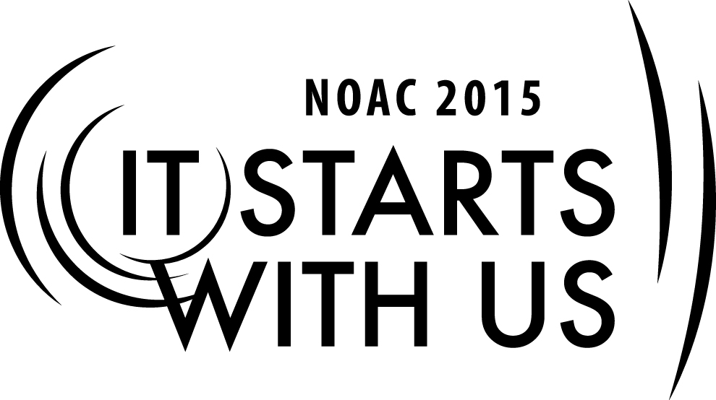
Adviser Forum: Three Keys Pro-Active Advisers Embrace
2015 National Order of the Arrow Conference

Session Length: 50 Minutes
Through this session,
Explain the importance of recruiting, training, and communication/follow-up in successful advisership
Demonstrate working together in small groups to share successes and challenges (and how to overcome them)
Guide guests in determining the most important components of recruiting, training, and communication
Enable guests to improve OA advisership and program function within their own lodges by setting personal goals

This session will help the Lodge with the Journey to Excellence Requirement(s) 4, 7, 10, 14, and 16

The theme of NOAC 2015 is “It Starts With Us”. This session will relay this theme in the following ways:
- Lodge Adviser focus on 3 key areas of improvement that will strengthen any component of OA program.
- By engaging in dialogue with other Advisers and sharing experiences and challenges met, initiation for improvement that will benefit all starts with them.
SESSION NARRATIVE

Adviser Forum, Three Keys 50 minutes

Trainer Instructions: Trainer will lead slide introduction and guide formation of small groups at appropriate time for breakouts #1-3 (guests will stay in same groups)

Introduction:
“Welcome to Lodge Adviser Forum, Session A.”
Introduce trainers present
“Let’s get started, because we have a lot to cover in our short time.”

Read through learning objectives (slide)
Then pose this question to guests:
“What could “IT” be that we are starting?
(give a minute for guests to offer possible answers). They will likely mirror the next slide that lists some “ITs.” After showing it for about 10 seconds, go to the next slide that lists some components of successful lodge program and events.
Trainer should read through or narrate around them while guests read them

Introduction of the 3 Keys to Adviser: Recruiting, Training, and Communication/Follow-up.
“In this session, we are going to explore three keys to making not only your life as Lodge Adviser more effective, but will help improve your Lodge’s ability to implement your programs and events. These three keys are: (show next slide listing them)

“Let’s get started in our exploration of these by breaking out into small groups.”
(Can be by whatever method works and may depend on number of guests)
“Each group will have poster paper and markers. One or more than one person can be the secretary. Here is your first task.” Switch to next slide that outlines possible discussion points for the group to consider regarding RECRUITING.
Trainer reminds groups they have 10 minutes to brainstorm and discuss the most important points in this area as has been their experience. Then a spokesperson for the group will share out (30 seconds for each group) to the whole class.
During the discussion time, the trainers should walk among the small groups and help facilitate their discussion, making sure they don’t get bogged down in one single point, but rather hit on 3-5 top components of success in RECRUITING.

Then show slide of common traits of leaders (most of these should come as no surprise, but may reinforce points they came up with in small groups)

Trainer should have a timer handy. When 10 minutes is done, have small groups share out for up to 2 minutes
*(Remind guests to write at least one goal for them to begin when they return home to their lodge).
allow for Q&A regarding RECRUITING that lasts no more than 2 minutes.

“We’re now going to move onto our 2nd key for Advisers, which is training.”
Small groups go to a new poster page, but stay in same groups

Flash up next slide for small group discussion on TRAINING components, pros and cons, etc.
As groups discuss, trainers walk the room and listen to small group discussion.
Keep them off of staying on one point, but to try and get top 3-5 (at least) points at least.
At the end of 10 minutes (using timer), round everyone up and share out group by group again.
Then show slide of common traits of training (most of these should come as no surprise, but may reinforce points they came up with in small groups)

*(Remind guests to write at least one goal for them to begin when they return home to their lodge).
allow for Q&A regarding TRAINING that lasts no more than 2 minutes.

“We’re now going to move onto our 3rd and last key for Advisers, which is communication and follow-up.”
Small groups go to a new poster page, but stay in same groups

Flash up next slide for small group discussion on COMMUNICATION components, challenges, etc.
As groups discuss, trainers walk the room and listen to small group discussion.
Keep them off of staying on one point, but to try and get top 3-5 (at least) points at least.
At the end of 10 minutes (using timer), round everyone up and share out group by group again.
Then show slide of common components of successful communication (most of these should come as no surprise, but may reinforce points they came up with in small groups)

*(Remind guests to write at least one goal for them to begin when they return home to their lodge).
allow for Q&A regarding COMMUNICATION/FOLLOW-UP that lasts no more than 2 minutes.

Closing
Show slide that reviews the 3 Keys for Lodge Advisers, review the learning objectives (if there is time), and how they did these. Thanks guests for being there, and show final two slides that inform about resources and contact info on travel drive downloads.

TRAINER PREPARATION

What qualifications should the trainer have to perform this session?
Experience as a Lodge Adviser or working with Lodge Advisers, Lodge Chief or LEC experience.
Knowledge of resources available.

