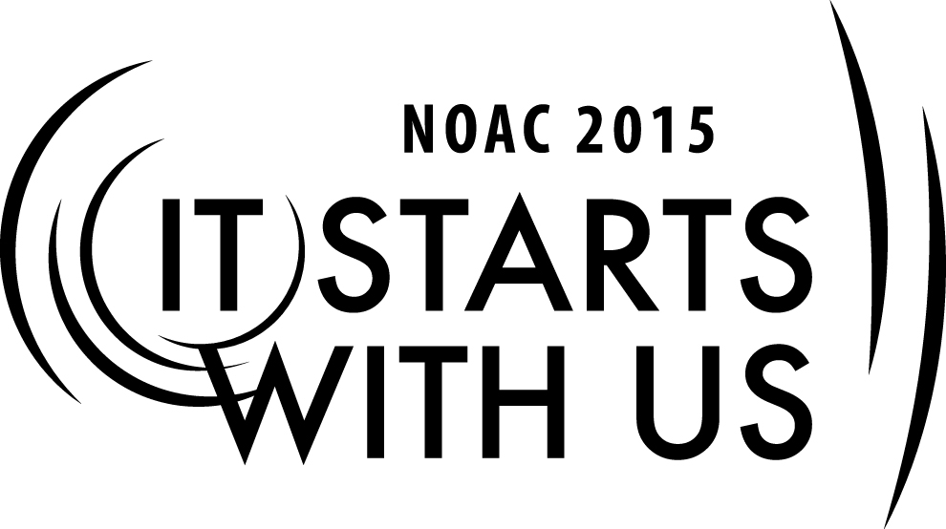
2015 National Order of the Arrow Conference
Adviser Forum: Panel Discussion-2
Session Length: 55 Minutes
Through this session, you will:
Explain – This is a panel discussion with questions posed by both the trainer and guests
Demonstrate - The panel will demonstrate their knowledge of OA issues and challenges.
Guide - We will guide the guests to ask relevant questions of the panel.
Enable - We will enable guests to use the experience of the panel to their best advantage when they return to their Lodge.

This session may help the Lodge/Chapter/Section with the Journey to Excellence Requirement(s) dependent upon the category of questions posed by guests.

- Item 1 – Fiscal Management
- Item 2 – Contribution to Council
- Item 3 – Membership Impact
- Item 4 – Membership Retention
- Item 5 – Unit Elections
- Item 6 – Ordeal Completion
- Item 7 – Lodge Event Participation
- Item 8 – Brotherhood Completion
- Item 9 – Service Projects
- Item 10 – Section and National Event Attendance
- Item 11 – Unit Visitation
- Item 12 – Unit of Excellence Award
- Item 13 – Council Designated Support
- Item 14 – Council Program Support
- Item 15 – Council Camping Support
- Item 16 – Leadership Development
- Item 17 – Planning and Reporting

The theme of NOAC 2015 is “It Starts With Us”. This session will relay this theme in the following ways:
- Provide guests with a clear frame of reference and resources to handle issues for which they are seeking remediation.
- By empowering guests to address issues and challenges they were unsure about.
SESSION NARRATIVE

INTRODUCTION 5 Minutes

The introduction will address the purpose of the session which is for guests to bring their questions about the issues and challenges that they face in their Lodge and/or Chapter before the panel so they can understand how to best resolve them.

The opening session will also consist of an introduction to the panel members and a short list of rules that ensure everyone has a chance to ask questions and do so in a way that is non-confrontational. The rules should include the following:
- Guests wishing to ask questions should stand
- Speak into a microphone, if provided
- State the following:
  - Name
  - Lodge & Council
  - Role in their lodge
- Politeness shall prevail.

Trainer Instructions: The trainer should obtain an “elevator” biography of each panel member before the session begins.

QUESTION & ANSWER PERIOD 50 Minutes

In this session, the trainer will invite guests to ask their most pressing questions and to assist in directing them to the proper panelist.

Trainer Instructions: There may be some hesitation by the guests to begin asking questions. The trainer should have a short list of questions to begin the process, if that becomes necessary.

CONCLUSION 3 Minutes

In this session, the trainer will thank guests for their questions and the panel for their thoughtful responses. In addition, the trainer should remind guests that there are several references available to them in PDF which include:

- Advising Advisers
- Guide for Officers and Advisers (2012)
- Lodge Adviser’s Handbook (2012)
- Chapter Operations Guide (2012)
- Field Operations Guide (2013)

Trainer Instructions: The trainer should be mindful that some guests might request to continue the conversation with a panelist. If panelists are available following the session, the trainer should assist. If not, the trainer should provide a means for the guest to contact the panelist, i.e. email address, etc.

TRAINER PREPARATION

The trainer should have a working knowledge of moderating guests and panelists.

Appendix Resources:
- There are none required for this session.

