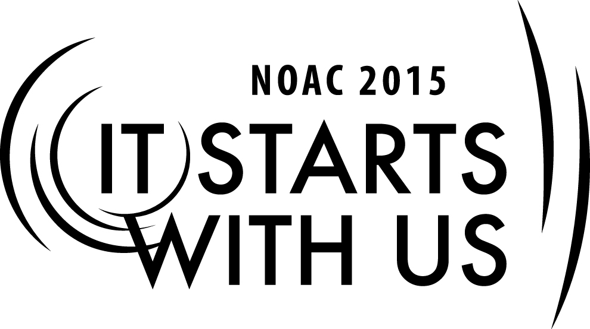
2015 National Order of the Arrow Conference
Adviser Forum: Panel Discussion-1
Session Length: 55 Minutes
Through this session, you will:
Explain – This is a panel discussion with questions posed by both the trainer and guests
Demonstrate - The panel will demonstrate their knowledge of issues and challenges on OA member retention.
Guide – The panel will guide the guests to balance retention with JTE scoring.
Enable - We will enable guests to use the experience of the panel to their best advantage when they return to their Lodge.

This session may help the Lodge/Chapter/Section with the Journey to Excellence Requirement(s) dependent upon the category of questions posed by guests.

- Item 2 - Contribution to Council
- Item 4 – Membership Retention
- Item 8 – Brotherhood Completion

The theme of NOAC 2015 is “It Starts With Us”. This session will relay this theme in the following ways:
- Provide guests with a clear frame of reference and resources to handle membership retention issues for which they are seeking remediation.
- By empowering guests to address issues and challenges they were unsure about.
SESSION NARRATIVE

INTRODUCTION 5 Minutes

The introduction will address the purpose of the session through the following:

“The National Office has published the latest statistics on OA membership. To many, they are less than stellar. The BSA’s honor society only retains one in every five Ordeal members. We are here today to discuss membership retention and how that is affected by council contributions and Brotherhood conversion and to seek some ‘best practices’ to assist OA leadership.”

The opening session will also consist of an introduction to the panel members and a short list of rules that ensure everyone has a chance to ask questions and do so in a way that is non-confrontational. The rules should include the following:
- The panel will begin by answering questions posed by the trainer. (The first question is a warm-up, with no follow-up allowed.)
- Guests wishing to ask follow-up or clarification questions should stand and do the following:
  - Speak into a microphone, if provided
  - State the following:
    - Name
    - Lodge & Council
    - Role in their lodge
- Politeness shall prevail.

Trainer Instructions: The trainer should obtain an “elevator” biography of each panel member before the session begins.

QUESTION & ANSWER PERIOD 50 Minutes

In this session, the trainer will begin the discussion by asking the following:

- Assuming the 1:5 statistic is accurate, does that reflect your experience and is your experience better or worse?

- What are some of the reasons you've heard Arrowmen give for leaving their brothers or failing to pay their dues, aside from perfume and petroleum?
  - Are there any reasons that are actionable?
  - What should be the advisor’s role?
  - What should be the role of the lodge chief and other youth leadership?
  - Is there anything in the published OA guidelines that offer useful suggestions on how to retain Arrowmen while meeting JTE fiscal and conversion goals?

- Some have the perspective that OA naturally devolves to a ‘dance team’. That seems to be a pretty unfair characterization. What activities have you found that capture the attention and involve a large number of your Arrowmen?

- The OA election process has guidelines that BSA units and Arrowmen are asked to follow in terms of eligibility for election. And, yet in some cases it becomes a popularity contest in which some nominees only seek the cool patch and sash. If that's a fair assessment, is there anything that may help in electing those who will be motivated to convert to Brotherhood?

- There is an old management maxim that says, “What gets measured, gets done.” There are a couple of critical JTE measures that lodge leadership must grapple with regularly, the conversion rate to Brotherhood, retention of all lodge members and the collection of annual dues.
  - How does your lodge/chapter/section successfully handle annual dues contributions?
    - Do you allow a “grace period” or “forgive” dues for any segment of membership?
    - If there is a dues forgiveness aspect, is it fair to all segments?
  - How does your lodge/chapter/section increase membership even though many new Arrowmen do not convert to Brotherhood?
  - Is there some magic in balancing membership growth and the seemingly competing JTE goals?

Trainer Instructions: The trainer should remember that the purpose of the panel discussion is to assist guests to learn ‘best practices’, not necessarily to complete asking all the questions listed above.

CONCLUSION 3 Minutes

In this session, the trainer will thank the panel and guests for their questions and for their thoughtful responses. In addition, the trainer should remind guests that there are several references available to them in PDF which include:

- Advising Advisers
- Guide for Officers and Advisers (2012)
- Lodge Adviser’s Handbook (2012)
- Chapter Operations Guide (2012)
- Field Operations Guide (2013)

Trainer Instructions: The trainer should be mindful that some guests might request to continue the conversation with a panelist. If panelists are available following the session, the trainer should assist. If not, the trainer should provide a means for the guest to contact the panelist, i.e. email address, etc.

TRAINER PREPARATION

The trainer should have a working knowledge of moderating guests and panelists.

Appendix Resources:
- There are none required for this session.

