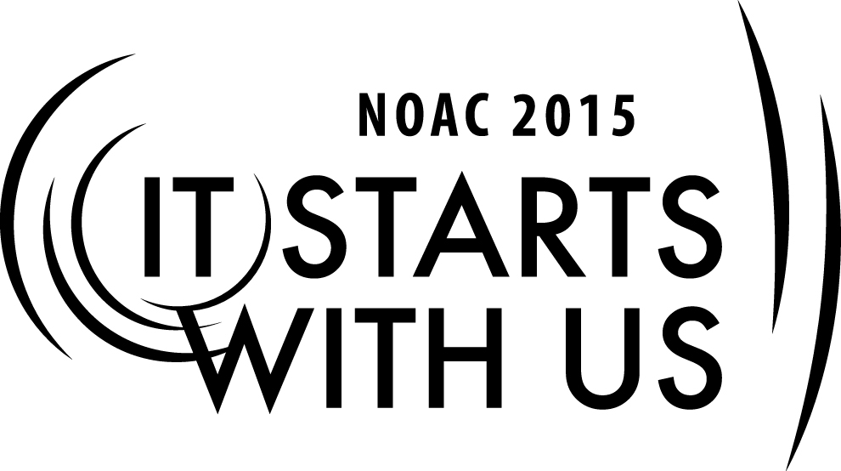
Chapter Programs
2015 National Order of the Arrow Conference
Session Length: 50 Minutes
Through this session, you will:
Explain -
- To acquaint students with concepts of OA Chapter programming and how the programs relate both formally and informally to the Lodge.

Demonstrate-
- Various examples of Chapter programs.

Guide
- The participants, through lecture and discussion will learn about Chapter programs and program planning.

Enable:
- The participants will understand and explain Chapter programs and the basics of Program Planning.

This session will help the Lodge/Chapter/Section with the 2015 Journey to Excellence Requirement 14: Council program support: Provide OA Member staff support for council and district program events.

The theme of NOAC 2015 is “It Starts With Us”. This session will relay this theme in the following ways:
- It starts with us to understand Chapter Programs.
- It starts with us to understand the basics of Program Planning and provide quality Chapter Programs.
Program Planning Basics
SESSION NARRATIVE
10 Minutes
"We showed up to the bowling alley and we found out it was biker's night, and our boys had four lanes at the far end...."
"The ski trip didn't work so well when the weather was 70 degrees in January..."
"The first half the chapter meeting was uneventful: half the boys were playing Pokemon in the corner, while the other half kept looking down at their phones and snickering. That poor chapter chief standing up front..."
We all likely have a story that starts this way about our chapters. Some of these situations are unavoidable; however, good advising can help prevent the rest.
As an adviser to a chapter trying to plan a program, you may feel a bit like a troop leader. This is okay, and is probably good! The chapter often times functions as the "troop" of the Order of the Arrow. While it should not replace the boys participation in the unit, it can be a way for arrowmen to connect with each other on a more personal level than they may connect through the Lodge. It also provides a leadership opportunity - for many boys, the first outside of their troop.
We'll begin our session today with an open forum: what is the one tip you would recommend to a group of boys planning a chapter program, whether that be an activity, a chapter meeting, or a program as part of a lodge event?

Thanks for those great ideas! Let's move onto discuss more specific events and programs that you could have at your chapter.
Chapter Events
30 minutes
For the purposes of this class, we will try to stick to activities and events that are universal to all lodges - whether chapter heavy or chapter light. A staple of most chapter systems is that the chapter is the group that organizes fellowship activities in local communities. Really this is more a matter of convenience than anything else: The chapter is a smaller group with closer geographical ties. But this also plays an important part in OA's purpose of serving the units: local chapters do not have to coordinate with as many units schedules. It is easier for 10 boys from 3 troops to plan an activity than 30 boys from 10 troops.
Let's take some time to collaborate and share ideas. Break into small groups of 3-4 people, preferably people you do not know. With that group, take about 10-12 minutes to design a chapter event: whether that be a bowling trip, a campout, or a service project. Think through the logistics of the event, what needs to be determined by the youth, and what role the chapter adviser needs to play to ensure safe and productive Scout activity.
- Trainer Tip: After each group has had sufficient time to plan, take 10-12 minutes to go around the room and share ideas. Give each group 1-2 minutes (depending on number of groups) to share the idea, what tasks must be done before going on that trip, and how the adviser helps make it happen.
Great work! Let's take a moment to debrief. You probably noticed that all of these activities were relatively easy to plan. These are typically simple activities, but focused on fun and fellowship. This is because the youth leading the chapter are typically not developmentally able to lead more complex events: planning a chapter ski-trip is the starting point for planning an entire induction for a lodge. You probably also noticed that the adviser's role was more to support the logistics than guide the vision: that is because a lot of the work of the chapter is youth-run. Much like a troop, chapter activities can be a boy's first experience being in charge and getting to pick what he wants to do.
Conclusion and Cell Wrap-up
10 minutes
At this point in our day, we have talked about the role of the chapter chief and the chapter adviser. We have also talked about how the chapter fits into the lodge, and we began to get into your role as an adviser to the chapter and how you can leave an impact on the chapter. Finally, we discussed chapter programs and shared ideas for chapter events.
In the last few minutes together, we would like to wrap up with each of our trainer's favorite success stories - the moments when we felt like being a chapter adviser was truly a rewarding experience.

Finally, we'd like to open up the floor for any last questions or burning thoughts.

Thank you all for attending today, and we wish you the best of luck as chapter advisers.
TRAINER PREPARATION

What qualifications should the trainer have to perform this session?
- Facilitation skills
- Technology skills to load and run PowerPoint Program

Appendix Resources:
Guide for Officers and Advisers #24-413 (2012) http://www.oa-bsa.org/pages/content/publications#goa

Chapter Operations Guide (2012) http://www.oa-bsa.org//uploads/publications/cog-2012.pdf

Best Practices from around the Nation http://www.oa-bsa.org/pages/content/best-practices

